Name

Class

Date

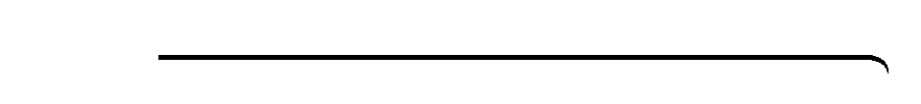

**Puzzle: What Is a Line’s Favorite Kind of Fruit?**

1.2

Measuring Segments (10 points)

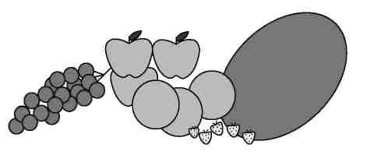

**Solve the problems below to answer the riddle. *YOU MUST SHOW ALL WORK TO RECEIVE FULL CREDIT!***

**What is a line’s favorite kind of fruit?**

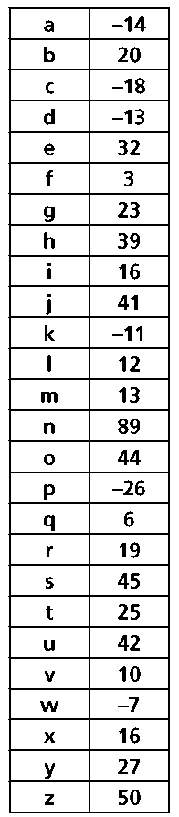

**Look for your answer in the key at the right and put the corresponding letter in the answer blank at the bottom of the page.**

**1.** Points *A*, *B*, and *C* are collinear and *A* is between *B* and *C*. *AB =* 4*x −* 3, *BC =* 7*x +* 5, and *AC =* 5*x −* 16.

Find each value.

**a.** *BC*

**b.** *AB*

**c.** *AC*

**2.** On a number line, *G =* 8 and *H =* –3. If *H* is the midpoint of , find the coordinate of *I*.

**3.** *J* is the midpoint of . Find *KJ* if *KL* = 38.

**For 4–6, refer to the number line below.**



1. Suppose *O* is the midpoint of and *N* is the midpoint of . If *NO =* 8, find *MQ*.
2. Suppose *P* is the midpoint of , *OP =* 11, and *OQ =* 35. Find *NO*.
3. If *NO =* 2*y +* 11, *OP =* 3*y −* 2, *NP =* 6*y +* 3, and *MP =* 64, find each value.

**a.** *NO*

**b.** *MN*

