* 1. Angle Pairs Classwork & HW

*10 points*

**Use the diagram below. Is each statement true? Explain using the definition of the vocabulary word.**

1. 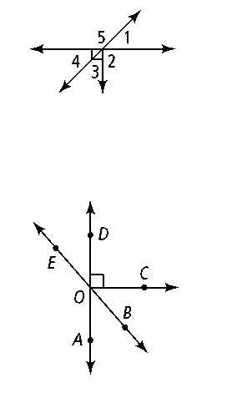**∠**2 and ∠5 are adjacent angles.

1. ∠1 and ∠4 are vertical angles.
2. ∠4 and ∠5 are complementary.

**Name an angle or angles in the diagram described by each of the following.**

1. complementary to ∠*BOC*

1. supplementary to ∠*DOB*

**6.** adjacent and supplementary to ∠*AOC*

**7. Reasoning** Describe all the situations in which the following statements are true.

**a.** Two vertical angles are also complementary.

**b.** A linear pair is also supplementary.

**c.** Two supplementary angles are also a linear pair.

**d.** Two vertical angles are also a linear pair.

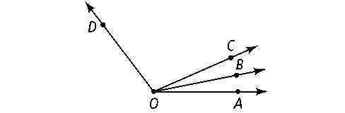**Use the diagram below for Exercises 7 and 8. Solve for *x.* Find the angle measures.**

**7.** *m*∠*AOB* = 4*x* − 1; *m*∠*BOC* = 2*x* + 15; *m*∠*AOC* = 8*x* + 8

**8.** *m*∠*COD* = 8*x* + 13; *m*∠*BOC* = 3*x* − 10; *m*∠*BOD* = 12*x* − 6

**9.** ∠*ABC* and ∠*EBF* are a pair of vertical angles; *m*∠*ABC* = 3*x* + 8 and *m*∠*EBF* = 2*x* + 48. What are *m*∠*ABC* and *m*∠*EBF?*

**10.** ∠*JKL* and ∠*MNP* are complementary; *m*∠*JKL* = 2*x* − 3 and *m*∠*MNP* = 5*x* + 2. What are *m*∠*JKL* and *m*∠*MNP?*

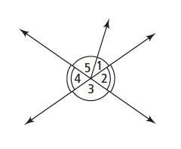**For Exercises 11–14, can you make each conclusion from the information in the diagram? Explain.**

**11.** ∠3 ≅ ∠4 **12.** ∠2 ≅ ∠4

**13.** *m*∠1 + *m*∠5 = *m*∠3 **14.** *m*∠3 = 90

**15. **bisects ∠*JKL.* If *m*∠*JKM* = 86, what is *m*∠*JKL?*

**16. **bisects ∠*RST.* If *m*∠*RST* = 62, what is *m*∠*RSV?*

 bisects ∠*PQR.* Solve for *x* and find *m*∠*PQR.***

**17.** *m*∠*PQS* = 3*x; m*∠*SQR* = 5*x* − 20

**18.** *m*∠*PQS* = 2*x* + 1; *m*∠*RQS* = 4*x* − 15

**19.** *m*∠*PQR* = 3*x* − 12; *m*∠*PQS* = 30

**20.** *m*∠*PQS* = 2*x* + 10; *m*∠*SQR* = 5*x* − 17

**For Exercises 21–24, can you make each conclusion from the information in the diagram below? Explain.**

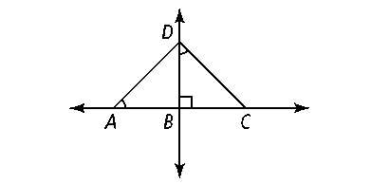

**21.** ∠*DAB* and ∠*CDB* are congruent.

**22.** ∠*ADB* and ∠*CDB* are complementary.

**23.** ∠*ADB* and ∠*CDB* are congruent.

**24.** ∠*ADB* and ∠*BCD* are congruent.

**25. Algebra** ∠*MLN* and ∠*JLK* are complementary, *m*∠*MLN* = 7*x* − 1, and   
*m*∠*JLK* = 4*x* + 3.

**a.** Solve for *x.*

**b.** Find *m*∠*MLN* and *m*∠*JKL.*

**c.** Show how you can check your answer.

**27. Open-Ended** Write and solve an equation using an angle bisector to find the measure of an angle.