**Classwork: Notation and logical reasoning**

Listed are standard terminology and notation. Use it to be more precise and save time.

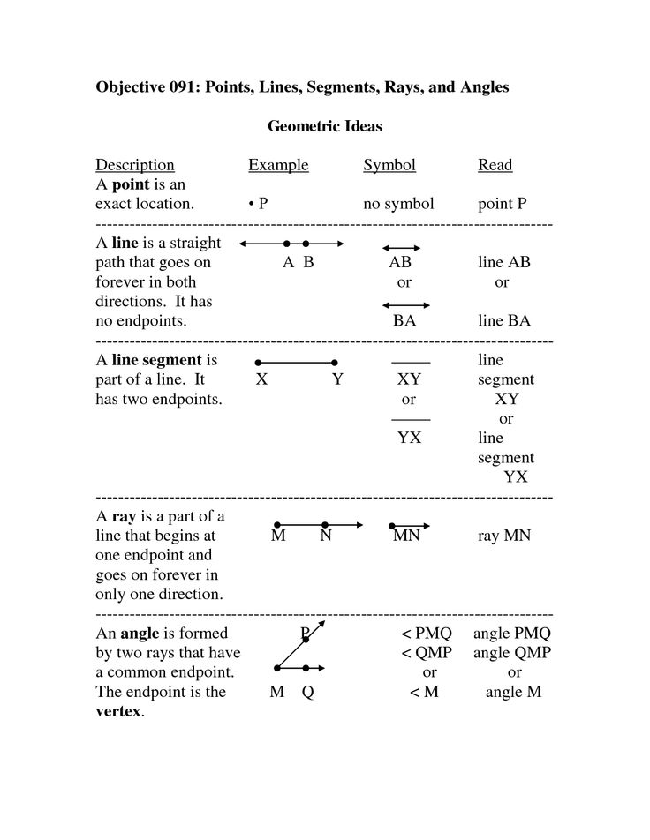

A **circle** is a collection of all the points that are an equal distance, the **radius**, from a specific point, the **center**.

O

Circle O with radius *r*

Rewrite these steps

