**adjacent angles angle bisector complementary angles supplementary angle vertical angles**

**Choose the word from the list above that is defined by each statement.**

|  |  |  |
| --- | --- | --- |
| **1.** | two angles whose measures have a sum of 180 |  |
| **2.** | two angles whose measures have a sum of 90 |  |
| **3.** | two angles whose sides are opposite rays |  |
| **4.** | two angles that share a side but do not overlap |  |
| **5.** | a ray that divides one angle into two angles with the same measure |  |

**Use a word from the list to complete each sentence.**

**6.** If the measure of one angle in a pair of is *n,* the  
measure of the other angle is 180 – *n.*

**7.**  never share a side.

**8.**  always share a side.

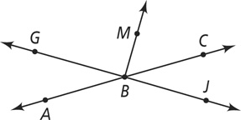

1. Which of the following are a pair of vertical angles?

|  |  |
| --- | --- |
| a**∠***GBA* and **∠***CBJ* | *c* **∠***ABM* and **∠***MBC* |
| b **∠***GBA* and **∠***GBM* | d**∠***ABJ* and **∠***MBC* |
|  |  |

1. Which of the following are supplementary angles?

|  |  |
| --- | --- |
| f **∠***GBA* and **∠***CBJ* | h **∠***ABM* and **∠***MBC* |
| ICON **∠***GBA* and **∠***GBM* | ICON-I **∠***ABM* and **∠***MBC* |

**Draw the angle bisector for each angle.**

