**Homework: Linear Functions**

**1.** On the set of axes below, draw the graph of the equation $y=-\frac{3}{2}x+2$.



Is the point (4, -5) a solution to the equation? Explain your answer based on the graph drawn.

**2.**

**3.** The graph represents a jogger's speed during her 20-minute jog around her neighborhood. Describe what the jogger was doing during the  minute interval of her jog?

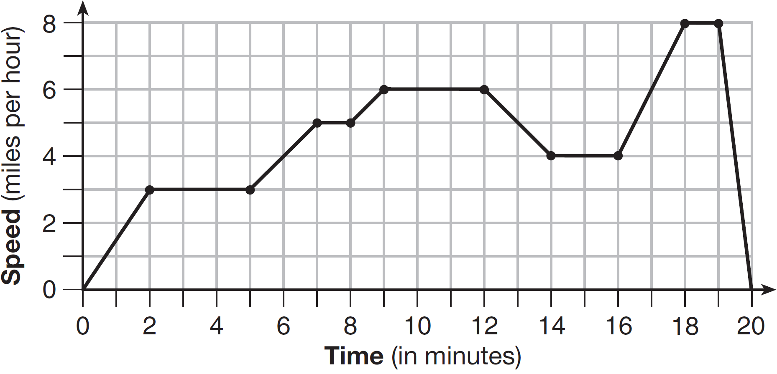

4. The function  represents the height, , in feet, of an object from the ground at *t* seconds after it is dropped.

a) What is the height after one second?

b) How much time has elapsed when the ball hits the ground?

5. The graph represents a jogger's speed during her 20-minute jog around her neighborhood. Describe what the jogger was doing during the  minute interval of her jog?

6.The graph of the function  is shown below. What is the domain of the function?

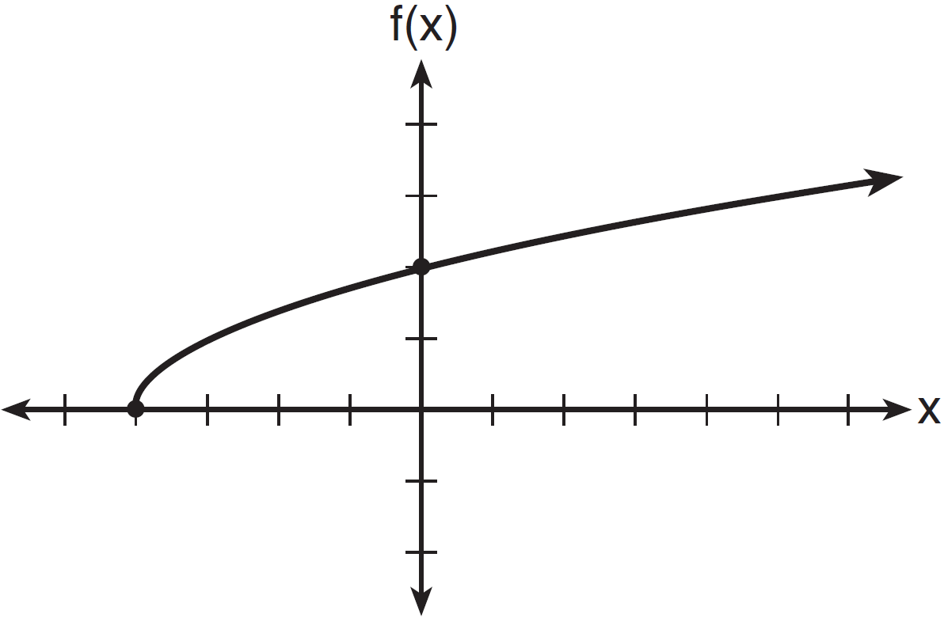

7. Joey enlarged a 3-inch by 5-inch photograph on a copy machine. He enlarged it four times. The table below shows the area of the photograph after each enlargement.

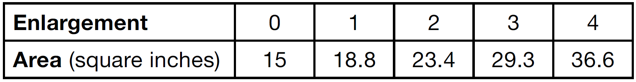

What is the average rate of change of the area from the original photograph to the fourth enlargement, to the *nearest tenth*?

8. An astronaut drops a rock off the edge of a cliff on the Moon. The distance, , in meters, the rock travels after *t* seconds can be modeled by the function 

a) What distance has it traveled after 5 seconds?

b) How far has it traveled after 10 seconds?

c) What is the average speed, in meters per second, of the rock between 5 and 10 seconds after it was dropped?

10. A function is shown in the table below.

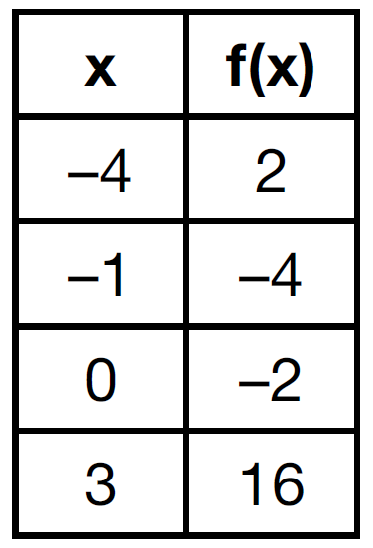

If included in the table, which ordered pair,  or , would result in a relation that is no longer a function? Explain your answer.

11. A driver leaves home for a business trip and drives at a constant speed of 60 miles per hour for 2 hours. Her car gets a flat tire, and she spends 30 minutes changing the tire. She resumes driving and drives at 30 miles per hour for the remaining one hour until she reaches her destination. On the set of axes below, draw a graph that models the driver’s distance from home.

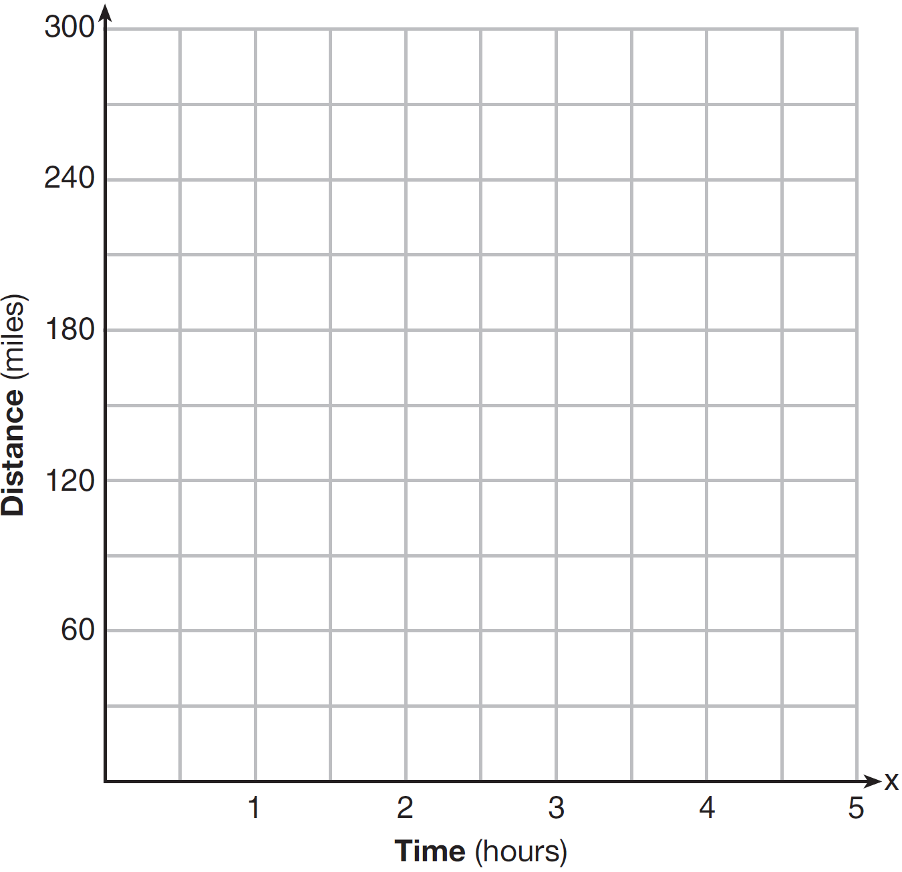

a) How far did she travel from home to her destination?

b) How long did it take, including the stop?

c) What is her average speed over the entire trip, including when she was stopped?