**Homework:** Answer the questions below and be prepared to discuss tomorrow

Zara is considering opening a store on Fordham Road.

Rent for the store is $20,000 per month.

The store will need 5 employees at a minimum – they will earn $50,000 per year each.

1. How much will the store cost per year to operate?

Most of the clothing sold at the store is sold at twice what it costs to make:

* Shirts that cost $5 to make are sold at $10. Gross profit will then be $5 ($10 - $5).
* Jackets that cost $25 to make are sold at $50. Gross profit of $25 ($50 - $25).
* Shoes that cost $50 to make are sold at $100. Gross profit of $50 ($100 - $50).

1. If the store sells $40,000 of merchandise per week, how much gross profit will the store make per week?
2. How much gross profit is that per year?

1. If you subtract the cost of the rent, and the staff, how much profit (operating profit) will Zara make from the store per year?

1. Can you draw a graph of Zara’s profit, at different levels of sales?  
     
   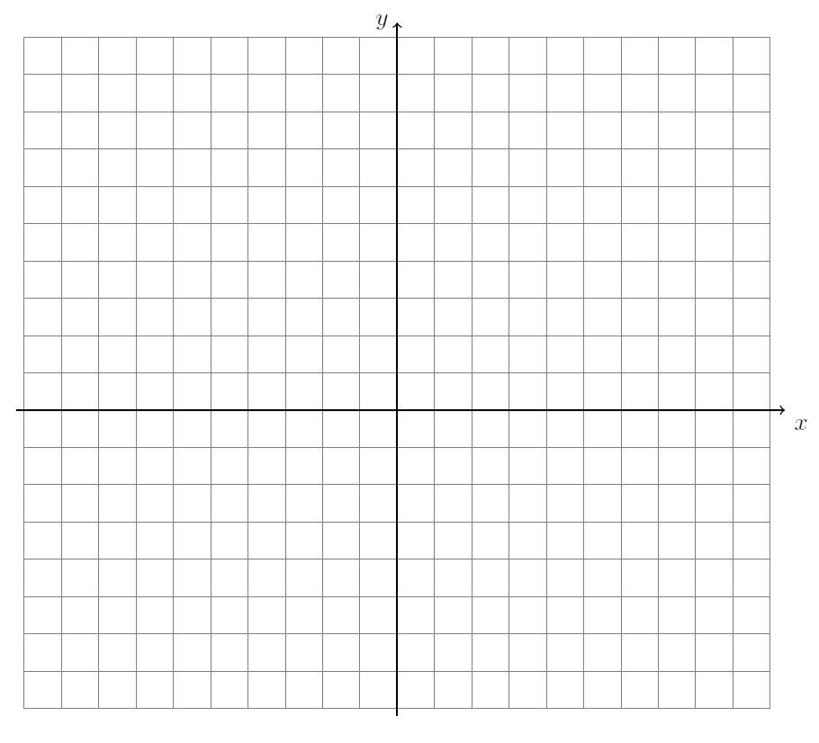
2. What is the gradient of the graph, and what does it signify?

1. What is the y-intercept, and what does it represent?
2. BONUS: what is the x-intercept, and what does it represent?

**Classwork:** Financial mathematics, slope & *y*-intercept

**Apple Incorporated** (simplified example, actual figures are on the second page)

Apple *sales* are expected to be $250 billion next year. The *cost* to manufacture all those iphones, ipads, airpods and macbooks is expected to be $150 billion.

1. What should Apple’s gross profit be?

The cost of stores, employees, research advertising, etc. is expected to be $35 billion. These are *operating expenses*.

1. How much *operating profit* will Apple make?
2. If Apple pays *taxes* of 15%, how much *net profit* will Apple make?
3. Apple has 4.7 billion *shares*. How much of that net profit goes to each *shareholder*?
4. If Apple gives all of those profits to its shareholders, how many years will it take for Apple shareholders to get back the $175 the shares cost today?

1. Graph Apple’s operating profit (*y*) as a function of sales (*x*). Hint: plot two points, zero sales and $250 billion sales. What is the *y*-intercept and what is the slope?

Apple Inc.’s Financial Reports (10-K)

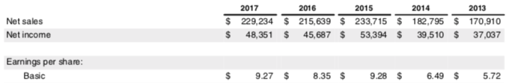

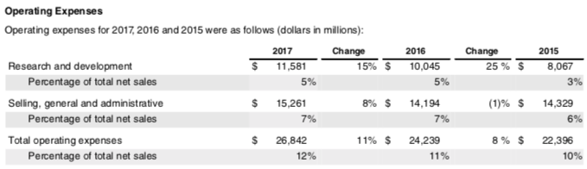

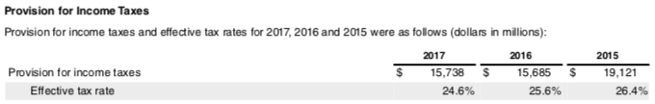

**What-if scenarios**

China is 20% of Apple’s sales. If sales decline by 25% in China, what happens to Apple’s profits?

(then how many years?)

If Apple’s tax rate goes up by 5% (from 15% to 20%), what happens to Apple’s net profit?  
(then how many years?)

If i-phones are 60% of Apple’s revenue, what happens if people change their phones every 3 years instead of every 2 years?

(then how many years?)

What happens if Apple cuts the price of its i-phones by 10%?  
(then how many years?)

Apple is developing an electric car. If it sells 1 million cars per year at $50,000 each. How much extra revenue will it earn?  
(then how many years?)