**Classwork & homework review. Due Monday.**

**1a.** *[2 marks]*

Let  and 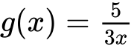, for .

Find .

**1b.** *[2 marks]*

Show that 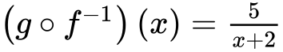.

**1c.** *[2 marks]*

Let 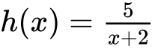, for . The graph of *h* has a horizontal asymptote at .

Find the -intercept of the graph of .

**1d.** *[3 marks]*

Hence, sketch the graph of .

**1e.** *[1 mark]*

For the graph of , write down the -intercept;

**1f.** *[1 mark]*

For the graph of , write down the equation of the vertical asymptote.

**1g.** *[3 marks]*

Given that , find the value of .

**2a.** *[3 marks]*

Let  , for  .

Find  .

**2b.** *[3 marks]*

Let  be a function such that  exists for all real numbers. Given that  , find  .

**3a.** *[3 marks]*

Let  and  .

Find  .

**3b.** *[3 marks]*

Find  .

**4a.** The diagram below shows the graph of a function  , for  . *[1 mark]*

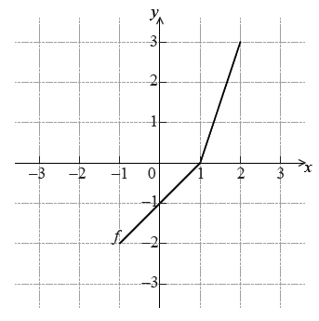

Write down the value of .

**4b.** Write down the value of  . *[2 marks]*

**4c.** Sketch the graph of  on the grid below. *[3 marks]*

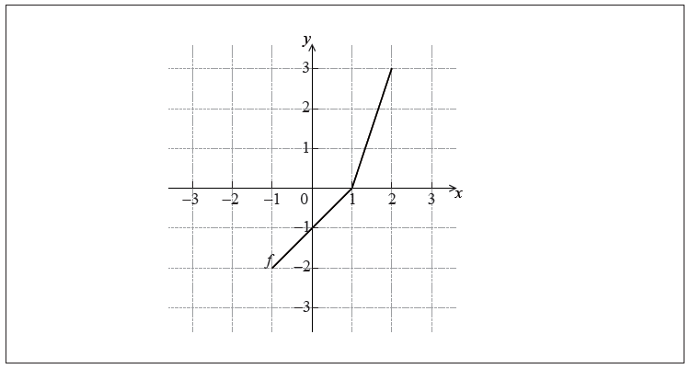

**5a.** *[6 marks]*

Let  and  be functions such that  .

(a) The graph of  is mapped to the graph of  under the following transformations:

vertical stretch by a factor of  , followed by a translation 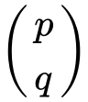 .

Write down the value of

(i)  ;

(ii)  ;

(iii)  .

(b) Let  . The point A(, ) on the graph of  is mapped to the point  on the graph of  . Find  .

**5b.** *[3 marks]*

The graph of  is mapped to the graph of  under the following transformations:

vertical stretch by a factor of  , followed by a translation  .

Write down the value of

(i)  ;

(ii)  ;

(iii)  .

**5c.** Let  . The point A(, ) on the graph of  is mapped to the point  on the graph of  . Find  . *[3 marks]*

**6a.** *[4 marks]*

The following diagram shows the graph of a quadratic function *f* , for  .

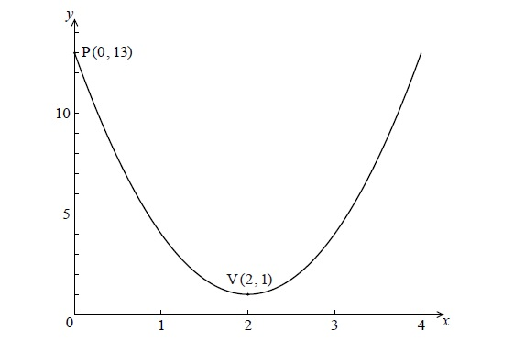

The graph passes through the point P(0, 13) , and its vertex is the point V(2, 1) .

The function can be written in the form  .

(i) Write down the value of *h* and of *k* .

(ii) Show that  .

**6b.** *[3 marks]*

Find  , giving your answer in the form  .

**6c.** *[8 marks]*

Calculate the area enclosed by the graph of *f* , the *x*-axis, and the lines  and  .

**7a.** *[5 marks]*

Consider  , for  . The equation  has two equal roots.

Find the value of *k* .

**7b.** *[2 marks]*

The line  intersects the graph of *f* . Find all possible values of *p* .

**8a.** *[2 marks]*

The following diagram shows part of the graph of a quadratic function *f* .

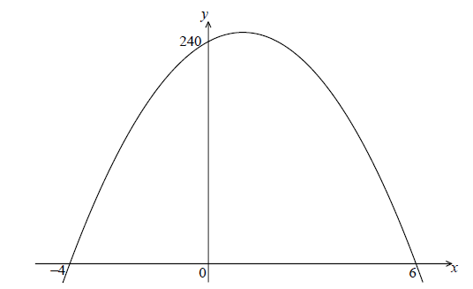

The *x*-intercepts are at  and  , and the *y*-intercept is at  .

Write down  in the form  .

**8b.** *[4 marks]*

Find another expression for  in the form  .

**8c.** *[2 marks]*

Show that  can also be written in the form  .

**8d.** *[7 marks]*

A particle moves along a straight line so that its velocity,  , at time *t* seconds is given by  , for  .

(i) Find the value of *t* when the speed of the particle is greatest.

(ii) Find the acceleration of the particle when its speed is zero.

**9a.** Let  , for  .

Show that  . *[2 marks]*

**9b.** Find the value of  and of  . *[3 marks]*

**9c.** *[6 marks]*

The function *f* can also be written in the form 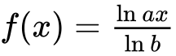 .

(i) Write down the value of *a* and of *b* .

(ii) Hence on graph paper, **sketch** the graph of *f* , for  ,  , using a scale of 1 cm to 1 unit on each axis.

(iii) Write down the equation of the asymptote.

**9d.** *[1 mark]*

Write down the value of  .

**9e.** *[4 marks]*

The point A lies on the graph of *f* . At A,  .

On your diagram, sketch the graph of  , noting clearly the image of point A.

**10a.** *[2 marks]*

Let  . The graph of *f* is translated 1 unit to the right and 2 units down. The graph of *g* is the image of the graph of *f* after this translation.

Write down the coordinates of the vertex of the graph of *g* .

**10b.** Express *g* in the form  . *[2 marks]*

**10c.** The graph of *h* is the reflection of the graph of *g* in the *x*-axis.

Write down the coordinates of the vertex of the graph of *h* . *[2 marks]*

**11a.** *[2 marks]*

Let  , for  .

Show that  .

**11b.** *[1 mark]*

Write down the range of  .

**11c.** *[4 marks]*

Let  , for  .

Find the value of  , giving your answer as an integer.

**12.** *[7 marks]*

Solve  , for  .

**13a.** *[3 marks]*

Let  .

Given that  , find the value of  .

**13b.** *[4 marks]*

Find 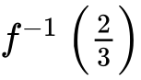 .

**14a.** *[3 marks]*

Let  .

(i) Show that  .

(ii) Write down the domain of  .

**14b.** *[4 marks]*

Solve the equation  .

**15a.** *[1 mark]*

Find  .

**15b.** *[4 marks]*

Given that 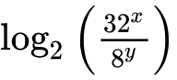 can be written as  , find the value of *p* and of *q*.

**16a.** Expand  and simplify your result. *[3 marks]*

**16b.** Find the term in  in  . *[3 marks]*

**17a.** Let  .

Show that  . *[2 marks]*

**17b.** *[8 marks]*

For the graph of *f*

(i) write down the coordinates of the vertex;

(ii) write down the **equation** of the axis of symmetry;

(iii) write down the *y*-intercept;

(iv) find both *x*-intercepts.

**17c.** **Hence** sketch the graph of *f* . *[2 marks]*

**17d.** *[3 marks]*

Let  . The graph of *f* may be obtained from the graph of *g* by the two transformations:

a stretch of scale factor *t* in the *y*-direction

followed by a translation of 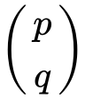 .

Find  and the value of *t*.