**Homework: Pretest statistics review**

**1a.** Jim heated a liquid until it boiled. He measured the temperature of the liquid as it cooled. The following table shows its temperature,  degrees Celsius,  minutes after it boiled.



Write down the independent variable. *[1 mark]*

**1b.** Write down the boiling temperature of the liquid. *[1 mark]*

**1c.** Jim believes that the relationship between  and  can be modelled by a linear regression equation.

Jim describes the correlation as **very strong**. Circle the value below which best represents the correlation coefficient. *[2 marks]*



**1d.** Jim’s model is , for . Use his model to predict the decrease in temperature for any 2 minute interval. *[2 marks]*

**2a.** Consider the following frequency table.

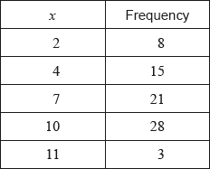

Write down the mode. *[1 mark]*

**2b.** Find the value of the range. *[2 marks]*

**2c.** *[2 marks]*

Find the mean.

**2d.** *[2 marks]*

Find the variance.

**3a.** A school collects cans for recycling to raise money. Sam’s class has 20 students.

The number of cans collected by each student in Sam’s class is shown in the following stem and leaf diagram.

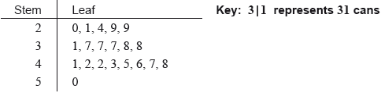

Find the median number of cans collected. *[2 marks]*

**3b.** *[3 marks]*

The following box-and-whisker plot also displays the number of cans collected by students in Sam’s class.

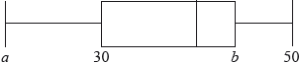

(i) Write down the value of .

(ii) The interquartile range is 14. Find the value of .

**3c.** *[3 marks]*

Sam’s class collected 745 cans. They want an average of 40 cans per student.

How many more cans need to be collected to achieve this target?

**3d.** *[5 marks]*

There are 80 students in the school.

The students raise $0.10 for each recycled can.

(i) Find the largest amount raised by a student in Sam’s class.

(ii) The following cumulative frequency curve shows the amounts in dollars raised by all the students in the school. Find the percentage of students in the school who raised more money than anyone in Sam’s class.

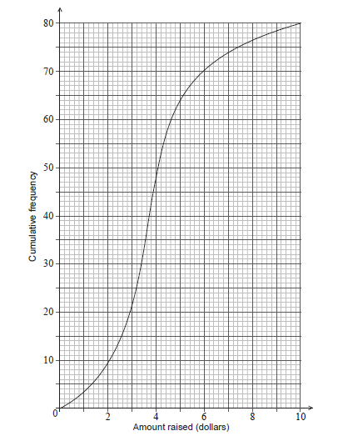

**3e.** The mean number of cans collected is 39.4. The standard deviation is 18.5.

Each student then collects 2 more cans.

(i) Write down the new mean.

(ii) Write down the new standard deviation. *[2 marks]*