**Homework: Function graphs**

**1a.** *[1 mark]*

The following diagram shows the graph of , the derivative of .

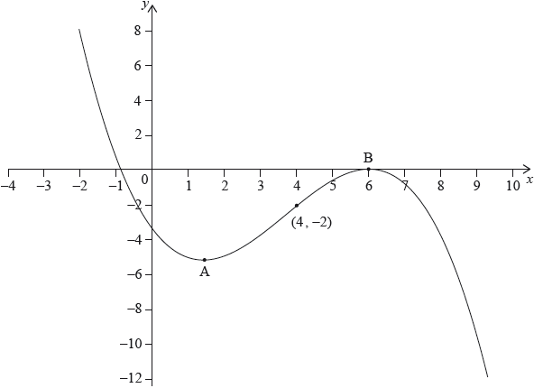

The graph of  has a local minimum at A, a local maximum at B and passes through .

The point  lies on the graph of the function, .

Write down the gradient of the curve of  at P.

**1b.** *[3 marks]*

Find the equation of the normal to the curve of  at P.

**1c.** *[2 marks]*

Determine the concavity of the graph of  when  **and** justify your answer.

**2a.** *[4 marks]*

Let 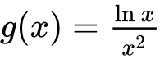 , for  .

Use the quotient rule to show that 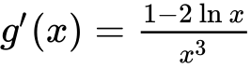 .

**2b.** *[3 marks]*

The graph of *g* has a maximum point at A. Find the *x*-coordinate of A.

**3a.** *[2 marks]*

A function *f* is defined for  . The graph of *f* is given below.

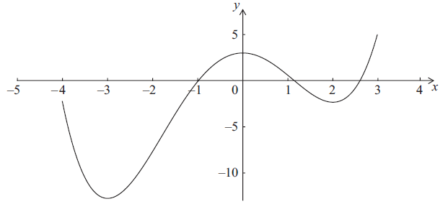

The graph has a local maximum when  , and local minima when  ,  .

Write down the *x*-intercepts of the graph of the **derivative** function,  .

**3b.** *[2 marks]*

Write down all values of *x* for which  is positive.

**3c.** *[2 marks]*

At point D on the graph of *f* , the *x*-coordinate is . Explain why  at D.

**4a.** *[3 marks]*

Let 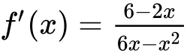, for .

The graph of  has a maximum point at P.

Find the -coordinate of P.

**4b.** *[8 marks]*

Let , for .

The graph of  has a maximum point at P.

The -coordinate of P is .

Find , expressing your answer as a single logarithm.

**4c.**

Let , for .

The graph of  has a maximum point at P.

The -coordinate of P is .

The graph of  is transformed by a vertical stretch with scale factor . The image of P under this transformation has coordinates .

Find the value of  and of , where .

Printed for Bronx Early College Academy

© International Baccalaureate Organization 2018

International Baccalaureate® - Baccalauréat International® - Bachillerato Internacional®