# Homework: Mixed review, short answer (57 marks). ***Paper 1, no calculator***

**1a.** In an arithmetic sequence, the first term is 8 and the second term is 5.

Find the common difference. *[2 marks]*

**1b.** Find the tenth term. *[2 marks]*

**1c.** Find the sum of the first ten terms. *[2 marks]*

**2a.** The following diagram shows the graph of a function , with domain .

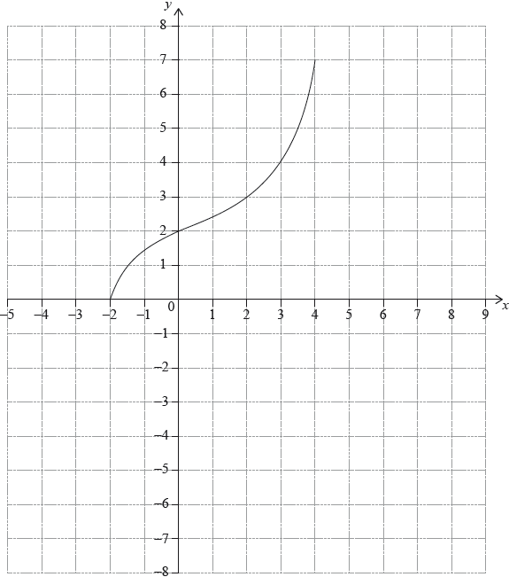

The points  and  lie on the graph of .

Write down the range of . *[1 mark]*

**2b.** Write down ; *[1 mark]*

**2c.** Write down . *[1 mark]*

**2d.** On the grid, sketch the graph of . *[3 marks]* **3a.** *[2 marks]*

Let  and , for , where  is a constant.

Find .

**3b.** *[4 marks]*

Given that 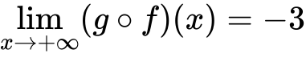, find the value of .

**4.** *[7 marks]*

Let , for . The following diagram shows part of the graph of  and the rectangle OABC, where A is on the negative -axis, B is on the graph of , and C is on the -axis.

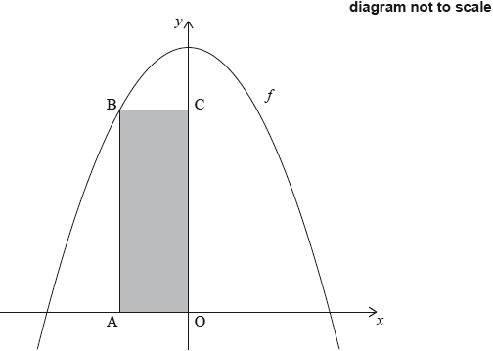

Find the -coordinate of A that gives the maximum area of OABC.

**5.** *[7 marks]*

Consider , for , where .

The equation  has exactly one solution. Find the value of .

**6a.** In a group of 20 girls, 13 take history and 8 take economics. Three girls take both history and economics, as shown in the following Venn diagram. The values  and  represent numbers of girls.

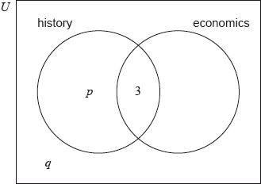

Find the value of ; *[2 marks]*

**6b.** Find the value of . *[2 marks]*

**6c.** A girl is selected at random. Find the probability that she takes economics but not history. *[2 marks]*

**7.** The following diagram shows triangle PQR.

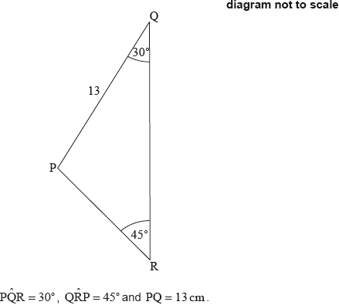

Find PR. *[6 marks]*

**8a.** *[1 mark]*

Jim heated a liquid until it boiled. He measured the temperature of the liquid as it cooled. The following table shows its temperature,  degrees Celsius,  minutes after it boiled.



Write down the independent variable.

**8b.** Write down the boiling temperature of the liquid. *[1 mark]*

**8c.** *[2 marks]*

Jim believes that the relationship between  and  can be modelled by a linear regression equation.

Jim describes the correlation as **very strong**. Circle the value below which best represents the correlation coefficient.



**8d.** *[2 marks]*

Jim’s model is , for . Use his model to predict the decrease in temperature for any 2 minute interval.

**9a.** *[4 marks]*

Find .

**9b.** *[3 marks]*

Find , given that  and .