# **Homework: Calculus review**

**1.** Let . Given that , find . *[6 marks]*

**2a.** The velocity  of a particle after  seconds is given by

, for 

The following diagram shows the graph of .

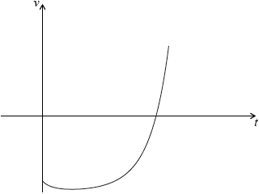

Find the value of  when the particle is at rest. *[3 marks]*

**2b.** Find the value of  when the acceleration of the particle is . *[3 marks]*

**3.** Let 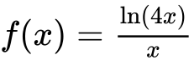 for .

Points  and  are on the curve of . The tangent to the curve of  at  is perpendicular to the tangent at . Find the coordinates of . *[7 marks]*

**4a.** Let , for .

Sketch the graph of  on the following grid. *[3 marks]*

**4b.** Solve . *[2 marks]*

**4c.** The region enclosed by the graph of  and the -axis is rotated  about the -axis.

Find the volume of the solid formed. *[3 marks]*

**5a.** Let 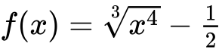.

Find . *[2 marks]*

**5b.** Find . *[4 marks]*

**6a.** *[4 marks]*

Consider  .

Find  .

**6b.** *[3 marks]*

Find the gradient of the curve of  at  .

**7.** *[7 marks]*

A rocket moving in a straight line has velocity  km s–1 and displacement  km at time  seconds. The velocity  is given by  . When  ,  .

Find an expression for the displacement of the rocket in terms of  .

**8a.** A particle’s displacement, in metres, is given by  , for  , where *t* is the time in seconds.

On the grid below, sketch the graph of  . *[4 marks]*

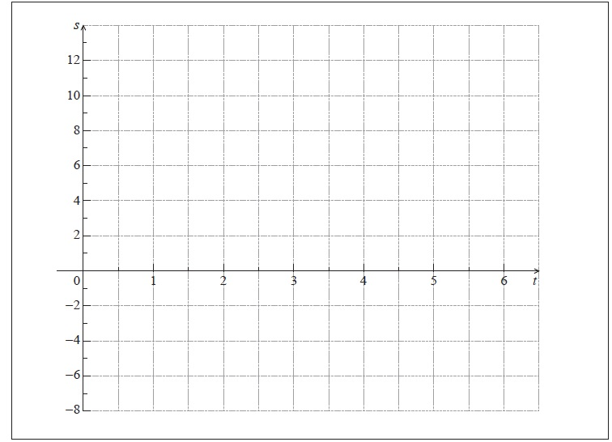

**8b.** *[3 marks]*

Find the maximum velocity of the particle.

**9a.** *[3 marks]*

Let 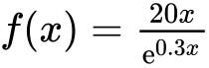 , for  .

Sketch the graph of *f* .

**9b.** *[3 marks]*

(i) Write down the *x*-coordinate of the maximum point on the graph of *f* .

(ii) Write down the interval where *f* is increasing.

**9c.** *[5 marks]*

Show that 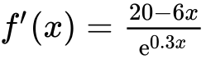 .

**9d.** *[4 marks]*

Find the interval where the rate of change of *f* is increasing.

**10a.** *[1 mark]*

The velocity *v* ms−1 of a particle at time *t* seconds, is given by  , for  .

Write down the velocity of the particle when  .

**10b.** *[8 marks]*

When  , the acceleration is zero.

(i) Show that  .

(ii) Find the exact velocity when  .

**10c.** *[4 marks]*

When  , 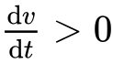 and when  ,  .

Sketch a graph of *v* against *t* .

**10d.** *[3 marks]*

Let *d* be the distance travelled by the particle for  .

(i) Write down an expression for *d* .

(ii) Represent *d* on your sketch.

**11a.** *[2 marks]*

The following diagram shows a waterwheel with a bucket. The wheel rotates at a constant rate in an anticlockwise (counter-clockwise) direction.

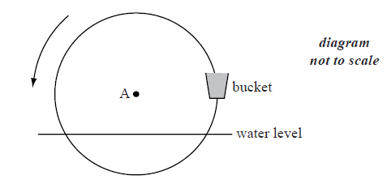

The diameter of the wheel is 8 metres. The centre of the wheel, A, is 2 metres above the water level. After *t* seconds, the height of the bucket above the water level is given by  .

Show that  .

**11b.** *[2 marks]*

The wheel turns at a rate of one rotation every 30 seconds.

Show that  .

**11c.** *[6 marks]*

In the first rotation, there are two values of *t* when the bucket is **descending** at a rate of  .

Find these values of *t* .

**11d.** *[4 marks]*

In the first rotation, there are two values of *t* when the bucket is **descending** at a rate of  .

Determine whether the bucket is underwater at the second value of *t* .

**12a.** *[2 marks]*

The following diagram shows the graph of  .

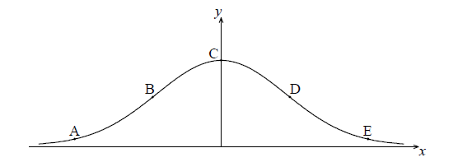

The points A, B, C, D and E lie on the graph of *f* . Two of these are points of inflexion.

Identify the **two** points of inflexion.

**12b.** (i) Find  .

(ii) Show that  . *[5 marks]*

**12c.** Find the *x*-coordinate of each point of inflexion. *[4 marks]*

**12d.** *[4 marks]*

Use the second derivative to show that one of these points is a point of inflexion.

**13a.** The diagram below shows a plan for a window in the shape of a trapezium.

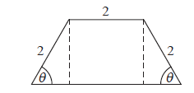

Three sides of the window are  long. The angle between the sloping sides of the window and the base is  , where  .

Show that the area of the window is given by  . *[5 marks]*

**13b.** *[4 marks]*

Zoe wants a window to have an area of . Find the two possible values of  .

**13c.** *[7 marks]*

John wants two windows which have the same area *A* but different values of  .

Find all possible values for *A* .

**14a.** *[2 marks]*

A particle moves in a straight line. Its velocity, , at time  seconds, is given by

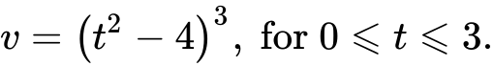

Find the velocity of the particle when .

**14b.** *[3 marks]*

Find the value of  for which the particle is at rest.

**14c.** *[3 marks]*

Find the total distance the particle travels during the first three seconds.

**14d.** *[3 marks]*

Show that the acceleration of the particle is given by .

**14e.** *[4 marks]*

Find all possible values of  for which the velocity and acceleration are both positive or both negative.

**15a.** *[2 marks]*

The first three terms of a infinite geometric sequence are , where .

Write down an expression for the common ratio, .

**15b.** *[2 marks]*

Hence, show that  satisfies the equation .

**15c.** *[3 marks]*

Find the two possible values of .

**15d.** *[3 marks]*

Find the possible values of .

**15e.** *[3 marks]*

The sequence has a finite sum.

State which value of  leads to this sum **and** justify your answer.

**15f.** *[3 marks]*

The sequence has a finite sum.

Calculate the sum of the sequence.

**16a.** Consider the lines  and  with equations  : 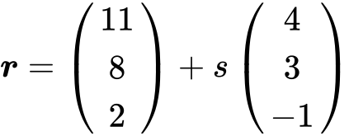 and  : 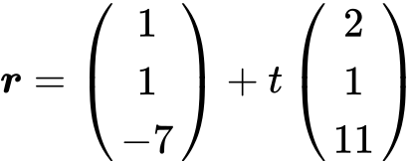.

The lines intersect at point . Find the coordinates of . *[6 marks]*

**16b.** Show that the lines are perpendicular. *[5 marks]*

**16c.** The point  lies on . The point  is the reflection of  in the line .

Find the coordinates of . *[6 marks]*

**17a.** Consider the functions  ,  and  . The following table gives some values associated with these functions.

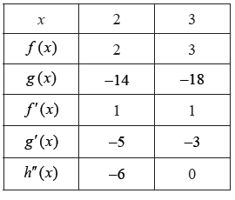

Write down the value of  , of  , and of  . *[3 marks]*

**17b.** The following diagram shows parts of the graphs of  and  .

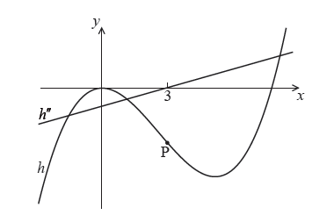

There is a point of inflexion on the graph of  at P, when  .

Explain why P is a point of inflexion. *[2 marks]*

**17c.** Given that  ,

find the -coordinate of P. *[2 marks]*

**17d.** find the equation of the normal to the graph of  at P. *[7 marks]*