# 6-1-P1_Calculus-tangents

**1a.** *[4 marks]*

Let  .

Find  .

**1b.** *[3 marks]*

Find the gradient of the graph of *g* at  .

**2a.** *[1 mark]*

Let  .

Write down  .

**2b.** *[4 marks]*

The tangent to the graph of *f* at the point  has gradient *m* .

(i)     Show that  .

(ii)    Find *b* .

**2c.** *[1 mark]*

Hence, write down the equation of this tangent.

**3.** *[6 marks]*

Let  . Find the gradient of the normal to the curve of *f* at  .

**4a.** *[4 marks]*

Consider  .

Find  .

**4b.** *[3 marks]*

Find the gradient of the curve of  at  .

**5a.** *[2 marks]*

Part of the graph of  is shown below.

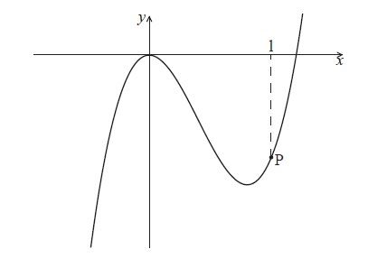

The point P lies on the graph of  . At P, *x* = 1.

Find  .

**5b.** *[4 marks]*

The graph of  has a gradient of  at the point P. Find the value of  .

**6a.** *[2 marks]*

Let  and , for , where  is a constant.

Find .

**6b.** *[4 marks]*

Given that 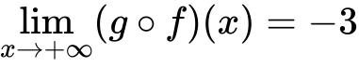, find the value of .

**7.** *[6 marks]*

Let  . The point  lies on the curve of *f* . At P, the normal to the curve is parallel to 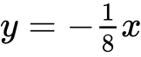 . Find the value of *k*.

**8.** *[6 marks]*

Let . The line  is the tangent to the curve of  at .

Find the equation of  in the form .

**9a.** *[1 mark]*

The following diagram shows the graph of , the derivative of .

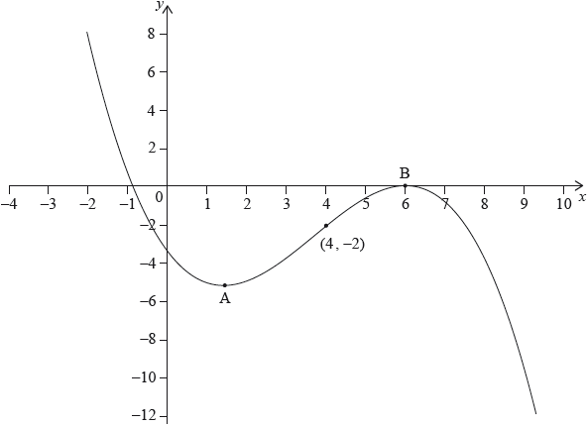

The graph of  has a local minimum at A, a local maximum at B and passes through .

The point  lies on the graph of the function, .

Write down the gradient of the curve of  at P.

**9b.** *[3 marks]*

Find the equation of the normal to the curve of  at P.

**9c.** *[2 marks]*

Determine the concavity of the graph of  when  **and** justify your answer.

**10.** *[7 marks]*

Consider *f*(*x*), *g*(*x*) and *h*(*x*), for x∈ where *h*(*x*) = (*x*).

Given that *g*(3) = 7 , *g′* (3) = 4 and *f ′*(7) = −5 , find the gradient of the normal to the curve of *h* at *x* = 3.

**11a.** *[5 marks]*

The following diagram shows part of the graph of the function  .

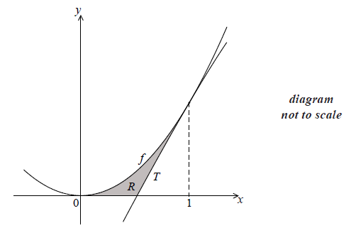

The line *T* is the tangent to the graph of *f* at  .

Show that the equation of *T* is  .

**11b.** *[2 marks]*

Find the *x*-intercept of *T* .

**11c.** *[9 marks]*

The shaded region *R* is enclosed by the graph of *f* , the line *T* , and the *x*-axis.

(i)     Write down an expression for the area of *R* .

(ii)    Find the area of *R* .

**12a.** *[3 marks]*

Consider 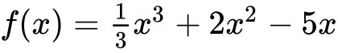 . Part of the graph of *f* is shown below. There is a maximum point at M, and a point of inflexion at N.

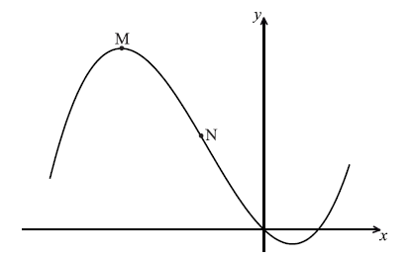

Find  .

**12b.** *[4 marks]*

Find the *x*-coordinate of M.

**12c.** *[3 marks]*

Find the *x*-coordinate of N.

**12d.** *[4 marks]*

The line *L* is the tangent to the curve of *f* at . Find the equation of *L* in the form  .

**13a.** *[3 marks]*

Let , for . The following diagram shows part of the graph of .

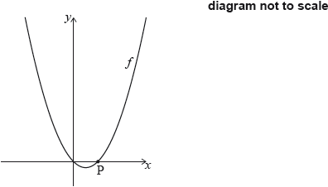

The graph of  crosses the -axis at the origin and at the point .

Show that .

**13b.** *[3 marks]*

The line *L* is the normal to the graph of *f* at P.

Find the equation of  in the form .

**13c.** *[4 marks]*

The line  intersects the graph of  at another point Q, as shown in the following diagram.

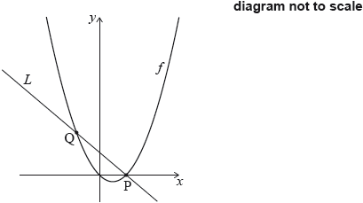

Find the -coordinate of Q.

**13d.** *[6 marks]*

Find the area of the region enclosed by the graph of  and the line .

**14a.** *[3 marks]*

A quadratic function  can be written in the form . The graph of  has axis of symmetry  and -intercept at 

Find the value of .

**14b.** *[3 marks]*

Find the value of .

**14c.** *[8 marks]*

The line  is a tangent to the curve of . Find the values of .

**15a.** *[2 marks]*

A function  has its derivative given by , where  is a constant.

Find .

**15b.** *[3 marks]*

The graph of  has a point of inflexion when .

Show that .

**15c.** *[2 marks]*

Find .

**15d.** *[4 marks]*

Find the equation of the tangent to the curve of  at , giving your answer in the form .

**15e.** *[3 marks]*

Given that , explain why the graph of  has a local maximum when .

**16a.** *[3 marks]*

Let  , for  .

Find  .

**16b.** *[3 marks]*

Let  be a quadratic function such that  . The line  is the axis of symmetry of the graph of  .

Find  .

**16c.** *[4 marks]*

The function  can be expressed in the form  .

(i)     Write down the value of  .

(ii)     Find the value of  .

**16d.** *[6 marks]*

Find the value of  for which the tangent to the graph of  is parallel to the tangent to the graph of  .

**17a.** *[3 marks]*

The following diagram shows the graph of  , for  .

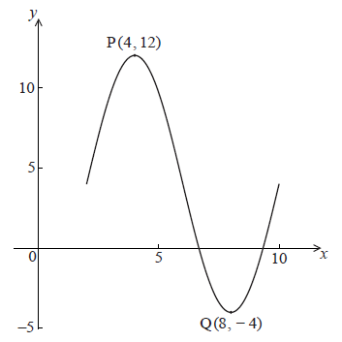

There is a maximum point at P(4, 12) and a minimum point at Q(8, −4) .

Use the graph to write down the value of

(i)     *a* ;

(ii)    *c* ;

(iii)   *d* .

**17b.** *[2 marks]*

Show that  .

**17c.** *[3 marks]*

Find  .

**17d.** *[6 marks]*

At a point R, the gradient is  . Find the *x*-coordinate of R.

**18a.** *[4 marks]*

Let , for .

Find .

**18b.** *[2 marks]*

Consider another function . Let R be a point on the graph of . The -coordinate of R is 1. The equation of the tangent to the graph at R is .

Write down .

**18c.** *[2 marks]*

Find .

**18d.** *[7 marks]*

Let . Find the equation of the tangent to the graph of  at the point where .

**19a.** *[1 mark]*

Let . The following diagram shows part of the graph of .

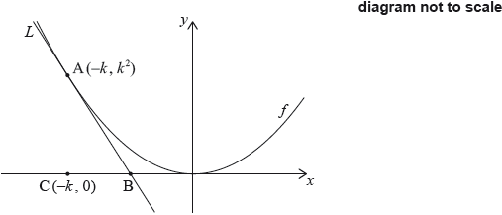

The line  is the tangent to the graph of  at the point , and intersects the -axis at point B. The point C is .

Write down .

**19b.** *[2 marks]*

Find the gradient of .

**19c.** *[5 marks]*

Show that the -coordinate of B is .

**19d.** *[2 marks]*

Find the area of triangle ABC, giving your answer in terms of .

**19e.** *[7 marks]*

The region  is enclosed by , the graph of , and the -axis. This is shown in the following diagram.

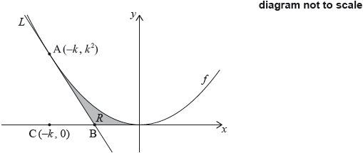

Given that the area of triangle ABC is  times the area of , find the value of .

**20a.** *[6 marks]*

The following diagram shows the graph of , for , where .

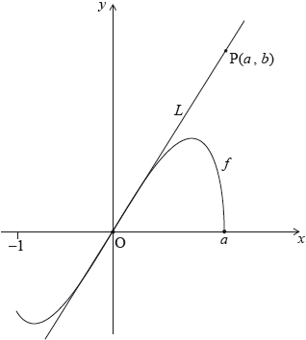

The line  is the tangent to the graph of  at the origin, O. The point  lies on .

(i)     Given that 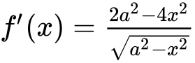, for , find the equation of .

(ii)     Hence or otherwise, find an expression for  in terms of .

**20b.** *[6 marks]*

The point  lies on the graph of . Let  be the region enclosed by the graph of  and the -axis. This information is shown in the following diagram.

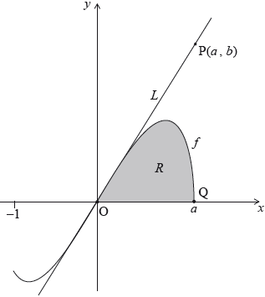

Let  be the area of the region .

Show that 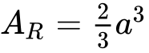.

**20c.** *[4 marks]*

Let  be the area of the triangle OPQ. Given that , find the value of .

**21a.** *[2 marks]*

Let , for  x  . The following diagram shows the graph of , the derivative of .

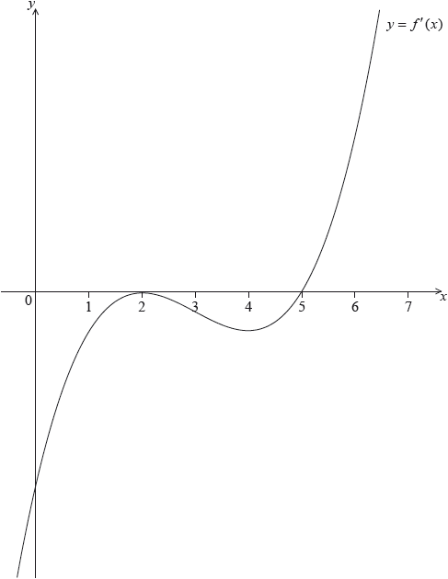

The graph of  has a local maximum when , a local minimum when , and it crosses the *-*axis at the point .

Explain why the graph of  has a local minimum when .

**21b.** *[2 marks]*

Find the set of values of  for which the graph of  is concave down.

**21c.** *[5 marks]*

The following diagram shows the shaded regions ,  and .

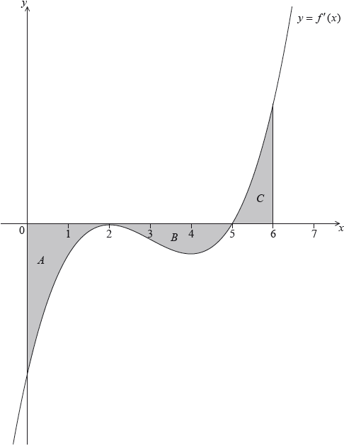

The regions are enclosed by the graph of , the -axis, the -axis, and the line .

The area of region  is 12, the area of region  is 6.75 and the area of region  is 6.75.

Given that , find .

**21d.** *[6 marks]*

The following diagram shows the shaded regions ,  and .



The regions are enclosed by the graph of , the *x*-axis, the *y*-axis, and the line .

The area of region  is 12, the area of region  is 6.75 and the area of region  is 6.75.

Let . Given that , find the equation of the tangent to the graph of  at the point where .

**22a.** *[2 marks]*

Consider  .

Find the value of  .

**22b.** *[5 marks]*

Find the set of values of  for which  is increasing.

**22c.** *[5 marks]*

The second derivative is given by 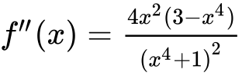 .

The equation  has only three solutions, when  ,   .

(i)     Find  .

(ii)     **Hence**, show that there is no point of inflexion on the graph of  at  .

**22d.** *[3 marks]*

There is a point of inflexion on the graph of  at   .

Sketch the graph of  , for  .

**23a.** *[3 marks]*

Consider the functions  ,  and  . The following table gives some values associated with these functions.

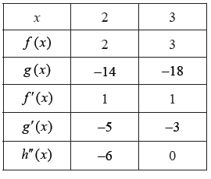

Write down the value of  , of  , and of  .

**23b.** *[2 marks]*

The following diagram shows parts of the graphs of  and  .

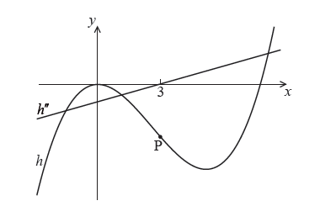

There is a point of inflexion on the graph of  at P, when  .

Explain why P is a point of inflexion.

**23c.** *[2 marks]*

Given that  ,

find the -coordinate of P.

**23d.** *[7 marks]*

find the equation of the normal to the graph of  at P.

**24a.** *[4 marks]*

Let  . The line *L* is the tangent to the curve of *f* at (4, 6) .

Find the equation of *L* .

**24b.** *[6 marks]*

Let 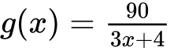 , for  . The following diagram shows the graph of *g* .

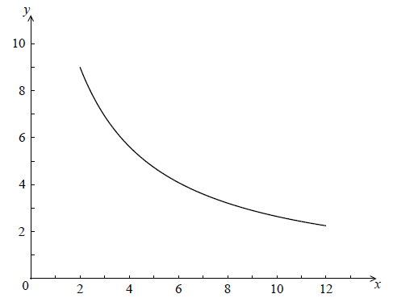

Find the area of the region enclosed by the curve of *g* , the *x*-axis, and the lines  and  . Give your answer in the form  , where  .

**24c.** *[3 marks]*

The graph of *g* is reflected in the *x*-axis to give the graph of *h* . The area of the region enclosed by the lines *L* ,  ,  and the *x*-axis is 120  .

Find the area enclosed by the lines *L* ,  ,  and the graph of *h* .

**25a.** *[7 marks]*

Let . The following diagram shows part of the graph of *f* .

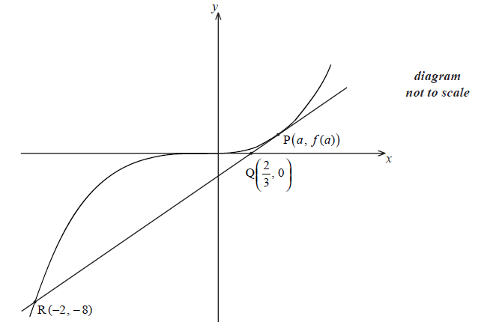

The point  , where  , lies on the graph of *f* . The tangent at P crosses the *x*-axis at the point 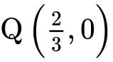 . This tangent intersects the graph of *f* at the point R(−2, −8) .

(i)     Show that the gradient of [PQ] is 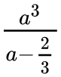 .

(ii)    Find  .

(iii)   Hence show that  .

**25b.** *[9 marks]*

The equation of the tangent at P is  . Let *T* be the region enclosed by the graph of *f* , the tangent [PR] and the line  , between  and  where  . This is shown in the diagram below.

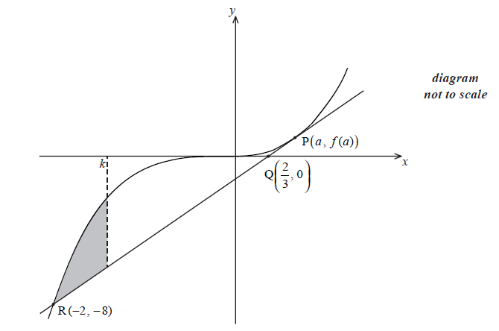

Given that the area of *T* is  , show that *k* satisfies the equation  .

**26a.** *[2 marks]*

Consider a function . The line *L*1 with equation  is a tangent to the graph of  when 

Write down .

**26b.** *[2 marks]*

Find .

**26c.** *[5 marks]*

Let  and P be the point on the graph of  where .

Show that the graph of *g* has a gradient of 6 at P.

**26d.** *[7 marks]*

Let *L*2 be the tangent to the graph of *g* at P. *L*1 intersects *L*2 at the point Q.

Find the y-coordinate of Q.

**27a.** *[4 marks]*

Let  . Line *L* is the normal to the graph of *f* at the point (4, 2) .

Show that the equation of *L* is  .

**27b.** *[2 marks]*

Point A is the *x*-intercept of *L* . Find the *x*-coordinate of A.

**27c.** *[3 marks]*

In the diagram below, the shaded region *R* is bounded by the *x*-axis, the graph of *f* and the line *L* .

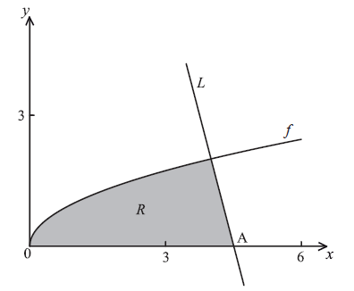

Find an expression for the area of *R* .

**27d.** *[8 marks]*

The region *R* is rotated  about the *x*-axis. Find the volume of the solid formed, giving your answer in terms of  .

Printed for Bronx Early College Academy

© International Baccalaureate Organization 2019

International Baccalaureate® - Baccalauréat International® - Bachillerato Internacional®