# 6-2-P1_Calculus-differentiation

**1.** *[6 marks]*

Let  . Find  .

**2a.** *[4 marks]*

Let 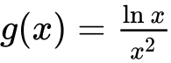 , for  .

Use the quotient rule to show that 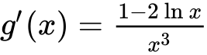 .

**2b.** *[3 marks]*

The graph of *g* has a maximum point at A. Find the *x*-coordinate of A.

**3a.** *[2 marks]*

Consider  ,  , where *p* is a constant.

Find  .

**3b.** *[4 marks]*

There is a minimum value of  when  . Find the value of  .

**4a.** *[2 marks]*

The values of the functions  and  and their derivatives for  and  are shown in the following table.

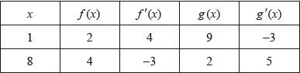

Let .

Find .

**4b.** *[3 marks]*

Find .

**5a.** *[2 marks]*

A function *f* has its first derivative given by  .

Find the second derivative.

**5b.** *[1 mark]*

Find  and  .

**5c.** *[2 marks]*

The point P on the graph of *f* has *x*-coordinate . Explain why P is not a point of inflexion.

**6a.** *[2 marks]*

Let .

Find .

**6b.** *[5 marks]*

Given that , show that .

**7a.** *[4 marks]*

Given that  , answer the following.

Find the first four derivatives of  .

**7b.** *[3 marks]*

Write an expression for  in terms of *x* and *n* .

**8a.** *[6 marks]*

A function *f*(*x*) has derivative *f ′*(*x*) = 3*x*2 + 18*x*. The graph of *f* has an *x*-intercept at *x* = −1.

Find *f*(*x*).

**8b.** *[4 marks]*

The graph of *f* has a point of inflexion at *x* = *p*. Find *p*.

**8c.** *[3 marks]*

Find the values of *x* for which the graph of *f* is concave-down.

**9a.** *[2 marks]*

Let  and 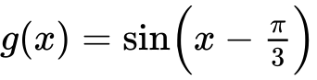 .

Write down

(i)      ;

(ii)     .

**9b.** *[4 marks]*

Let 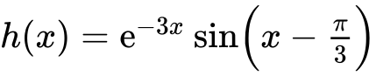 . Find the exact value of 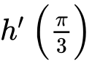 .

**10a.** *[8 marks]*

Let  . Part of the graph of *f* is shown below.

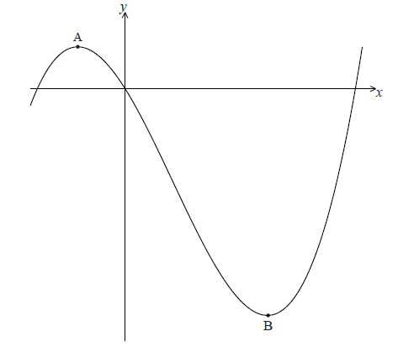

There is a maximum point at A and a minimum point at B(3, − 9) .

Find the coordinates of A.

**10b.** *[6 marks]*

Write down the coordinates of

(i)     the image of B after reflection in the *y*-axis;

(ii)    the image of B after translation by the vector 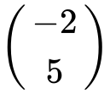 ;

(iii)   the image of B after reflection in the *x*-axis followed by a horizontal stretch with scale factor  .

**11a.** *[2 marks]*

A closed cylindrical can with radius r centimetres and height h centimetres has a volume of 20 cm3.

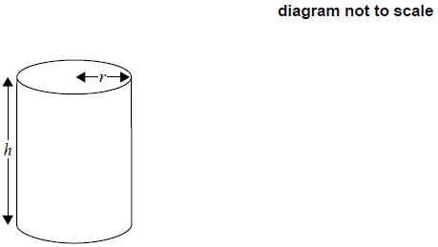

Express *h* in terms of *r.*

**11b.** *[4 marks]*

The material for the base and top of the can costs 10 cents per cm2 and the material for the curved side costs 8 cents per cm2. The total cost of the material, in cents, is *C*.

Show that .

**11c.** *[9 marks]*

Given that there is a minimum value for *C*, find this minimum value in terms of .

**12a.** *[3 marks]*

Let 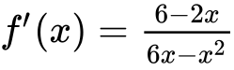, for .

The graph of  has a maximum point at P.

Find the -coordinate of P.

**12b.** *[8 marks]*

The -coordinate of P is .

Find , expressing your answer as a single logarithm.

**12c.**

The graph of  is transformed by a vertical stretch with scale factor . The image of P under this transformation has coordinates .

Find the value of  and of , where .

**13a.** *[5 marks]*

Let  , for  .

Use the quotient rule to show that 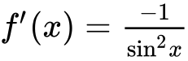 .

**13b.** *[3 marks]*

Find  .

**13c.** *[3 marks]*

In the following table,  and  . The table also gives approximate values of  and  near  .

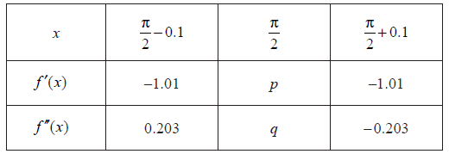

Find the value of *p* and of *q*.

**13d.** *[2 marks]*

Use information from the table to explain why there is a point of inflexion on the graph of *f* where  .

**14a.** *[7 marks]*

Let 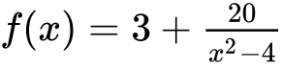 , for  . The graph of *f* is given below.

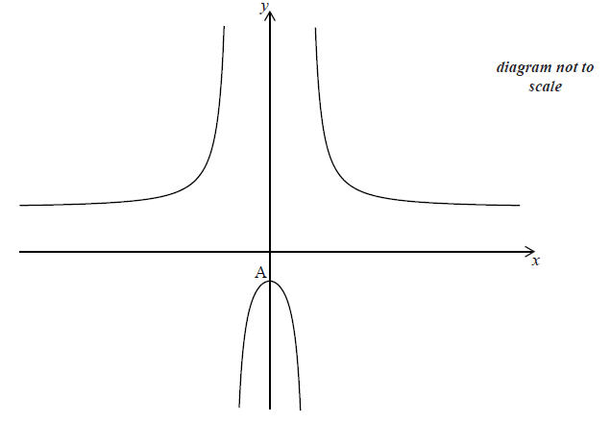

The *y*-intercept is at the point A.

(i)     Find the coordinates of A.

(ii)    Show that  at A.

**14b.** *[6 marks]*

The second derivative 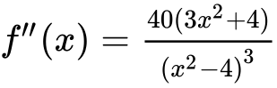 . Use this to

(i)     justify that the graph of *f* has a local maximum at A;

(ii)    explain why the graph of *f* does **not** have a point of inflexion.

**14c.** *[1 mark]*

Describe the behaviour of the graph of  for large  .

**14d.** *[2 marks]*

Write down the range of  .

**15a.** *[4 marks]*

Fred makes an open metal container in the shape of a cuboid, as shown in the following diagram.

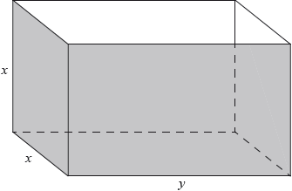

The container has height , width  and length . The volume is .

Let  be the outside surface area of the container.

Show that .

**15b.** *[2 marks]*

Find .

**15c.** *[5 marks]*

Given that the outside surface area is a minimum, find the height of the container.

**15d.** *[5 marks]*

Fred paints the outside of the container. A tin of paint covers a surface area of  and costs $20. Find the total cost of the tins needed to paint the container.

**16a.** *[2 marks]*

Consider  .

Find the value of  .

**16b.** *[5 marks]*

Find the set of values of  for which  is increasing.

**16c.** *[5 marks]*

The second derivative is given by 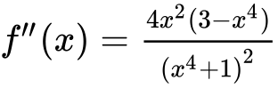 .

The equation  has only three solutions, when  ,   .

(i)     Find  .

(ii)     **Hence**, show that there is no point of inflexion on the graph of  at  .

**16d.** *[3 marks]*

There is a point of inflexion on the graph of  at   .

Sketch the graph of  , for  .

**17a.** *[3 marks]*

Consider the functions  ,  and  . The following table gives some values associated with these functions.

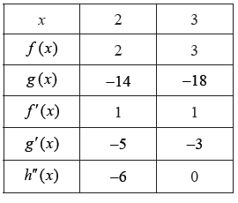

Write down the value of  , of  , and of  .

**17b.** *[2 marks]*

The following diagram shows parts of the graphs of  and  .

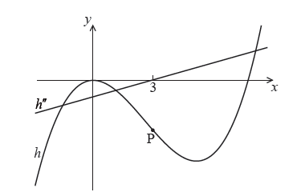

There is a point of inflexion on the graph of  at P, when  .

Explain why P is a point of inflexion.

**17c.** *[2 marks]*

Given that  ,

find the -coordinate of P.

**17d.** *[7 marks]*

find the equation of the normal to the graph of  at P.

**18a.** *[6 marks]*

Let 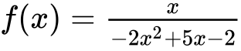 for  ,  ,  . The graph of  is given below.

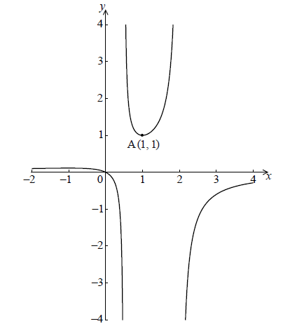

The graph of  has a local minimum at A(, ) and a local maximum at B.

Use the quotient rule to show that 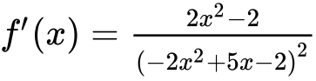 .

**18b.** *[7 marks]*

Hence find the coordinates of B.

**18c.** *[3 marks]*

Given that the line  does not meet the graph of *f* , find the possible values of *k* .

**19a.** *[2 marks]*

Consider a function . The line *L*1 with equation  is a tangent to the graph of  when 

Write down .

**19b.** *[2 marks]*

Find .

**19c.** *[5 marks]*

Let  and P be the point on the graph of  where .

Show that the graph of *g* has a gradient of 6 at P.

**19d.** *[7 marks]*

Let *L*2 be the tangent to the graph of *g* at P. *L*1 intersects *L*2 at the point Q.

Find the y-coordinate of Q.

**20a.** *[4 marks]*

Let .

(i)     Find the first four derivatives of .

(ii)     Find .

**20b.** *[5 marks]*

Let , where .

(i)     Find the first three derivatives of .

(ii)     Given that 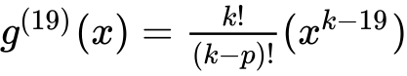, find .

**20c.** *[7 marks]*

Let  and .

(i)     Find .

(ii)     Hence, show that 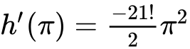.

**21a.** *[2 marks]*

Let  ,  . The following diagram shows the graph of  .

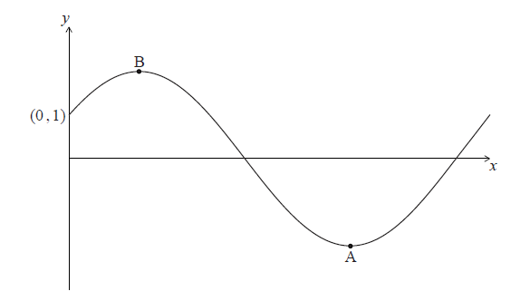

The -intercept is at (, ) , there is a minimum point at A (, ) and a maximum point at B.

Find  .

**21b.** *[10 marks]*

Hence

(i)     show that  ;

(ii)    verify that A is a minimum point.

**21c.** *[3 marks]*

Find the maximum value of  .

**21d.** *[2 marks]*

The function  can be written in the form  .

Write down the value of *r* and of *a* .