BECA / Huson / 12.1 IB Math SL Name:

13 December 2017

**Pretest**: Vector and calculus, plus review

**1a.** Line  passes through points  and  .

Find  . *[2 marks]*

**1b.** Find an equation for  in the form  . *[2 marks]*

**1c.** Line  has equation 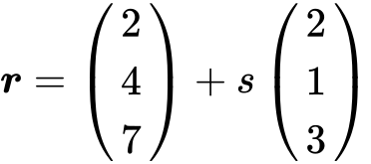 .

Find the angle between  and  . *[7 marks]*

**1d.** The lines  and  intersect at point C. Find the coordinates of C. *[6 marks]*

**2a.** The diagram shows quadrilateral ABCD with vertices A(1, 0), B(1, 5), C(5, 2) and D(4, −1) .

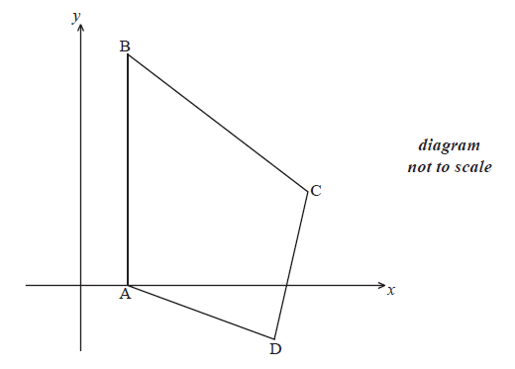(i) Show that 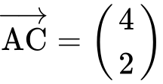 .

(ii) Find  .

(iii) Show that  is perpendicular to  . *[5 marks]*

**2b.** The line (AC) has equation  .

(i) Write down vector ***u*** and vector ***v*** .

(ii) Find a vector equation for the line (BD). *[4 marks]*

**2c.** The lines (AC) and (BD) intersect at the point  .

Show that  . *[3 marks]*

**2d.** The lines (AC) and (BD) intersect at the point  .

**Hence** find the area of triangle ACD. *[5 marks]*

**3.** Let 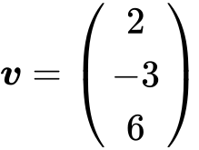 and 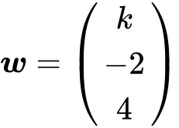 , for  . The angle between ***v*** and ***w*** is  .

Find the value of  . *[7 marks]*

**4a.**

The line  is represented by the vector equation 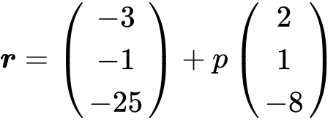 .

A second line  is parallel to  and passes through the point B(, , ) .

Write down a vector equation for  in the form  . *[2 marks]*

**4b.** A third line  is perpendicular to  and is represented by 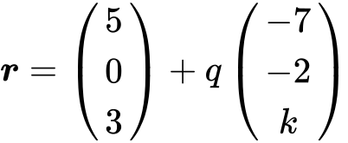 .

Show that  . *[5 marks]*

**4c.** The lines  and  intersect at the point A.

Find the coordinates of A. *[6 marks]*

**4d.** The lines and intersect at point C where 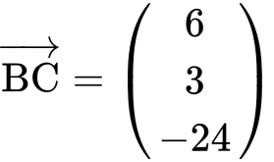 .

(i) Find  .

(ii) Hence, find 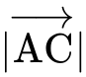 . *[5 marks]*

**5a.** Let 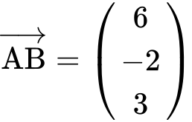 and 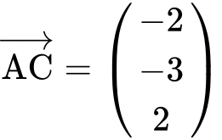 .

Find  . *[2 marks]*

**5b.** *[3 marks]*

Find a unit vector in the direction of  .

**5c.** *[3 marks]*

Show that  is perpendicular to  .

**6a.** *[4 marks]*

*In this question, distance is in metres.*

Toy airplanes fly in a straight line at a constant speed. Airplane 1 passes through a point A.

Its position, *p* seconds after it has passed through A, is given by 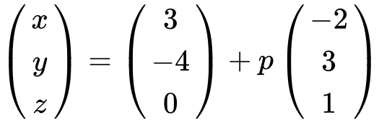 .

(i) Write down the coordinates of A.

(ii) Find the speed of the airplane in .

**6b.** *[5 marks]*

After seven seconds the airplane passes through a point B.

(i) Find the coordinates of B.

(ii) Find the distance the airplane has travelled during the seven seconds.

**6c.** Airplane 2 passes through a point C. Its position *q* seconds after it passes through C is given by 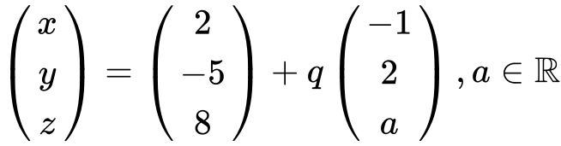 .

The angle between the flight paths of Airplane 1 and Airplane 2 is  . Find the two values of *a*.

*[7 marks]*

**7a.** Let 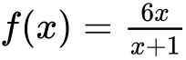 , for  .

Find  . *[5 marks]*

**7b.** Let 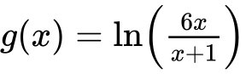 , for  .

Show that 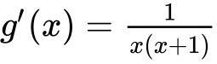 . *[4 marks]*

**7c.** Let 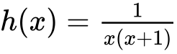 . The area enclosed by the graph of *h* , the *x*-axis and the lines 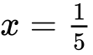 and  is  . Given that 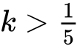 , find the value of *k* . *[7 marks]*

**8a.** Part of the graph of  is shown below.

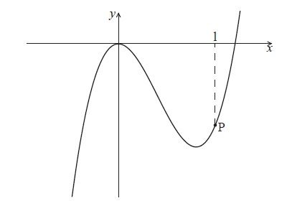

The point P lies on the graph of  . At P, *x* = 1.

Find  . *[2 marks]*

**8b.** The graph of  has a gradient of  at the point P. Find the value of  . *[4 marks]*

**9a.** In this question, you are given that 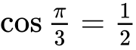 , and 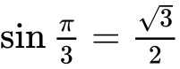 .

The displacement of an object from a fixed point, O is given by  for  .

Find  . *[3 marks]*

**9b.** In this interval, there are only two values of *t* for which the object is not moving. One value is  .

Find the other value. *[4 marks]*

**9c.** Show that  between these two values of *t* . *[3 marks]*

**9d.** Find the distance travelled between these two values of *t* . *[5 marks]*

**10a.** Let  .

Write down  . *[1 mark]*

**10b.** The tangent to the graph of *f* at the point  has gradient *m* .

(i) Show that  .

(ii) Find *b* . *[4 marks]*

**10c.** Hence, write down the equation of this tangent. *[1 mark]*

**11a.** Let 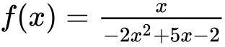 for  ,  ,  . The graph of  is given below.

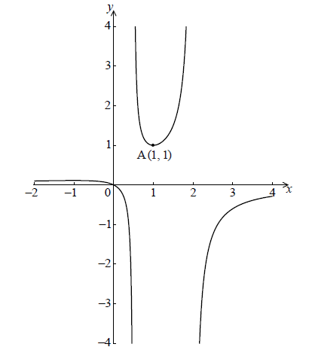

The graph of  has a local minimum at A(, ) and a local maximum at B.

Use the quotient rule to show that 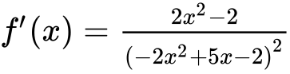 . *[6 marks]*

**11b.** Hence find the coordinates of B. *[7 marks]*

**11c.** Given that the line  does not meet the graph of *f* , find the possible values of *k* . *[3 marks]*

**12a.** The following diagram shows part of the graph of a quadratic function .

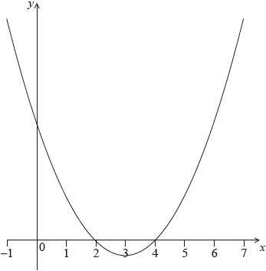

The vertex is at  and the -intercepts at 2 and 4.

The function  can be written in the form .

Write down the value of  and of . *[2 marks]*

**12b.** The function can also be written in the form .

Write down the value of  and of . *[2 marks]*

**12c.** Find the -intercept. *[2 marks]*

**13.** Three consecutive terms of a geometric sequence are , 6 and .

Find the possible values of . *[6 marks]*

**14a.** Let  and , for .

Solve . *[3 marks]*

**14b.** Find the area of the region enclosed by the graphs of  and . *[3 marks]*

**15a.** A population of rare birds, , can be modelled by the equation , where  is the initial population, and  is measured in decades. After one decade, it is estimated that 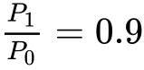.

(i) Find the value of .

(ii) Interpret the meaning of the value of . *[3 marks]*

**15b.**Find the least number of **whole** years for which 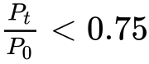. *[5 marks]*

**16a.** The price of a used car depends partly on the distance it has travelled. The following table shows the distance and the price for seven cars on 1 January 2010.

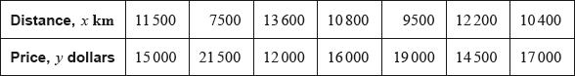

The relationship between  and  can be modelled by the regression equation .

(i) Find the correlation coefficient.

(ii) Write down the value of  and of . *[4 marks]*

**16b.** On 1 January 2010, Lina buys a car which has travelled .

Use the regression equation to estimate the price of Lina’s car, giving your answer to the nearest 100 dollars. *[3 marks]*

**16c.** The price of a car decreases by 5% each year.

Calculate the price of Lina’s car after 6 years. *[4 marks]*

**16d.** Lina will sell her car when its price reaches dollars.

Find the year when Lina sells her car. *[4 marks]*

**17a.** Let 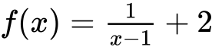, for .

Write down the equation of the horizontal asymptote of the graph of . *[2 marks]*

**17b.** Find . *[2 marks]*

**17c.** Let , for . The graphs of  and  have the same horizontal asymptote.

Write down the value of . *[2 marks]*

**17d.** Given that , find the value of . *[4 marks]*

**17e.** There is a value of , for , for which the graphs of  and  have the same gradient. Find this gradient. *[4 marks]*

**18a.** Let , for .

Find . *[3 marks]*

**18b.** Let  be a function so that . Find . *[3 marks]*

**19a.** The following diagram shows part of the graph of a quadratic function .

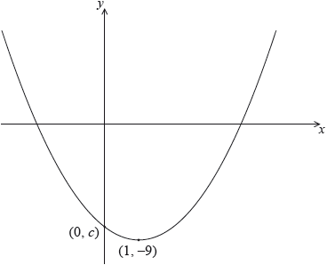The vertex is at , and the graph crosses the *y*-axis at the point .

The function can be written in the form .

Write down the value of  and of . *[2 marks]*

**19b.** Let . The graph of  is obtained by a reflection of the graph of  in the -axis, followed by a translation of 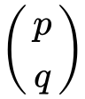.  
Find the value of  and of . *[5 marks]*

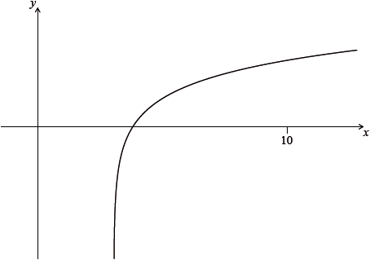 **20a.** Let , for . The diagram shows part of the graph of . Find the equation of the vertical asymptote to the graph of . *[2 marks]*

**20b.** Find the -intercept of the graph of . *[2 marks]*

**21a.** The first three terms of a geometric sequence are , and .

Find the value of . *[2 marks]*

**21b.** Find the value of . *[2 marks]*

**21c.** Find the least value of  such that . *[3 marks]*