**Quiz: Function graphs**

*Answer the first four problems in the space provided.*

**1.** The following diagram shows part of the graph of .

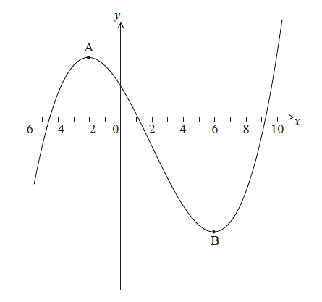

The graph has a local maximum at , where , and a local minimum at , where .

On the graph above, sketch the graph of . *[4 marks]*

**2a.** The diagram below shows part of the graph of the gradient function,  .

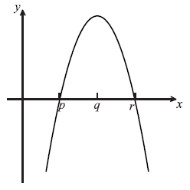

On the grid below, sketch a graph of  , clearly indicating the *x*-intercept. *[2 marks]*

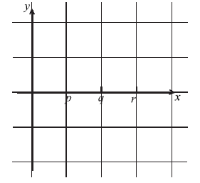

**2b.** Complete the table, for the graph of  .  *[2 marks]*

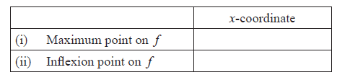

**2c.** Justify your answer to part (b) (ii). *[2 marks]*

**3a.** The following diagram shows the graph of a function . There is a local minimum point at , where .

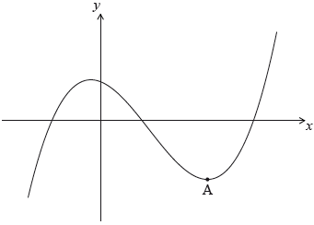

The derivative of  is given by .

Find the -coordinate of . *[5 marks]*

**3b.** The -intercept of the graph is at (). Find an expression for . *[6 marks]*

**4a.** The following diagram shows the graph of , the derivative of *f*.

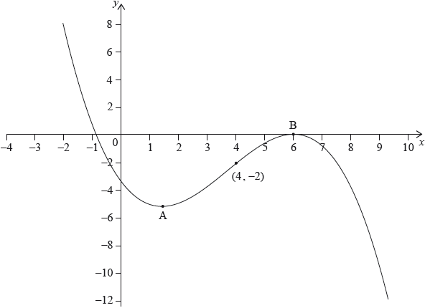

The graph of  has a local minimum at A, a local maximum at B and passes through .

The point  lies on the graph of the function, *f*.

Write down the gradient of the curve of *f* at P. *[1 mark]*

**4b.** Find the equation of the normal to the curve of *f* at P. *[3 marks]*

**4c.** Determine the concavity of the graph of *f* when  **and** justify your answer. *[2 marks]*

***For the remaining problems, answer on lined paper.***

**5a.** Let , for  x  . The following diagram shows the graph of , the derivative of .

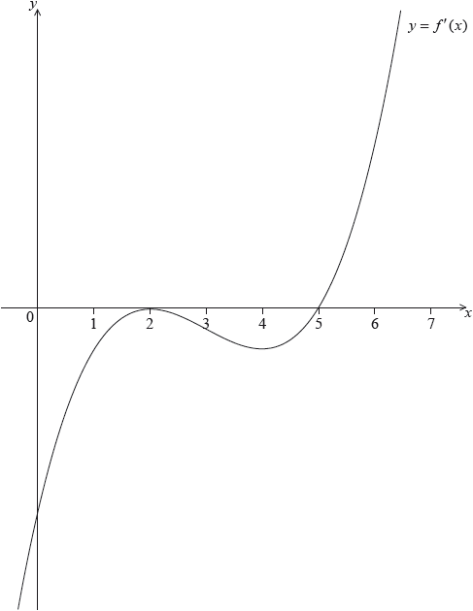

The graph of  has a local maximum when , a local minimum when , and it crosses the *-*axis at the point .

Explain why the graph of  has a local minimum when . *[2 marks]*

**5b.** Find the set of values of  for which the graph of  is concave down. *[2 marks]*

**6a.** Let 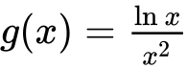 , for  .

Use the quotient rule to show that 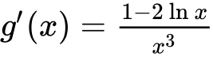 . *[4 marks]*

**6b.** The graph of *g* has a maximum point at A. Find the *x*-coordinate of A. *[3 marks]*

**7a.** Let 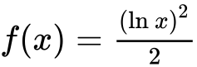, for .

Show that . *[2 marks]*

**7b.** There is a minimum on the graph of . Find the -coordinate of this minimum. *[3 marks]*

**7c.** Let . The following diagram shows parts of the graphs of  and *g*. *[2 marks]*

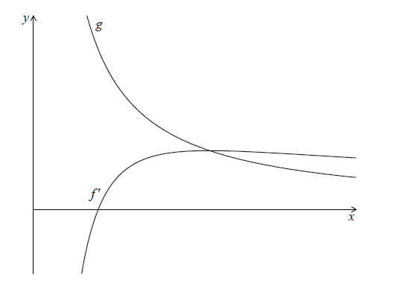

The graph of  has an *x*-intercept at .

Write down the value of .

**7d.** The graph of  intersects the graph of  when .

Find the value of . *[3 marks]*

**7e.** Let  be the region enclosed by the graph of , the graph of  and the line .

Show that the area of  is . *[5 marks]*