BECA / Huson / 12.1 IB Math SL Name:

15 December 2017

**Homework**: **Probability-distributions**

**1a.** The following table shows the probability distribution of a discrete random variable .

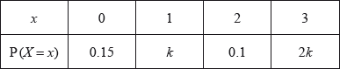

Find the value of . *[3 marks]*

**1b.** Find . *[2 marks]*

**2a.** Adam travels to school by car () or by bicycle (). On any particular day, he is equally likely to travel by car or by bicycle.

The probability of being late () for school is  if he travels by car.

The probability of being late for school is  if he travels by bicycle.

This information is represented by the following tree diagram.

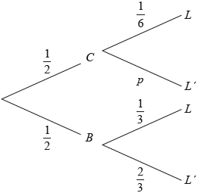

Find the value of . *[2 marks]*

**2b.** Find the probability that Adam will travel by car and be late for school. *[2 marks]*

**2c.** Find the probability that Adam will be late for school. *[4 marks]*

**2d.** Given that Adam is late for school, find the probability that he travelled by car. *[3 marks]*

**2e.** Adam will go to school three times next week. *[4 marks]*

Find the probability that Adam will be late exactly once.

**3a.** The following table shows the probability distribution of a discrete random variable *X* .



Find the value of *k* . *[3 marks]*

**3b.** Find  . *[3 marks]*

**4a.** The following table shows the probability distribution of a discrete random variable , in terms of an angle .



Show that . *[6 marks]*

**4b.** Given that , find . *[3 marks]*

**5a.** In a large university, the probability that a student is left handed is 0.08. A sample of 150 students is randomly selected from the university. Let  be the expected number of left-handed students in this sample. Find . *[2 marks]*

**5b.** Hence, find the probability that exactly  students are left handed; *[2 marks]*

**5c.** Hence, find the probability that fewer than  students are left handed. *[2 marks]*

**6.** The following table shows a probability distribution for the random variable , where .

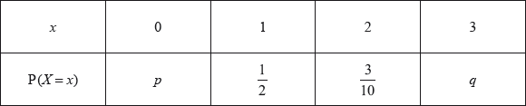

A bag contains white and blue marbles, with at least three of each colour. Three marbles are drawn from the bag, without replacement. The number of blue marbles drawn is given by the random variable .

A game is played in which three marbles are drawn from the bag of ten marbles, without replacement. A player wins a prize if three white marbles are drawn.

Jill plays the game nine times. Find the probability that she wins exactly two prizes. *[2 marks]*

**7a.** The random variable *X* has the following probability distribution, with  .

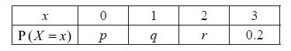

Find the value of *r* . *[2 marks]*

**7b.** Given that  , find the value of *p* and of *q* . *[6 marks]*

**8a.** The probability of obtaining “tails” when a biased coin is tossed is . The coin is tossed ten times. Find the probability of obtaining **at least** four tails. *[4 marks]*

**8b.** The probability of obtaining “tails” when a biased coin is tossed is 0.57. The coin is tossed ten times. Find the probability of obtaining the fourth tail on the tenth toss. *[3 marks]*

**9a.** The histogram below shows the time *T* seconds taken by 93 children to solve a puzzle.

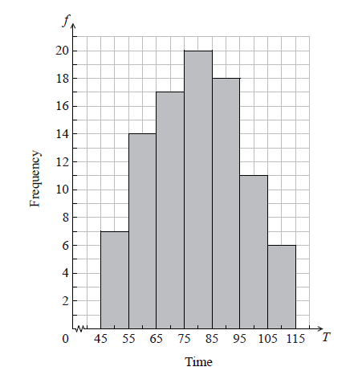

The following is the frequency distribution for *T* .  


(i) Write down the value of *p* and of *q*.

(ii) Write down the median class. *[3 marks]*

**9b.** A child is selected at random. Find the probability that the child takes less than 95 seconds to solve the puzzle. *[2 marks]*

**9c.** Consider the class interval  .

(i) Write down the interval width.

(ii) Write down the mid-interval value. *[2 marks]*

**9d.** Hence find an estimate for the

(i) mean;

(ii) standard deviation. *[4 marks]*

**9e.** John assumes that *T* is normally distributed and uses this to estimate the probability that a child takes less than 95 seconds to solve the puzzle.

Find John’s estimate. *[2 marks]*

**10a.** A factory makes lamps. The probability that a lamp is defective is 0.05. A random sample of 30 lamps is tested.

Find the probability that there is at least one defective lamp in the sample. *[4 marks]*

**10b.** A factory makes lamps. The probability that a lamp is defective is 0.05. A random sample of 30 lamps is tested.

Given that there is at least one defective lamp in the sample, find the probability that there are at most two defective lamps. *[4 marks]*

**11.** The random variable X has the following probability distribution.

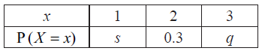

Given that  , find *q*. *[6 marks]*