Homework: Trig functions

**1a.** The following diagram shows triangle ABC, with , , and 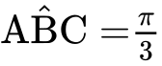.

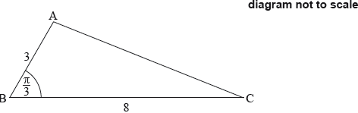

Show that . *[4 marks]*

**1b.** The shape in the following diagram is formed by adding a semicircle with diameter [AC] to the triangle.

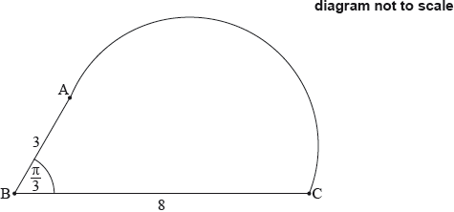

Find the exact perimeter of this shape. *[3 marks]*

**2.** The following diagram shows triangle PQR.

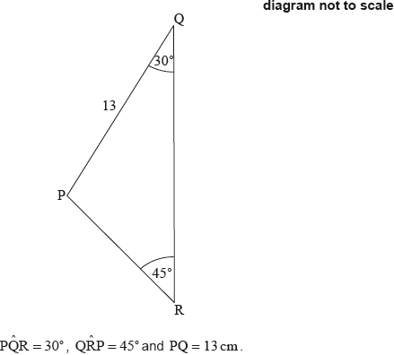

Find PR. *[6 marks]*

**3.** *[7 marks]*

The following diagram shows the chord [AB] in a circle of radius 8 cm, where .

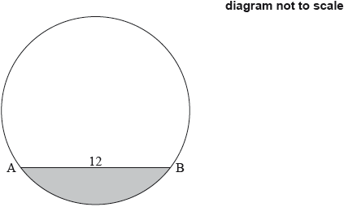

Find the area of the shaded segment.

**4a.** *[2 marks]*

The following diagram shows a circle with centre O and radius 40 cm.

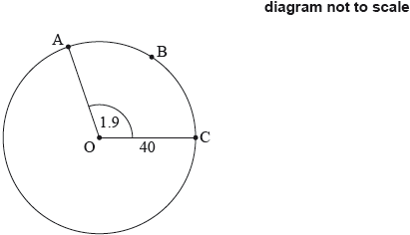

The points A, B and C are on the circumference of the circle and .

Find the length of arc ABC.

**4b.** Find the perimeter of sector OABC. *[2 marks]*

**4c.** Find the area of sector OABC. *[2 marks]*

**5a.** The depth of water in a port is modelled by the function , for , where  is the number of hours after high tide.

At high tide, the depth is 9.7 metres.

At low tide, which is 7 hours later, the depth is 5.3 metres.

Find the value of . *[2 marks]*

**5b.** Find the value of . *[2 marks]*

**5c.** Use the model to find the depth of the water 10 hours after high tide. *[2 marks]*

**6a.** *[3 marks]*

Let 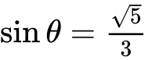, where  is acute.

Find .

**6b.** *[2 marks]*

Find .

**7a.** Let , for .

(i) Write down the amplitude of .

(ii) Find the period of . *[3 marks]*

**7b.** *[4 marks]*

On the following grid sketch the graph of .

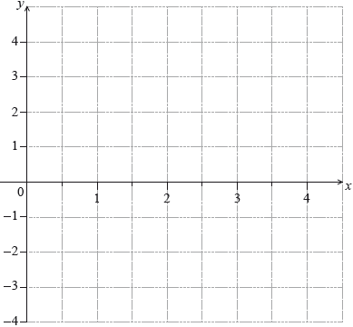

**8a.** *[5 marks]*

Let , for , and , for .

Let .

Write  in the form , where .

**8b.** *[2 marks]*

Hence find the range of .

**9a.** The height,  metros, of a seat on a Ferris wheel after  minutes is given by



Find the height of the seat when . *[2 marks]*

**9b.** The seat first reaches a height of 20 m after  minutes. Find . *[3 marks]*

**9c.** Calculate the time needed for the seat to complete a full rotation, giving your answer correct to one decimal place. *[3 marks]*

**10a.** Let .

Write down the amplitude of . *[1 mark]*

**10b.** Find the period of . *[2 marks]*

**10c.** On the following grid, sketch the graph of , for .

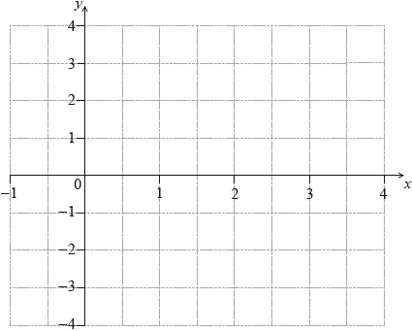 *[4 marks]*

**11a.** The following diagram shows part of the graph of .

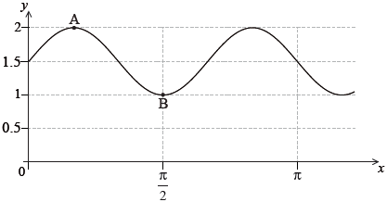

The point 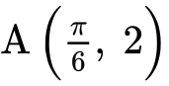 is a maximum point and the point 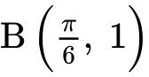 is a minimum point.

Find the value of *p; [2 marks]*

**11b.** *r; [2 marks]*

**11c.** *q. [2 marks]*

**12a.** *[3 marks]*

Let 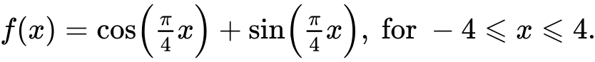

Sketch the graph of .

**12b.** *[5 marks]* Find the values of  where the function is decreasing.

**12c.** *[3 marks]*

The function  can also be written in the form 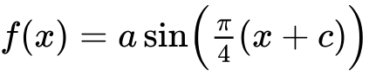, where , and . Find the value of ;

**12d.** *[4 marks]*

The function  can also be written in the form , where , and . Find the value of .

**13a.** *[6 marks]*

The following diagram shows the graph of , for .

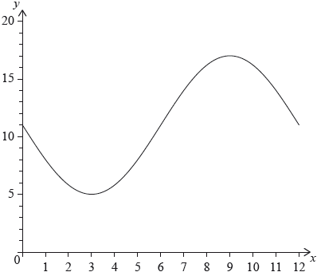

The graph of  has a minimum point at  and a maximum point at .

(i) Find the value of .

(ii) Show that .

(iii) Find the value of .

**13b.** *[3 marks]*

The graph of  is obtained from the graph of  by a translation of 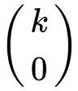. The maximum point on the graph of  has coordinates .

(i) Write down the value of .

(ii) Find .

**13c.** *[6 marks]*

The graph of  changes from concave-up to concave-down when .

(i) Find .

(ii) Hence or otherwise, find the maximum positive rate of change of .