**Classwork: Binomial Expansion problems**

**1a.** Consider the expansion of  .

Write down the number of terms in the expansion. *[1 mark]*

**1b.** Find the term in  . *[5 marks]*

**2a.** Expand  and simplify your result. *[3 marks]*

**2b.** Hence, find the term in  in 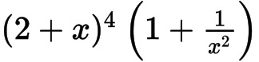 . *[3 marks]*

**3.** The third term in the expansion of  is  . Find the possible values of *p* . *[7 marks]*

**4.** In the expansion of , the coefficient of the term in  is , where . Find . *[7]*

**5a.** Two fair 4-sided dice, one red and one green, are thrown. For each die, the faces are labelled 1, 2, 3, 4. The score for each die is the number which lands face down.

List the pairs of scores that give a sum of 6. *[3 marks]*

**5b.** The probability distribution for the sum of the scores on the two dice is shown below.

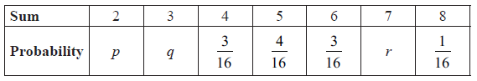

Find the value of *p* , of *q* , and of *r* . *[3 marks]*

**5c.** Fred plays a game. He throws two fair 4-sided dice four times. He wins a prize if the sum is 5 on three or more throws.

Find the probability that Fred wins a prize. *[6 marks]*

**6a.** Samantha goes to school five days a week. When it rains, the probability that she goes to school by bus is 0.5. When it does not rain, the probability that she goes to school by bus is 0.3. The probability that it rains on any given day is 0.2.

On a randomly selected school day, find the probability that Samantha goes to school by bus. *[4 marks]*

**6b.** Given that Samantha went to school by bus on Monday, find the probability that it was raining. *[3]*

**6c.** In a randomly chosen school week, find the probability that Samantha goes to school by bus on exactly three days. *[2 marks]*

**6d.** After  school days, the probability that Samantha goes to school by bus at least once is greater than . Find the smallest value of . *[5 marks]*