# **Homework: Normal distributions**

**1a.** The random variable  is normally distributed with a mean of 100. The following diagram shows the normal curve for .

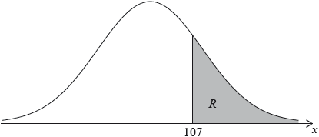

Let  be the shaded region under the curve, to the right of 107. The area of  is 0.24.

Write down . *[1 mark]*

**1b.** Find . *[3 marks]*

**1c.** Find . *[2 marks]*

**2a.** A random variable  is distributed normally with a mean of 20 and standard deviation of 4.

On the following diagram, shade the region representing . *[2 marks]*

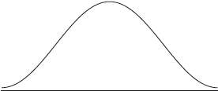

**2b.** Write down , correct to two decimal places. *[2 marks]*

**2c.** Let . Write down the value of . *[2 marks]*

**3a.** The time taken for a student to complete a task is normally distributed with a mean of  minutes and a standard deviation of  minutes.

A student is selected at random. Find the probability that the student completes the task in less than  minutes. *[2 marks]*

**3b.** The probability that a student takes between  and  minutes is . Find the value of . *[5 marks]*

**4a.** The weights, , of newborn babies in Australia are normally distributed with a mean 3.41 kg and standard deviation 0.57 kg. A newborn baby has a low birth weight if it weighs less than  kg.

Given that 5.3% of newborn babies have a low birth weight, find . *[3 marks]*

**4b.** A newborn baby has a low birth weight.

Find the probability that the baby weighs at least 2.15 kg. *[3 marks]*

**5a.** The masses of watermelons grown on a farm are normally distributed with a mean of  kg.

The watermelons are classified as small, medium or large.

A watermelon is small if its mass is less than  kg. Five percent of the watermelons are classified as small.

Find the standard deviation of the masses of the watermelons. *[4 marks]*

**5b.** The following table shows the percentages of small, medium and large watermelons grown on the farm.

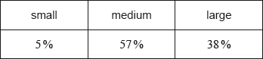

A watermelon is large if its mass is greater than  kg.

Find the value of . *[2 marks]*

**5c.** All the medium and large watermelons are delivered to a grocer. *[3 marks]*

The grocer selects a watermelon at random from **this** delivery. Find the probability that it is medium.

**6a.** The maximum temperature , in degrees Celsius, in a park on six randomly selected days is shown in the following table. The table also shows the number of visitors, , to the park on each of those six days.



The relationship between the variables can be modelled by the regression equation .

Find the value of  and of . *[3 marks]*

**6b.** Write down the value of . *[1 mark]*

**6c.** Use the regression equation to estimate the number of visitors on a day when the maximum temperature is 15 °C. *[3 marks]*

**7a.** The price of a used car depends partly on the distance it has travelled. The following table shows the distance and the price for seven cars on 1 January 2010.

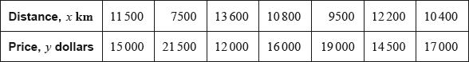

The relationship between  and  can be modelled by the regression equation .

(i) Find the correlation coefficient.

(ii) Write down the value of  and of . *[4 marks]*

**7b.** On 1 January 2010, Lina buys a car which has travelled .

Use the regression equation to estimate the price of Lina’s car, giving your answer to the nearest 100 dollars. *[3 marks]*

**7c.** The price of a car decreases by 5% each year.

Calculate the price of Lina’s car after 6 years. *[4 marks]*

**7d.** Lina will sell her car when its price reaches dollars.

Find the year when Lina sells her car. *[4 marks]*