**Pretest: Descriptive statistics**

**1a.** The time taken for a student to complete a task is normally distributed with a mean of 20 minutes and a standard deviation of 1.25 minutes.

A student is selected at random. Find the probability that the student completes the task in less than 21.8 minutes. *[2 marks]*

**1b.** The probability that a student takes between ***k*** and 21.8 minutes is 0.3. Find the value of ***k***. *[5 marks]*

**2.** A random variable  is normally distributed with  and  .

Find the interquartile range of  . *[7 marks]*

**3a.** A competition consists of two independent events, shooting at 100 targets and running for one hour.

The number of targets a contestant hits is the  score. The  scores are normally distributed with mean 65 and standard deviation 10.

A contestant is chosen at random. Find the probability that their  score is less than 50. *[2 marks]*

**3b.** The distance in km that a contestant runs in one hour is the  score. The  scores are normally distributed with mean 12 and standard deviation 2.5. The  score is independent of the  score.

Contestants are disqualified if their  score is less than 50 **and** their  score is less than  km.

Given that 1% of the contestants are disqualified, find the value of . *[4 marks]*

**4a.** A random variable  is normally distributed with mean, . In the following diagram, the shaded region between 9 and  represents 30% of the distribution.

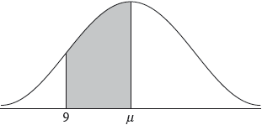

Find . *[2 marks]*

**4b.** The standard deviation of  is 2.1.

Find the value of . *[3 marks]*

**4c.** The random variable  is normally distributed with mean  and standard deviation 3.5. The events  and  are independent, and .

Find . *[5 marks]*

**4d.** Given that , find . *[5 marks]*

**5a.** A company makes containers of yogurt. The volume of yogurt in the containers is normally distributed with a mean of  ml and standard deviation of  ml.

A container which contains less than  ml of yogurt is **underfilled**.

A container is chosen at random. Find the probability that it is underfilled. *[2 marks]*

**5b.** The company decides that the probability of a container being underfilled should be reduced to 0.02. It decreases the standard deviation to  and leaves the mean unchanged.

Find . *[4 marks]*

**5c.** The company changes to the new standard deviation, , and leaves the mean unchanged.

A container is chosen at random for inspection. It passes inspection if its volume of yogurt is between  and  ml.

(i) Find the probability that it passes inspection. *[6 marks]*

(ii) Given that the container is **not** underfilled, find the probability that it passes inspection.

**5d.** A sample of  containers is chosen at random. Find the probability that  or more of the containers pass inspection. *[4 marks]*

**6a.** Adam is a beekeeper who collected data about monthly honey production in his bee hives. The data for six of his hives is shown in the following table.

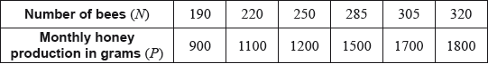

The relationship between the variables is modelled by the regression line with equation .

Write down the value of  and of . *[3 marks]*

**6b.** Use this regression line to estimate the monthly honey production from a hive that has 270 bees. *[2 marks]*

**6c.** Adam has 200 hives in total. He collects data on the monthly honey production of all the hives. This data is shown in the following cumulative frequency graph.

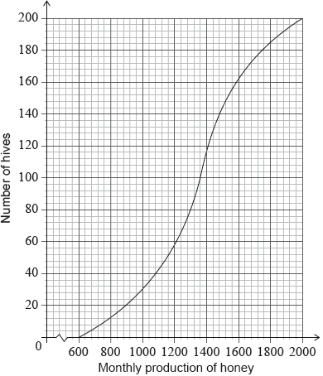

Adam’s hives are labelled as low, regular or high production, as defined in the following table.

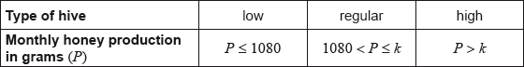

Write down the number of low production hives. *[1 mark]*

**6d.** Adam knows that 128 of his hives have a regular production.

Find the value of ; *[3 marks]*

**6e.** Find the number of hives that have a high production. *[2 marks]*

**6f.** Adam decides to increase the number of bees in each low production hive. Research suggests that there is a probability of 0.75 that a low production hive becomes a regular production hive. Calculate the probability that 30 low production hives become regular production hives. *[3 marks]*

**7a.** A jar contains 5 red discs, 10 blue discs and  green discs. A disc is selected at random and replaced. This process is performed four times.

Write down the probability that the first disc selected is red. *[1 mark]*

**7b.** Let  be the number of red discs selected. Find the smallest value of  for which .

*[5 marks]*

**8a.** Ann and Bob play a game where they each have an eight-sided die. Ann’s die has three green faces and five red faces; Bob’s die has four green faces and four red faces. They take turns rolling their own die and note what colour faces up. The first player to roll green wins. Ann rolls first. Part of a tree diagram of the game is shown below.

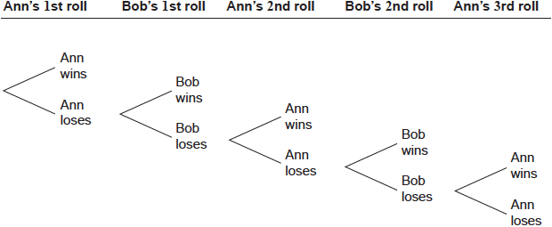

Find the probability that Ann wins on her first roll. *[2 marks]*

**8b.** Find the probability that Ann wins the game. *[7 marks]*