**Pretest Problem Set: Statistics free response**

**1a.** The weights of fish in a lake are normally distributed with a mean of  g and standard deviation . It is known that  of the fish have weights between  g and  g.

(i) Write down the probability that a fish weighs more than  g.

(ii) Find the probability that a fish weighs less than  g. *[4 marks]*

**1b.** *[4 marks]*

(i) Write down the standardized value for  g.

(ii) Hence or otherwise, find .

**1c.** *[2 marks]*

A fishing contest takes place in the lake. Small fish, called tiddlers, are thrown back into the lake. The maximum weight of a tiddler is  standard deviations below the mean.

Find the maximum weight of a tiddler.

**1d.** *[2 marks]*

A fish is caught at random. Find the probability that it is a tiddler.

**1e.** *[2 marks]*

 of the fish in the lake are salmon.  of the salmon are tiddlers. Given that a fish caught at random is a tiddler, find the probability that it is a salmon.

**2a.** The following cumulative frequency graph shows the monthly income,  dollars, of  families.

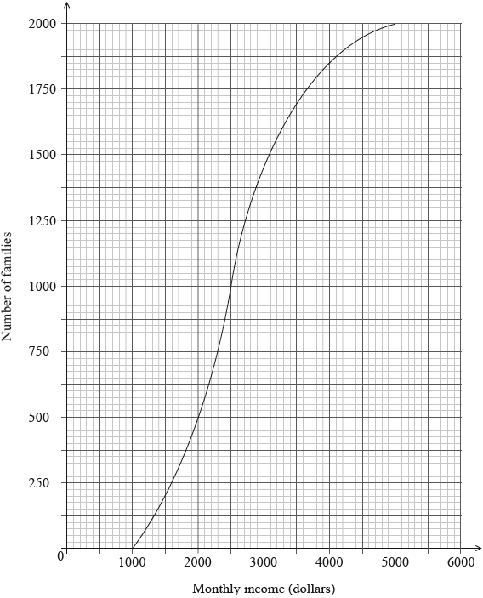

Find the median monthly income. *[2 marks]*

**2b.** (i) Write down the number of families who have a monthly income of  dollars or less.

(ii) Find the number of families who have a monthly income of more than  dollars. *[4 marks]*

**2c.** The  families live in two different types of housing. The following table gives information about the number of families living in each type of housing and their monthly income .

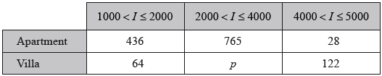

Find the value of . *[2 marks]*

**2d.** A family is chosen at random.

(i) Find the probability that this family lives in an apartment.

(ii) Find the probability that this family lives in an apartment, given that its monthly income is greater than  dollars. *[2 marks]*

**2e.** Estimate the mean monthly income for families living in a villa. *[2 marks]*

**3a.** *[2 marks]*

A company produces a large number of water containers. Each container has two parts, a bottle and a cap. The bottles and caps are tested to check that they are not defective.

A cap has a probability of 0.012 of being defective. A random sample of 10 caps is selected for inspection.

Find the probability that exactly one cap in the sample will be defective.

**3b.** The sample of caps passes inspection if at most one cap is defective. Find the probability that the sample passes inspection. *[2 marks]*

**3c.** The heights of the bottles are normally distributed with a mean of  and a standard deviation of .

(i) Copy and complete the following diagram, shading the region representing where the heights are less than .

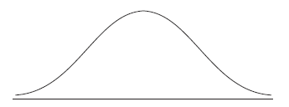

(ii) Find the probability that the height of a bottle is less than . *[5 marks]*

**3d.** (i) A bottle is accepted if its height lies between  and . Find the probability that a bottle selected at random is accepted.

(ii) A sample of 10 bottles passes inspection if all of the bottles in the sample are accepted. Find the probability that the sample passes inspection. *[5 marks]*

**3e.** *[2 marks]*

The bottles and caps are manufactured separately. A sample of 10 bottles and a sample of 10 caps are randomly selected for testing. Find the probability that both samples pass inspection.

**4a.** *[2 marks]*

The weights of players in a sports league are normally distributed with a mean of , (correct to three significant figures). It is known that  of the players have weights between  and . The probability that a player weighs less than  is 0.05.

Find the probability that a player weighs more than .

**4b.** *[4 marks]*

(i) Write down the standardized value, *z*, for .

(ii) Hence, find the standard deviation of weights.

**4c.** *[5 marks]*

To take part in a tournament, a player’s weight must be within 1.5 standard deviations of the mean.

(i) Find the set of all possible weights of players that take part in the tournament.

(ii) A player is selected at random. Find the probability that the player takes part in the tournament.

**4d.** *[4 marks]*

Of the players in the league,  are women. Of the women,  take part in the tournament.

Given that a player selected at random takes part in the tournament, find the probability that the selected player is a woman.

**5a.** The histogram below shows the time *T* seconds taken by 93 children to solve a puzzle.

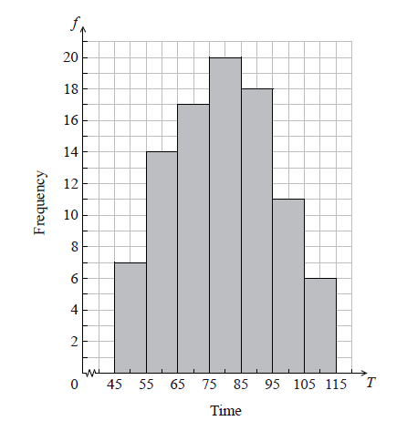

The following is the frequency distribution for *T* .



(i) Write down the value of *p* and of *q* .

(ii) Write down the median class. *[3 marks]*

**5b.** A child is selected at random. Find the probability that the child takes less than 95 seconds to solve the puzzle. *[2 marks]*

**5c.** Consider the class interval  .

(i) Write down the interval width.

(ii) Write down the mid-interval value. *[2 marks]*

**5d.** Hence find an estimate for the

(i) mean;

(ii) standard deviation. *[4 marks]*

**5e.** John assumes that *T* is normally distributed and uses this to estimate the probability that a child takes less than 95 seconds to solve the puzzle.

Find John’s estimate. *[2 marks]*