BECA / Huson / 12.1 IB Math SL Name:

18 December 2017

**Homework**: **Binomial distribution**

**1a.** A discrete random variable  has the following probability distribution.

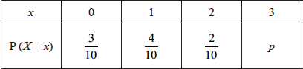

Find . *[3 marks]*

**1b.** Find . *[3 marks]*

**2a.** The following table shows the probability distribution of a discrete random variable *X* .



Find the value of *k* . *[3 marks]*

**2b.** Find  . *[3 marks]*

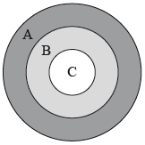 **3a.** The following diagram shows a board which is divided into three regions ,  and .

A game consists of a contestant throwing one dart at the board. The probability of hitting each region is given in the following table.

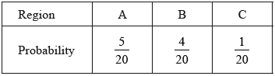

Find the probability that the dart does **not** hit the board. *[3 marks]*

**3b.** The contestant scores points as shown in the following table.

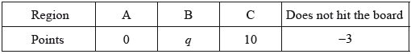

Given that the game is fair, find the value of . *[4 marks]*

**4a.** In a large university, the probability that a student is left handed is 0.08. A sample of 150 students is randomly selected from the university. Let  be the expected number of left-handed students in this sample.

Find . *[2 marks]*

**4b.** Hence, find the probability that exactly  students are left handed; *[2 marks]*

**4c.** Hence, find the probability that fewer than  students are left handed. *[2 marks]*

**5a.** A box holds 240 eggs. The probability that an egg is brown is 0.05.

Find the expected number of brown eggs in the box. *[2 marks]*

**5b.** Find the probability that there are 15 brown eggs in the box. *[2 marks]*

**5c.** Find the probability that there are at least 10 brown eggs in the box. *[3 marks]*

**6a.** The probability of obtaining “tails” when a biased coin is tossed is . The coin is tossed ten times. Find the probability of obtaining **at least** four tails. *[4 marks]*

**6b.** The probability of obtaining “tails” when a biased coin is tossed is 0.57. The coin is tossed ten times. Find the probability of obtaining the fourth tail on the tenth toss. *[3 marks]*

**7a.** A factory makes lamps. The probability that a lamp is defective is 0.05. A random sample of 30 lamps is tested.

Find the probability that there is at least one defective lamp in the sample. *[4 marks]*

**7b.** A factory makes lamps. The probability that a lamp is defective is 0.05. A random sample of 30 lamps is tested.

Given that there is at least one defective lamp in the sample, find the probability that there are at most two defective lamps. *[4 marks]*

**8.** Two lines with equations 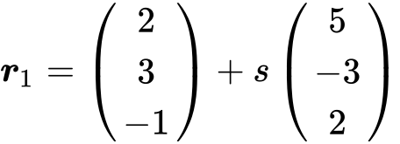 and 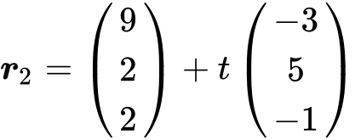 intersect at the point P. Find the coordinates of P. *[6 marks]*

**9a.** Consider the points A (1 , 5 , 4) , B (3 , 1 , 2) and D (3 , *k* , 2) , with (AD) perpendicular to (AB) .

Find

(i)  ;

(ii) 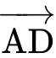 giving your answer in terms of *k* . ***[3 marks]***

**9b.** Show that  . *[3 marks]*

**9c.** The point O has coordinates (0 , 0 , 0) , point A has coordinates (1 , – 2 , 3) and point B has coordinates (– 3 , 4 , 2) .

The point C is such that 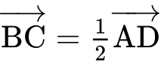 .

Find the position vector of C. *[4 marks]*

**9d.** Find  . *[3 marks]*

**10a.** Let  .

Show that  . *[3 marks]*

**10b.** Part of the graph of , for  , is shown below. The *x*-coordinates of the local minimum and maximum points are *r* and *s* respectively. *[1 mark]*  
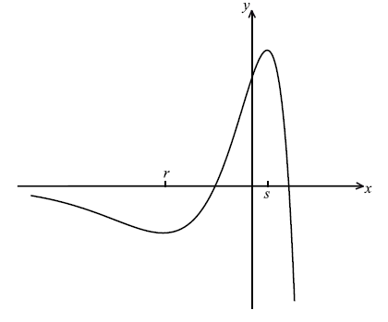

Write down the **equation** of the horizontal asymptote.

**10c.** Write down the value of *r* and of *s*. *[4 marks]*

**10d.** Let *L* be the normal to the curve of *f* at  . Show that *L* has equation  . *[4 marks]*