**Homework:** Integration as the area under a curve

**1a.** Consider a function  such that 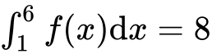. Find 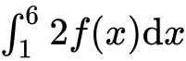. *[2 marks]*

**1b.** Find 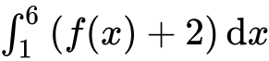. *[4 marks]*

**2a.** Find 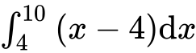 . *[4 marks]*

**2b.** Part of the graph of  , for  , is shown below. The shaded region *R* is enclosed by the graph of  , the line  , and the *x*-axis.

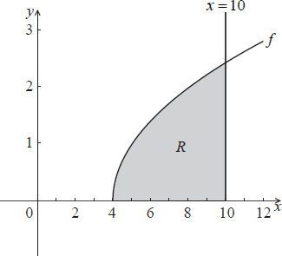

Find the area of the shaded region. *[3 marks]*

**3.** The following diagram shows the graph of 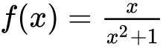, for , and the line .

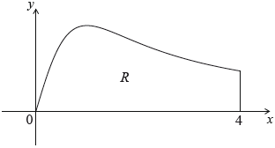

Let  be the region enclosed by the graph of  , the -axis and the line .

Find the area of . *[6 marks]*

**4a.** Let  and , for .

Solve . *[3 marks]*

**4b.** Find the area of the region enclosed by the graphs of  and . *[3 marks]*

**5.** Let , for     . The following diagram shows the graph of .

There are -intercepts at .

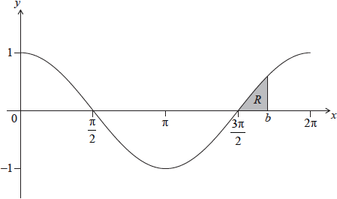

The shaded region  is enclosed by the graph of , the line , where , and the -axis. The area of  is 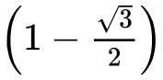. Find the value of . *[8 marks]*