**Homework: Probability & Statistics**

**1.** *[6 marks]*

Let  . Given that  , find  .

**2.** *[6 marks]*

The random variable X has the following probability distribution.

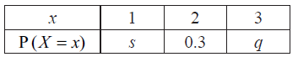

Given that  , find *q* .

**3a.** The following Venn diagram shows the events  and , where  and . The values  and  are probabilities.

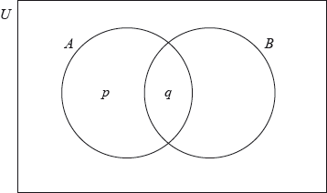

(i) Write down the value of .

(ii) Find the value of . *[3 marks]*

**3b.** Find . *[3 marks]*

**4a.** There are 10 items in a data set. The sum of the items is 60.

Find the mean. *[2 marks]*

**4b.** The variance of this data set is 3. Each value in the set is multiplied by 4.

(i) Write down the value of the new mean.

(ii) Find the value of the new variance. *[3 marks]*

**5a.** *[2 marks]*

A random variable  is distributed normally with a mean of 20 and standard deviation of 4.

On the following diagram, shade the region representing .

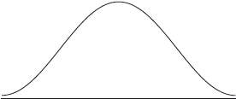

**5b.** Write down , correct to two decimal places. *[2 marks]*

**5c.** Let . Write down the value of . *[2 marks]*

**6a.** *[2 marks]*

The mass  of a decaying substance is measured at one minute intervals. The points  are plotted for , where  is in minutes. The line of best fit is drawn. This is shown in the following diagram.

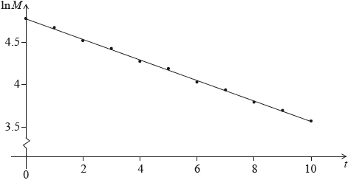

The correlation coefficient for this linear model is .

State **two** words that describe the linear correlation between  and .

**6b.** The equation of the line of best fit is . Given that , find the value of . *[4 marks]*

**7a.** A competition consists of two independent events, shooting at 100 targets and running for one hour.

The number of targets a contestant hits is the  score. The  scores are normally distributed with mean 65 and standard deviation 10.

A contestant is chosen at random. Find the probability that their  score is less than 50. *[2 marks]*

**7b.** The distance in km that a contestant runs in one hour is the  score. The  scores are normally distributed with mean 12 and standard deviation 2.5. The  score is independent of the  score.

Contestants are disqualified if their  score is less than 50 **and** their  score is less than  km.

Given that 1% of the contestants are disqualified, find the value of . *[4 marks]*

**8a.** The histogram below shows the time *T* seconds taken by 93 children to solve a puzzle.

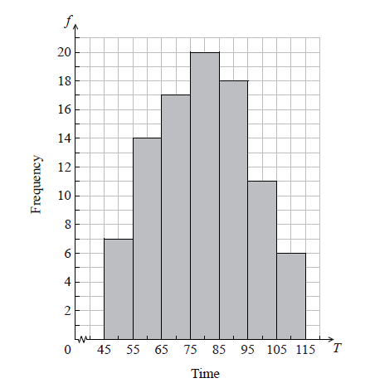

The following is the frequency distribution for *T* .



(i) Write down the value of *p* and of *q* .

(ii) Write down the median class. *[3 marks]*

**8b.** A child is selected at random. Find the probability that the child takes less than 95 seconds to solve the puzzle. *[2 marks]*

**8c.** Consider the class interval  .

(i) Write down the interval width.

(ii) Write down the mid-interval value. *[2 marks]*

**8d.** Hence find an estimate for the

(i) mean;

(ii) standard deviation. *[4 marks]*

**8e.** John assumes that *T* is normally distributed and uses this to estimate the probability that a child takes less than 95 seconds to solve the puzzle.

Find John’s estimate. *[2 marks]*

**9a.** The weights of players in a sports league are normally distributed with a mean of , (correct to three significant figures). It is known that  of the players have weights between  and . The probability that a player weighs less than  is 0.05.

Find the probability that a player weighs more than . *[2 marks]*

**9b.** (i) Write down the standardized value, *z*, for .

(ii) Hence, find the standard deviation of weights. *[4 marks]*

**9c.** *[5 marks]*

To take part in a tournament, a player’s weight must be within 1.5 standard deviations of the mean.

(i) Find the set of all possible weights of players that take part in the tournament.

(ii) A player is selected at random. Find the probability that the player takes part in the tournament.

**9d.** *[4 marks]*

Of the players in the league,  are women. Of the women,  take part in the tournament.

Given that a player selected at random takes part in the tournament, find the probability that the selected player is a woman.

**10a.** Two boxes contain numbered cards as shown below.

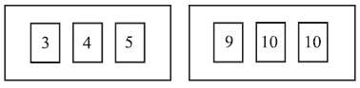

Two cards are drawn at random, one from each box.

Copy and complete the table below to show all nine equally likely outcomes. *[2 marks]*

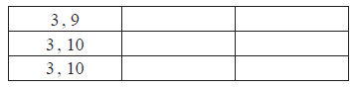

**10b.** Let *S* be the sum of the numbers on the two cards.

Find the probability of each value of *S*. *[2 marks]*

**10c.** Find the expected value of *S*. *[3 marks]*

**10d.** Anna plays a game where she wins  if *S* is even and loses  if *S* is odd.

Anna plays the game 36 times. Find the amount she expects to have at the end of the 36 games.

*[3 marks]*