Seatav1.3 AT模式研究demo

1. seata server 安装配置
   1. 安装环境

Jdk: 1.8

Os：macos

Nacos：1.2

Seata 版本: v1.3-RELEASE

Springboot：2.2.6-RELEASE

SpringCloud：Hoxton.SR3

* 1. Seata 安装

从seata官网下载v1.3稳定版

建议源码和二进制安装包都下载下来

(二进制安装包)

<http://seata.io/zh-cn/blog/download.html>

* 1. Seata 配置

解压seata-server 二进制包

进入conf 配置目录

配置 registry.conf

修改 type = "nacos"

nacos 请求地址

serverAddr = "192.168.1.231:8848"

修改config

type="nacos"

serverAddr = "192.168.1.231:8848"

registry {

# file 、nacos 、eureka、redis、zk、consul、etcd3、sofa

type = "nacos"

nacos {

application = "seata-server"

serverAddr = "192.168.1.231:8848"

group = "SEATA_GROUP"

namespace = ""

cluster = "default"

username = ""

password = ""

}

eureka {

serviceUrl = "http://localhost:8761/eureka"

application = "default"

weight = "1"

}

redis {

serverAddr = "localhost:6379"

db = 0

password = ""

cluster = "default"

timeout = 0

}

zk {

cluster = "default"

serverAddr = "127.0.0.1:2181"

sessionTimeout = 6000

connectTimeout = 2000

username = ""

password = ""

}

consul {

cluster = "default"

serverAddr = "127.0.0.1:8500"

}

etcd3 {

cluster = "default"

serverAddr = "http://localhost:2379"

}

sofa {

serverAddr = "127.0.0.1:9603"

application = "default"

region = "DEFAULT_ZONE"

datacenter = "DefaultDataCenter"

cluster = "default"

group = "SEATA_GROUP"

addressWaitTime = "3000"

}

file {

name = "file.conf"

}

}

config {

# file、nacos 、apollo、zk、consul、etcd3

type = "nacos"

nacos {

serverAddr = "192.168.1.231:8848"

namespace = ""

group = "SEATA_GROUP"

username = ""

password = ""

}

consul {

serverAddr = "127.0.0.1:8500"

}

apollo {

appId = "seata-server"

apolloMeta = "http://192.168.1.204:8801"

namespace = "application"

}

zk {

serverAddr = "127.0.0.1:2181"

sessionTimeout = 6000

connectTimeout = 2000

username = ""

password = ""

}

etcd3 {

serverAddr = "http://localhost:2379"

}

file {

name = "file.conf"

}

}

将seata-server 配置参数导入 nacos 进行管理

进入seata 1.3 源代码目录

seata/script/config-center

找到 config.txt文件

修改seata默认配置文件之前先备份

这里只是学习并非生产环境，精简了配置参数

主要修改数据库连接url 用户名和密码

config.txt 参数如下：

service.vgroupMapping.my_test_tx_group=default

store.mode=db

store.db.datasource=druid

store.db.dbType=mysql

store.db.driverClassName=com.mysql.cj.jdbc.Driver

store.db.url=jdbc:mysql://192.168.1.231:3307/seata?useUnicode=true

store.db.user=root

store.db.password=123456

store.db.minConn=5

store.db.maxConn=30

store.db.globalTable=global_table

store.db.branchTable=branch_table

store.db.queryLimit=100

store.db.lockTable=lock_table

store.db.maxWait=5000

使用电脑终端控制台进入seata 源码 config.txt 目录

执行命令：

nacos-config.sh -h 192.168.1.231 -p 8848 -g SEATA_GROUP

-h nacos 访问地址

-p nacos 访问端口

-g nacos 组

导入成功，可以登录nacos 进行查看和再次编辑

seata-server 数据库脚本安装：

进入seata 源码 文件夹

seata/script/server/db/mysql.sql

在mysql 服务器建立数据库 seata

执行建表语句（三张表）

global_table

branch_table

lock_table

到这里服务端配置全部完成

进入seata server 二进制包 bin目录

启动 seata server

sh seata-server.sh

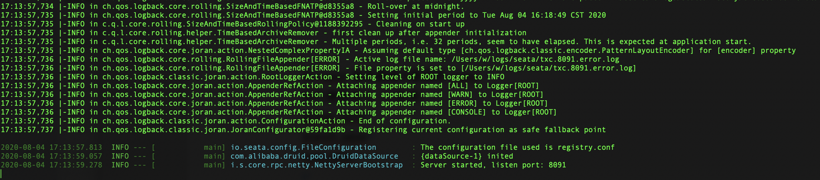

1. springcloud-nacos-seata 集成

详见 github seata at 模式工程代码

Doc 目录是数据库脚本和nacos 业务微服务yml配置文件

