ROLL NO : CH.SC.U4CSE24202

DATE : 30/11/2025

NAME : Avesh Ansari S

DAA
LAB_EXP_1
Q1. Write a program to find the sum of first n natural numbers using a user defined function.
Code:
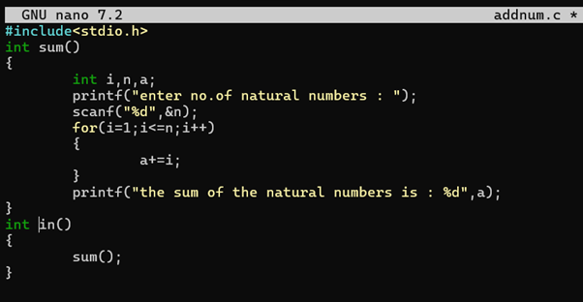

Output:
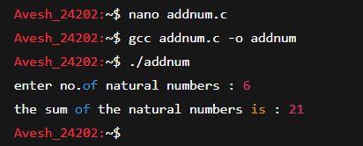

Interpretation: I created a user-defined function named sum() that receives the number n as its parameter. Inside the function, I used a for loop that runs from 1to n, and in each iteration, the loop adds the current value of i to the variable sum n. This helps to store the total sum step by step. The main() function handles user input. It first displays a sentence asking the user to enter a number. Then it reads the value of n using scanf() fn and passes that value to the sum() function. Finally, the function prints the total sum of the first n numbers.

Q2. Write a program to find the sum of squares of first n natural numbers using a user defined function.
CODE:
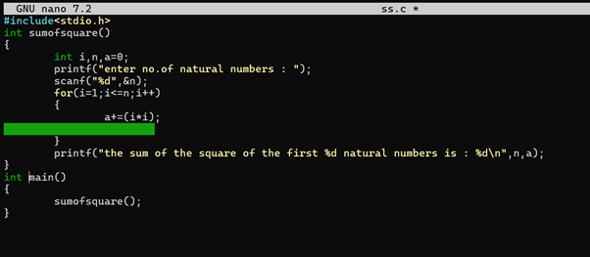

Output:
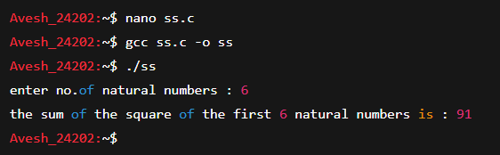

Interpretation: This C program calculates the sum of the squares of the first n natural numbers using a user-defined function called sumofsquare().
The program first asks the user to enter a number n. It then uses a for loop to go through all numbers from 1 to n. During each loop iteration, the program squares the current number i (i.e., i * i) and keeps adding it to the variable a, which stores the running total.
After the loop finishes, the accumulated value of a represents the total sum of squares from 1² + 2² + 3² + … + n². Finally, the program prints this result. The main() function simply calls sumofsquare() to execute the process.
Q3. Write a program to find the sum of cubes of first n natural numbers using a user defined function.
Code:
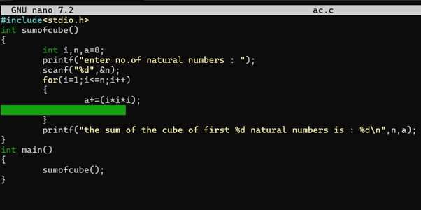

Output:
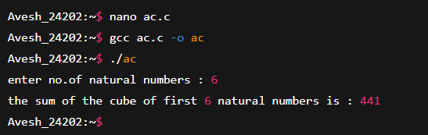

Interpretation: This C program finds the sum of the cubes of the first n natural numbers using a user-defined function called sumofcube(). The program first asks the user to enter a value for n. It then runs a loop from 1 to n, and during each iteration it calculates the cube of the current number (i*i*i) and adds it to the variable a, which stores the running total. After the loop ends, the program prints the final value of a, which represents the total sum of cubes from 1³ + 2³ + … + n³. The main() function simply calls this user-defined function.

Q4. Write a program to find factorial for n natural numbers using recursive function.
Code:
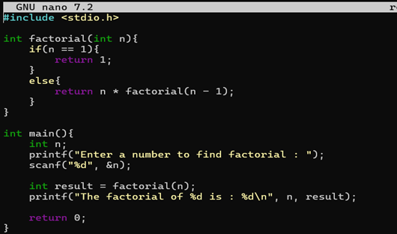

Output:

Interpretation:
This program finds the factorial of a number using a recursive function. The user is asked to enter a number n. The factorial() function then repeatedly calls itself, multiplying n by the factorial of the previous number until it reaches 1. This process builds up the final factorial value, which is returned to the main function and printed as the result.

Q5. Write a program to transpose a 3x3 matrix
Code:
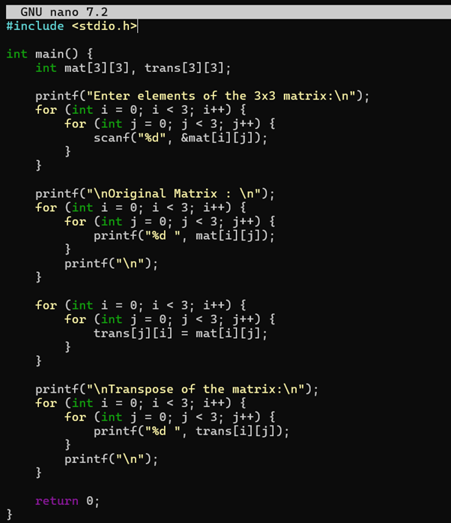

Output:
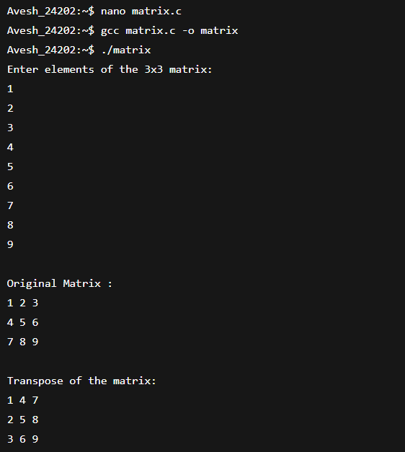
Interpretation:
This program reads a 3×3 matrix from the user, displays the original matrix, and then computes its transpose. To form the transpose, the rows and columns are swapped by storing each element at trans[j][i]. Finally, the program prints the transposed matrix.

