**GGCMaps:**

**User Documentation**

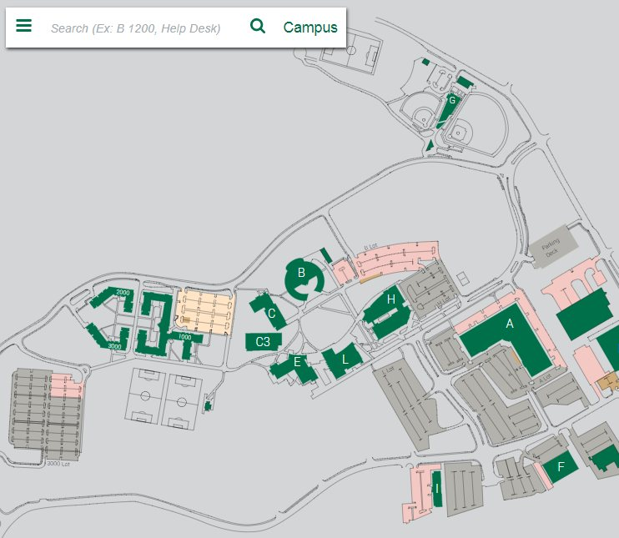

Overview

GGCMaps aims to better, as well as ease, the experience of students at GGC when trying to find various locations across campus. It allows users to search rooms and have them be highlighted on an interactive map for easier meetups, less time wasted finding that one classroom for the first time, and easier navigation across campus for guests.

This project was started by [Mike Deiters et al](https://github.com/ggcmaps/ggcmaps.github.io#fall-16---created-by), in Fall of 2016. It has since been picked up for continuation by [David Rivera et al](https://github.com/ggcmaps/ggcmaps.github.io#spring-17), to further develop its features, and fix bugs as our Software Development II project.

*Copied from GGCMaps Github, README.md, Description:* [*README.md*](https://github.com/soft-eng-practicum/ggcmaps)

Point of Contact

Mike Deiters

[about.me/mikedeiters](http://localhost:63342/GGCMaps%20Fall%202017/ggcmaps/about.me/mikedeiters)

mike@mikedeiters.com

David Rivera

[irl.solutions](http://localhost:63342/GGCMaps%20Fall%202017/ggcmaps/irl.solutions)

david@irl.solutions

Cengiz Gunay

cgunay@ggc.edu

Installation

For installation, please refer to GGCMaps Installation Documentation located on the GGCMaps Github.

Click here for more details: [Installation Documentation](https://github.com/soft-eng-practicum/ggcmaps/blob/master/InstallationDocumentation.md)

Getting Started

After completing the installation, please look over this Getting Started section if needed.

Opening/Closing Menu:

1. Locate three-bar icon to the left of the Search bar .
2. Click three-bar icon and the menu will open up.
3. To close, click the left-pointing arrow .

Getting Help:

1. Open Menu.
2. Scroll down to Getting Help.
3. Click Getting Help.
4. Help will be displayed to the right.

Searching:

Searching can be done two ways.

1. By Search Bar:
   1. Locate the search bar on the top left.
   2. If searching for a room, enter the building letter then room number
      1. Examples: A 1010, a1010, a 1010
   3. If searching for a GGC specific place, enter the name.
      1. Examples: moes, LVIS, lvis, Lvis, panda, den, The Den
   4. Searched location will be highlighted in yellow.
      1. If not, room was not located. Please enter a different name.
2. By Menu:
   1. Open menu and menu will display possible locations.
   2. Click desired location.
   3. Location will be displayed. If room, location will be highlighted in yellow.

Legends:

There are two possible legends to display. Only one legend can be shown at a time.

Building Legend:

1. Open Menu.
2. Scroll menu down to end.
3. Click toggle for Building Legend 
4. Building Legend will show to the right.

Parking Legend:

1. Open Menu.
2. Scroll menu down to end.
3. Click toggle for Parking Legend 
4. Building Legend will show to the right.

Safety Mode:

Safety Mode provides indicators for Fire Extinguishers, AED, Fire Alarms, and Severe Weather Shelters.

1. Open Menu.
2. Scroll menu down to end.
3. Click toggle for Safety Legend .
4. Safety Mode is activated for current building shown.

Campus Events:

Campus Events can be displayed for the entire campus or a certain building.

1. For entire campus:
   1. Open Menu.
   2. Click Campus at the top of the menu list.
   3. Open Menu again.
   4. Scroll down to Campus Events.
   5. Click Campus Events.
   6. Campus Events will be shown to the right.
   7. If possible, click event to navigate to room.
2. For certain building:
   1. Click building on campus map, click building on menu, or search for building.
   2. Open Menu.
   3. Scroll down to Campus Events.
   4. Click Campus Events.
   5. Campus Events will be shown to the right.

