Contracts Report - Portable View Testing
Summary of contracts for project ID 58971786
Prepared by: Kahua SuperAgent | January 22, 2026

Contracts Report - Portable View Testing

Project Overview
This report provides a summary of contracts from the project Portable View Testing.

Contracts Summary
Contract Number | Type | Total Value (USD) | Schedule Start | Schedule End
0001 | Basic Ordering Agreement (BOA) | 3,500.00 | 2026-01-21 | 2026-01-22
0002 | — | 0.00 | — | —

Chart: Contract Values Comparison
Below is a visual comparison of total contract values.
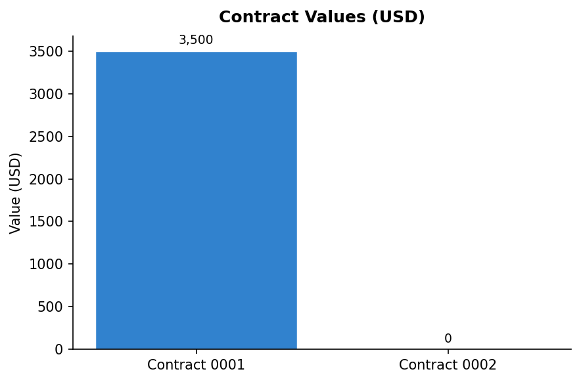
{{CHART_0}}
Prepared automatically by Kahua SuperAgent for reporting purposes.

Generated on January 22, 2026

