Roofing Contract Analysis Report
Project: Portable View Testing
Prepared by: Prepared by: Kahua Construction Analytics | January 22, 2026

Roofing Contract Analysis Report

Executive Summary
This report provides an in-depth analysis of the roofing contract under the Portable View Testing project. The contract titled Roof Repair (Contract #0003) is recorded as a Commercial unit price contract with an estimated total value of $5,650 USD. No amendments, change orders, or schedule data are tied to this record, indicating stable financial control and limited defined performance tracking.
**Insight:** The roofing contract appears modest in scope and financially contained, but lacks detail in deliverables and timeline milestones. Further updates to scope definitions and documentation will enhance overall project transparency and control.

Contract Overview
Attribute | Detail
Contract Number | 0003
Description | Roof repair
Type | Commercial Expense Contract
Cost Unit Entry Type | Unit Price
Currency | USD
Total Estimated Cost | $5,650.00
Created On | January 22, 2026
Last Modified | January 22, 2026
Overbilling Policy | Overbilling Allowed
Change Orders | None

Financial Analysis
The contract holds a single estimated total cost value of $5,650, showing no pending commitments or approved change orders. This implies controlled financial exposure and limited transactional activity to date.
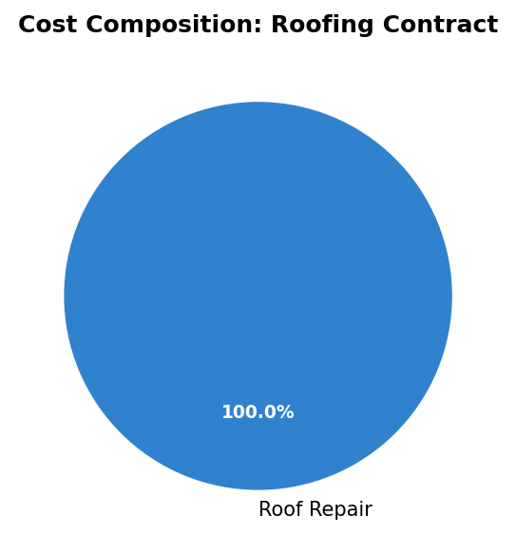

Financial Health Summary
- Current Exposure: $5,650 (stable)
- Changes/Amendments: None
- Pending Commitments: None
- Risk Level: Low, given static cost and limited scope.

Observations & Analysis
- Scope Definition: The “Roof repair” description lacks detailed scope items, area metrics, or material specifications.
- Contract Data Completeness: Missing contractor and responsible company details restrict thorough accountability.
- Schedule Control: No start or end dates provided — a potential gap in project tracking.
- Budget Integrity: Estimated value aligns with project-level contract tracking, but invoices or completion data have not been logged.

Recommendations
- Add Scope Documentation: Include materials list (e.g., membrane type, fasteners, insulation) and coverage area.
- Attach Supporting Submittals: Incorporate roofing detail drawings, specs, or inspection checklist in Kahua.
- Define Schedule and Milestones: Establish installation timelines and forecast completion within Kahua’s scheduling module.
- Link Performance Monitoring: Connect field observations or punch list items to validate roofing work quality upon execution.
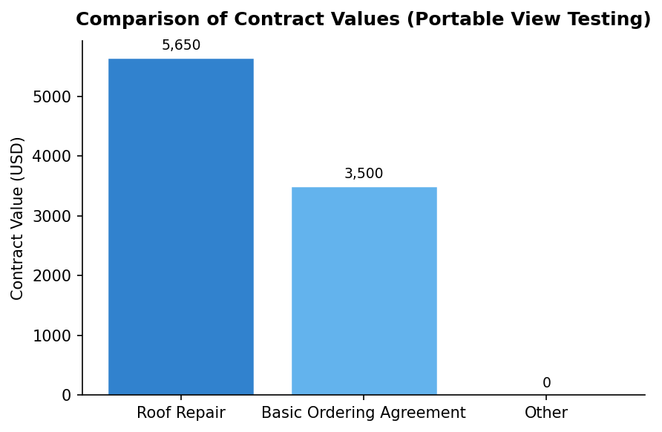
---
End of Report

Generated on January 22, 2026

