Roofing Contract Summary Report
Project: Portable View Testing
Prepared by: Prepared by: Kahua Construction Analytics | January 22, 2026

Roofing Contract Summary Report

Executive Overview
This report covers the roofing-related contract found under the Portable View Testing project. Based on the data, the contract (ID 58986785 – Roof repair) is categorized as a Commercial expense contract with a total estimated value of $5,650.00 USD. No change orders or amendments are currently linked to this contract, suggesting that the original scope and budget remain stable.
**Key Insight:** The roofing contract demonstrates a straightforward scope (roof repair) with controlled cost exposure and no recorded modifications. While financials appear stable, schedule and scope details were not provided, necessitating further documentation for project tracking.

Contract Details
Field | Value
Contract Number | 0003
Description | Roof repair
Contract Type | Commercial
Cost Unit Type | Unit Price
Currency | USD
Estimated Value | $5,650.00
Created Date | Jan 22, 2026
Last Modified | Jan 22, 2026
Overbilling Policy | Overbilling Allowed
Associated Project | Portable View Testing
Change Orders | None

Financial Summary
The roofing contract currently holds a total cost value of $5,650, and there are no outstanding commitments or approved changes. It represents approximately 1 contract under this project-specific portfolio.
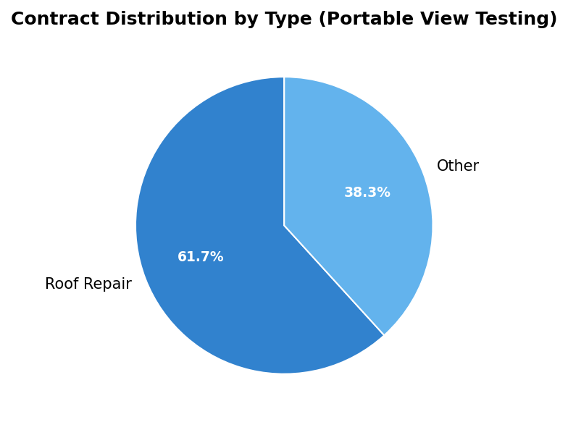

Observations
- Scope of Work: Not fully documented — recommended to include specifications or item-level descriptions for roofing material types and area coverage.
- Change Management: No recorded change orders, indicating either a completed and stable scope or initial data entry phase.
- Risk: Absence of milestone and schedule data may pose challenges for progress monitoring.
- Cost Control: Stable cost profile with single-entry value; recommend cross-verification with invoice or payment progress.

Recommendations
- Document Schedule Baselines: Add start/end dates for roof work to enable better forecasting of completion.
- Include Material Submittals: Link roofing material approvals or submittal packages within the Kahua environment.
- Establish QA/QC Tracking: Create punch list or field observation records once work begins to ensure workmanship aligns with specifications.
- Add Contractor Info: Update contractor and company details to ensure accountability and compliance tracking.
---
End of Report

Generated on January 22, 2026

