Cost Analysis Report – Scotiabank Arena Renovation Phase 3
Comprehensive Financial Overview
Prepared by: Prepared by Kahua Construction Analytics | January 23, 2026

📊 Cost Analysis Report

Project: Scotiabank Arena – Renovation Phase 3
Project ID: 9610179
Report Date: February 13, 2025
---

🧱 Project Overview
Field | Detail
**Project Type** | Major renovation / capital upgrade
**Phase** | Design
**Delivery Method** | Construction Management
**Project Health** | ✅ Green
**Budget Total** | **$67,000,000 USD**
**Schedule** | Start: *June 30, 2026* → End: *March 12, 2028*
**Status** | Pipeline (planning stage)
**Owner/Executive** | Defined in Kahua Directory
**Project Manager** | Defined in Kahua Directory
**Capital Plan Linked** | Yes (CapitalPlanID = 9603702 – Approved Capital Plan)

---

💵 Cost Structure Summary
Cost Category | Data Status | Notes
**Contracts** | None found | Preconstruction stage – no executed agreements yet.
**Change Orders** | None found | No budget modifications established.
**Invoices** | None found | Payment processing not yet initiated.
**Budget Tracking** | Base budget only | $67M total project allocation set.
**Capital Plan Linkage** | Active | Approved capital plan integration confirmed.

---

🧮 Financial Analysis
Budget Position: The project maintains a defined capital budget of $67 million USD, confirming established funding alignment within the approved plan.
Current Status: No contracts, change orders, or invoices recorded – consistent with a design-phase/preconstruction effort.
Forecast Insight: Anticipate cost activity to increase rapidly once GMP negotiation begins and trade packages are committed.
**Financial Visibility:** 1 of 5 major cost modules active (Budget only).
---

📈 Cost Readiness Snapshot
Metric | Value | Interpretation
Budget Defined | ✅ Yes ($67M) | Robust baseline established.
Contracts Entered | ❌ No | Awaiting procurement phase.
Change Orders Recorded | ❌ No | Variance control not yet started.
Invoices Logged | ❌ No | No billing cycle active.
Capital Plan Linked | ✅ Yes | Strategic funding integration complete.

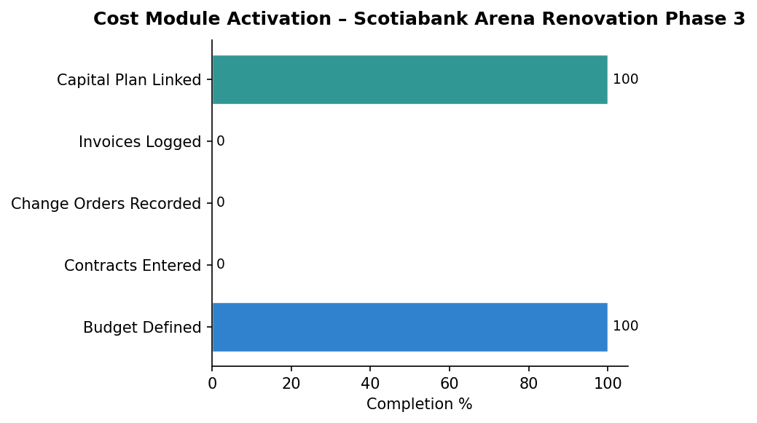
---

🔎 Recommendation Summary
- Contract Setup: Use Kahua contract templates to initiate cost tracking per trade.
- Cost Items Framework: Implement WBS and cost code indexing for granular visibility.
- Early Budget Controls: Conduct contingency and forecast analysis before GMP execution.
- Capital Plan Sync: Ensure funding progress tracking against milestones via CapitalPlanItems.
---

🧾 Executive Summary
**Project Health:** GREEN
**Phase:** Design → Procurement Pending
**Total Budget:** $67,000,000 USD
**Financial Setup Level:** Moderate (Base Budget Only)
**Action Priority:** Establish Contract and Cost Item Framework immediately.
---

📊 Chart
Cost Module Activation – Scotiabank Arena Renovation Phase 3

Generated on January 23, 2026

