Organization-Wide Contract Overview
Comprehensive Summary Across All Projects
Prepared by: Prepared by Kahua Construction Project Analyst | January 23, 2026

Executive Summary
This report provides an organization-wide overview of all contracts housed in the Kahua environment. The portfolio currently includes 613 contracts, spanning multiple projects and disciplines, along with related cost records such as invoices, change orders, and purchase orders. This broad review establishes a solid baseline for understanding overall commitment values and contract management activity.
---

Contract Data Summary
Entity | Record Count
Contracts | 613
Contract Items | 1,452
Change Orders | 401
Change Order Items | 532
Invoices | 571
Invoice Items | 3,806
Funding Budgets | 1,867
Budget Adjustments | 160
Purchase Orders | 84
Purchase Order Items | 113

---

Key Insights
- The large number of contract items suggests multi-line commitments, likely across trade packages and subcontractors.
- Over 400 change orders demonstrate active scope modifications and budget adjustments, which can be tracked for trend analysis.
- Nearly 600 invoices indicate regular billing cycles and financial throughput.
- High budget and funding record counts reflect robust cost tracking across the organization.
---

Chart Summary
The chart below illustrates proportional counts by cost entity type, highlighting the dominant categories of cost management data.
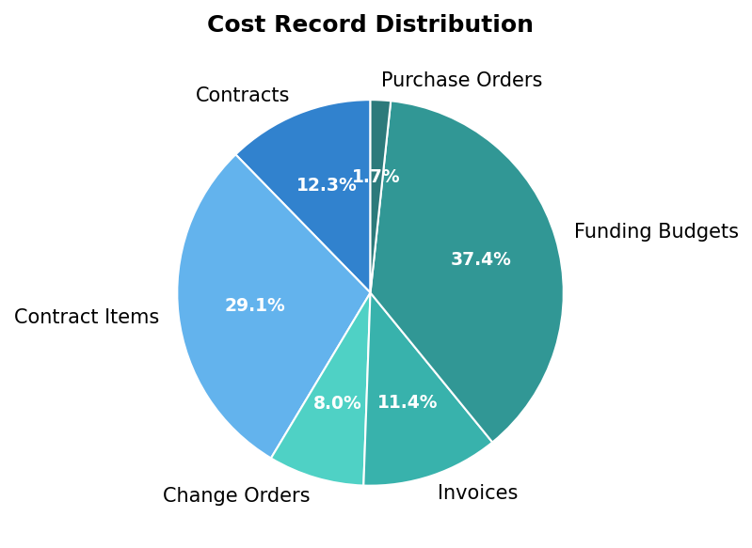
---

Recommendations
- Contract Performance Monitoring: Establish regular review cycles to analyze commitment growth vs. original budgets.
- Change Order Control: Consider tracking approval lead times and cumulative value impacts for proactive management.
- Invoice Reconciliation: Cross-reference contract totals against invoices for early detection of billing variances.
- Financial Integration: Utilize cost data trends to support forecasts and funding draw tracking across projects.

Generated on January 23, 2026

