Organization-wide RFI Status Report
Generated January 26, 2026
January 26, 2026

Executive Summary
Overview of RFI performance and key metrics.

Status Distribution
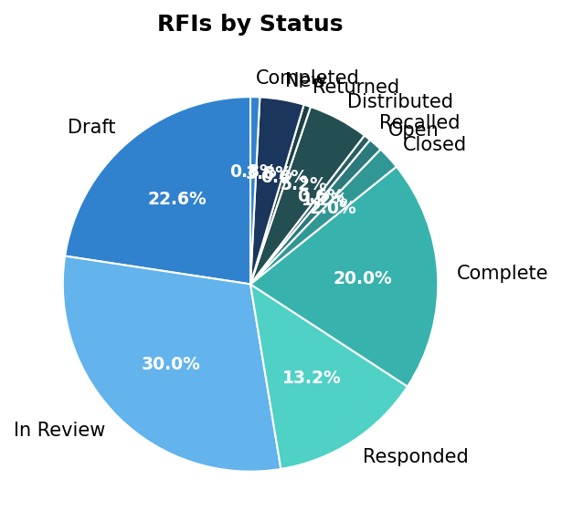

RFI Log
Number | Subject | Status | AssignedTo | DueDate | DaysOpen
01 | Test | Draft | [] | None
001 | Question | Draft | [] | None
01 | Question | In Review | [{'id': 10941516, 'referenceType': 1, 'h | 2026-01-23T00:00:00
01 | Test | Draft | [] | None
001 | Test RFI | Draft | [] | None
0000 | Test RFI | Draft | [] | None
0001 | Confirm structural shoring sequence | Draft | [] | None
0001 | Specify nurse station millwork details | Draft | [] | None
0001 | Routing for oxygen and vacuum risers | Draft | [] | None
0001 | Glazing laminate specification | Draft | [] | None
0001 | Clarify OR Ceiling Systems Integration | Draft | [] | None
0024 | Conductor Size/Material | Responded | [{'id': 10554925, 'referenceType': 1, 'h | 2025-12-22T00:00:00
002 | test | Complete | [] | 2025-12-18T00:00:00
098 | Leak Repair Question | Responded | [{'id': 10941516, 'referenceType': 1, 'h | 2026-01-23T00:00:00
0118 | Z Clips | Responded | [{'id': 5005854, 'referenceType': 1, 'hu | 2025-12-01T00:00:00
0023 | Electrical Conduit Routing Conflicts | Draft | [] | 2025-03-31T18:00:00
0022 | Material Substitution for Door Handle | Complete | [] | 2025-03-27T18:00:00
0021 | Clarification on Ceiling Height in Lobby | Complete | [] | 2025-03-04T17:00:00
0020 | Clarification on Construction Phasing Pl | Complete | [] | 2025-03-27T14:00:00
0019 | Lead-Based Paint Mitigation Procedure | In Review | [] | 2025-03-26T14:00:00
0018 | Load Bearing Capacity of Temporary Acces | Responded | [] | 2025-03-26T14:00:00
0017 | Material Substitution for Exterior Cladd | Responded | [] | 2025-03-26T14:00:00
0016 | Anti-Terrorism/Force Protection (AT/FP) | Complete | [] | 2025-03-25T14:00:00
0015 | Fire Protection System Water Supply Capa | In Review | [] | 2025-03-24T14:00:00
0014 | Electrical Conduit Routing Conflict | In Review | [] | 2025-03-24T14:00:00
0013 | Stormwater Drainage Design Clarification | Complete | [] | 2025-03-09T14:00:00
0012 | Discrepancy in Wall Thickness Specificat | In Review | [] | 2025-03-24T14:00:00
0011 | Changes to Phasing Plan Due to Weather C | Complete | [] | 2025-03-20T14:00:00
0010 | Concrete Mix Design Approval | Complete | [] | 2025-03-20T14:00:00
0009 | Security Requirements for Subcontractor | Complete | [] | 2025-03-19T14:00:00
0008 | Clarification on Seismic Design Criteria | Complete | [] | 2025-03-19T14:00:00
0007 | HVAC Equipment Substitution Request | Complete | [] | 2025-03-13T14:00:00
0006 | Environmental Compliance Requirements | Complete | [] | 2025-03-09T14:00:00
0005 | Site Utility Conflict | Complete | [] | 2025-03-09T14:00:00
0004 | Waterproofing System Compatibility | Complete | [] | 2025-03-13T14:00:00
0003 | Geotechnical Report Discrepancy | Complete | [] | 2025-03-12T14:00:00
0002 | Clarification on Structural Specificatio | Complete | [] | 2025-03-12T14:00:00
0001 | Clarification on Terminal Foundation Req | In Review | [] | 2025-03-12T14:00:00
0003 | Question on pipe length | Draft | [] | None
0022 | Access Panel Location | In Review | [] | 2025-10-03T00:00:00
0021 | Drawing Omission | In Review | [] | 2025-10-03T00:00:00
0020 | Temporary Utilities | Responded | [] | 2025-10-03T00:00:00
0019 | Fixture Mounting Detail | Closed | [] | 2025-10-03T00:00:00
0018 | Waterproofing Detail | Closed | [] | 2025-10-03T00:00:00
0017 | Code Interpretation | Closed | [] | 2025-10-03T00:00:00
0016 | Finish Schedule Clarification | Open | [] | 2025-10-03T00:00:00
0015 | Access Requirements | In Review | [] | 2025-10-03T00:00:00
0014 | Coordination Issue | In Review | [] | 2025-10-03T00:00:00
0013 | Elevation Mismatch | Closed | [] | 2025-10-03T00:00:00
0012 | Site Conditions | Closed | [] | 2025-10-03T00:00:00

Response Time Analysis
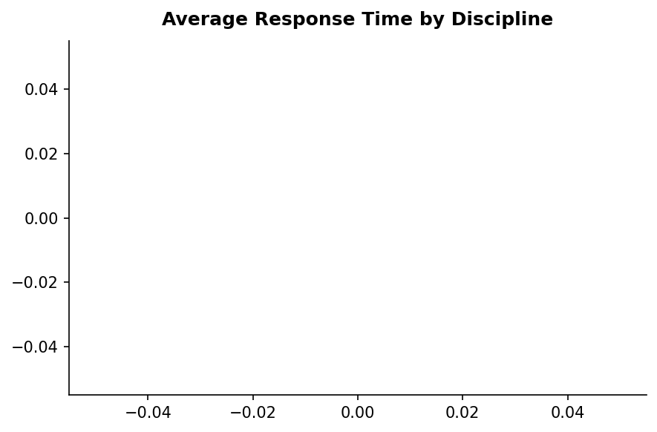

Generated on January 26, 2026

