Lucas Avezum

02/02/2018

# Introduction

The Basel II framework introduced the possibility of banks to use, upon approval by the supervisory agency, internal risk models (internal rating-based or IRB) to calculte the risk-weights used for capital adequacy ratio. The argument in favor of IRB versus the fixed risk weights standard approach (SA) is that the IRB approach would improve banks’ efficiency as “banks optimize risk weights and better account for the specific risk of each asset” (Beltratti and Paladino (2016)). Cucinelli et al. (2017) also point to the risk models having improved with the IRB approach as those models have to be approved by regulators.

However, Döme, Kerbl, and Behn (2017) show that the location where banks are headquarted is a significant explanatory variable of risk-weights across european banks. Within the Basel II framework, those differences driven by location are unintended as they do not reflect heterogeneity in risk, but rather, point to regulatory arbitrage. In this recent literature on capital adequacy risk-weights, while some papers study the determinants of differences in risk-weights across banks (Döme, Kerbl, and Behn (2017), Beltratti and Paladino (2016) and Montes et al. (2016)) others focus on the impact of the IRB versus the SA on lending. Behn, Haselmann, and Wachtel (2016) found that, in response to an exogenous shock to credit risk, banks decrease more lending under the IRB approach relative to the SA. Behn, Haselmann, and Vig (2016) show that banks underestimate risk for portfolios under the IRB while interest rate are higher, suggesting that banks are aware of the higher risks of those loans.

My proposal is to fill the gap between those two lines in the literature: study the impact on bank lending coming from *unintended* differences in risk-weights across IRB portfolios of European banks. Following prior evidence (Behn, Haselmann, and Vig (2016), Efing (2016)) I expect a risk-taking channel to be stronger for banks headquarted in more relaxed regulatory enviroment.

**Hypothesis 1** *Ceteris paribus, banks with lower risk-weights take greater amounts of syndicated loans.*

# Data and empirical strategy

Regulatory information at the bank-level is publicly available with the EU-wide transparency exercises. Those datasets contain information on assets and risk-weighted assets which can be use to derive risk weights. The information on exposures is divided by type (retail, corporate, government) and country (location of borrower). There are in total four exercises which contain variables for two periods each (December, 2012; June, 2013; December, 2014; June, 2015; December, 2015; June, 2016; December,2016 and June 2017). 132 European banks are included in the last exercise increasing from 64 in the first.

Further bank level information can be merged from the Orbis dataset.

The figure below shows the density function of risk weights for corporate exposures. While risk weights under the SA approach are concentrated around 100%, risk weights are more evenly distributed and concentrated at relatively lower values.

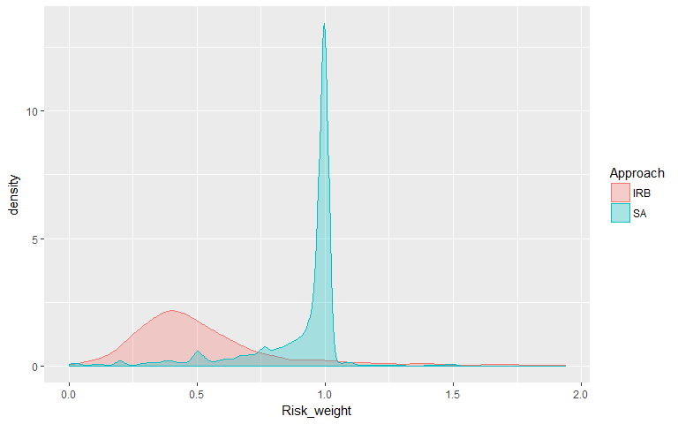

The next figures show the distributions of risk-weights for corporate exposures across headquarters and approaches (IRB and SA).

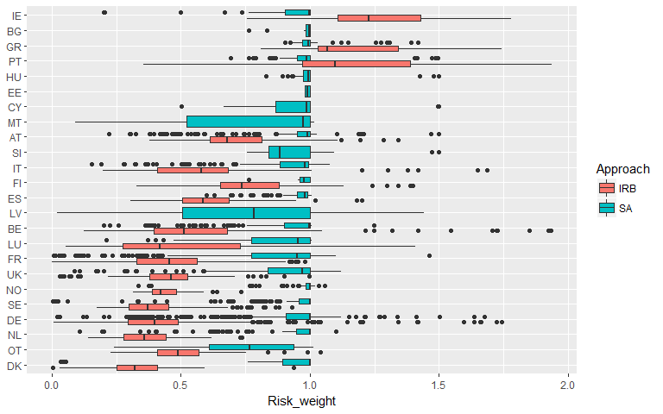

$Exposure_{i,c,t}=β_{0}({\overset{^}{RW}}_{i,c,t}^{SA}−RW_{i,c,t}^{IRB})+β_{1}NPL_{i,c,t}+β_{2}({\overset{^}{RW}}_{i,c,t}^{SA}−RW_{i,c,t}^{IRB})×NPL_{i,c,t}+α_{i,t}+α_{c,t}+ε_{i,c,t}$,

$Exposure_{i,c,t}$ is the total asset of bank $i$ in country $c$ at time $t$. $NPL_{i,c,t}$ is the amount of defaulted exposure. $RW_{i,c,t}^{IRB}$ is the risk weight of an exposure under the IRB approach. ${\overset{^}{RW}}_{i,c,t}^{SA}$ is the predicted value using the characteristics of $RW_{i,c,t}^{IRB}$ from the following regression:

$RW_{i,c,t}^{SA}=δ_{0}NPL_{i,c,t}+α_{i,t}+α_{c,t}+ε_{i,c,t}$.

This variable is a proxy of what would be the risk weight under SA for an exposure that is actually calculated using the IRB approach. Hence, ${\overset{^}{RW}}_{i,c,t}^{SA}−RW_{i,c,t}^{IRB}$ is our measure of regulatory risk weight strigency. Higher values indicate lower strigengy.

$β_{2}$ captures the risk-taking channel from regulatory arbitrage.

# References

Behn, Markus, Rainer FH Haselmann, and Vikrant Vig. 2016. “The Limits of Model-Based Regulation.”

Behn, Markus, Rainer Haselmann, and Paul Wachtel. 2016. “Procyclical Capital Regulation and Lending.” *The Journal of Finance* 71 (2). Wiley Online Library: 919–56.

Beltratti, Andrea, and Giovanna Paladino. 2016. “Basel Ii and Regulatory Arbitrage. Evidence from Financial Crises.” *Journal of Empirical Finance* 39. Elsevier: 180–96.

Cucinelli, Doriana, Maria Luisa Di Battista, Malvina Marchese, and Laura Nieri. 2017. “Credit Risk in European Banks: The Bright Side of the Internal Ratings Based Approach.”

Döme, Sophia, Stefan Kerbl, and Markus Behn. 2017. “Comparability of Basel Risk Weights in the Eu Banking Sector.” *Financial Stability Report*, no. 34. Oesterreichische Nationalbank (Austrian Central Bank): 68–89.

Efing, Matthias. 2016. “Arbitraging the Basel Securitization Framework: Evidence from German Abs Investment.”

Montes, Carlos Pérez, Carlos Trucharte Artigas, María Elizabeth Cristófoli, and Nadia Lavín San Segundo. 2016. “The Impact of the Irb Approach on the Risk Weights of European Banks.” *Journal of Financial Stability*. Elsevier.