DEPLOYMENT GUIDE – DOCKER ON AWS EC2

1 Launch EC2 Instance
Select Ubuntu 22.04 or Amazon Linux.
Create Security Group with inbound rules:
- SSH (22) your IP
- Port 5000 or 80 for app access.
Download your .pem key.

2 Connect to EC2
ssh -i your-key.pem ubuntu@EC2_PUBLIC_IP

3 Install Docker & Docker Compose
sudo apt update && sudo apt upgrade -y sudo apt install -y docker.io
sudo systemctl enable --now docker

sudo usermod -aG docker ubuntu
sudo apt install -y docker-compose

4 Upload Project Zip to Server
scp -i your-key.pem docker.zip ubuntu@EC2_PUBLIC_IP:/home/ubuntu unzip docker.zip && cd expense_tracker-main

5 Build & Run Project
docker compose up -d --build docker ps (check containers)

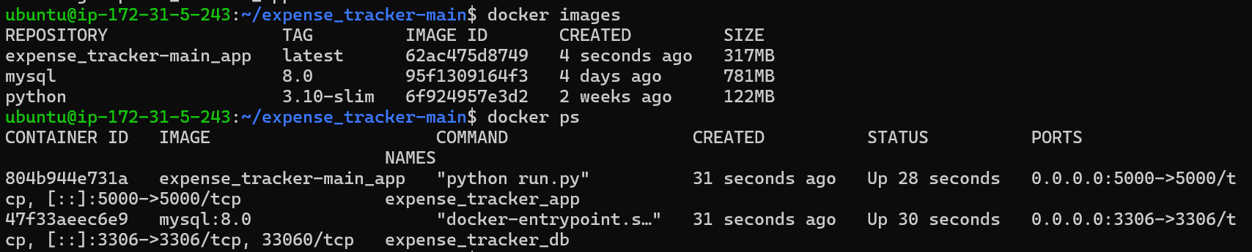

6 Push to Docker hub

docker tag expense_tracker-main_app:latest aindri1105/expense_tracker_app:v1
docker push aindri1105/expense_tracker_app:v1
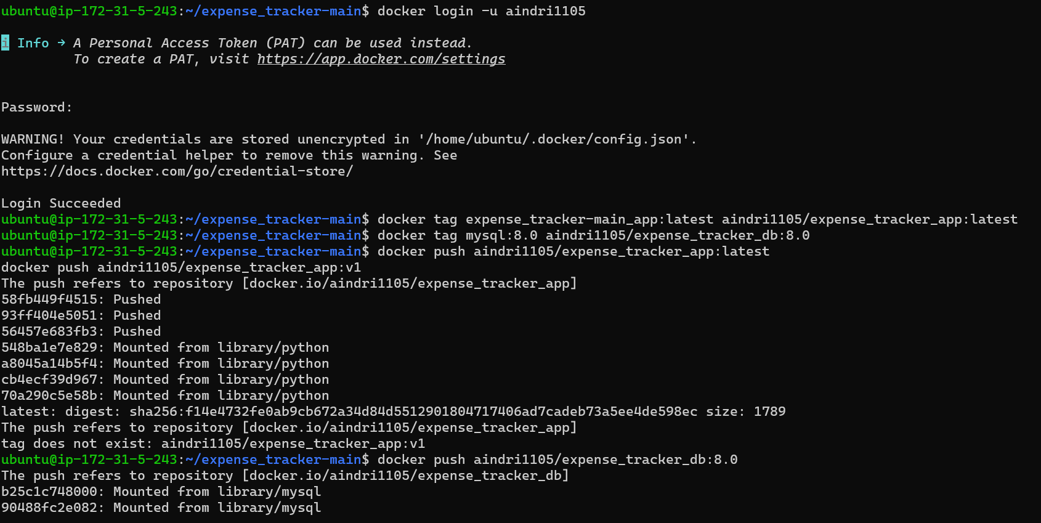

7 Access MySQL in Docker
docker exec -it expense_tracker_db bash
mysql -u root -p

SHOW DATABASES;
USE expense_tracker;
SHOW TABLES;
Select * from user;
Select * from expense;
Select * from category;

