**BSTree Insert (Recursive VS. Iterative)**

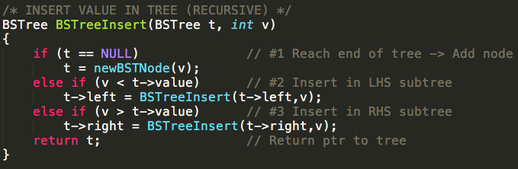

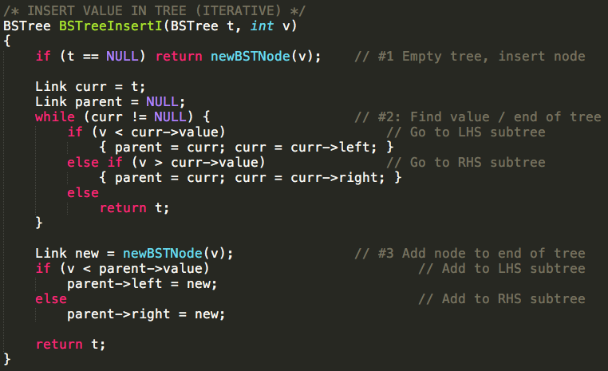

**BSTree Traverse (Recursive) – Depending on requested Traversal Order (Prefix, Infix, Postfix)**

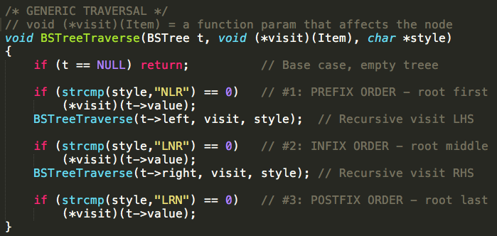

**BSTree Traverse (Recursive) – Changes values of each node**

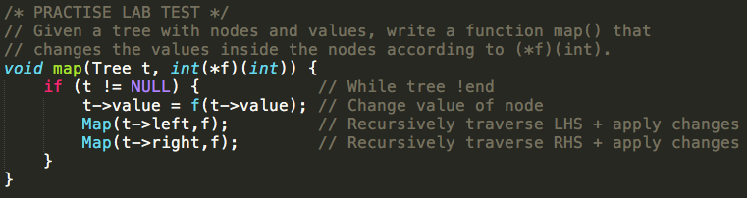

**BSTree LEVEL-ORDER Traverse** **(Breadth-First-Traversal)**

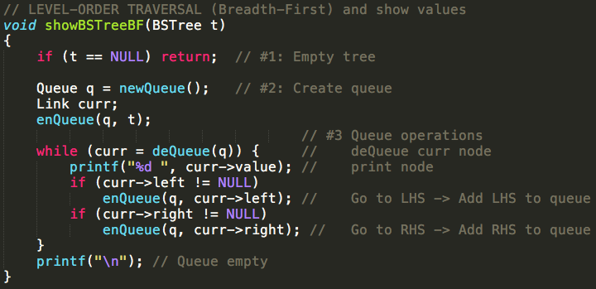

**BSTree Deletion – Delete value from tree (return new BSTree t without Key k)**

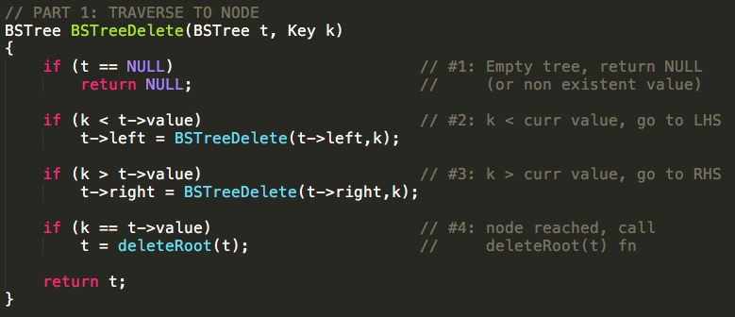

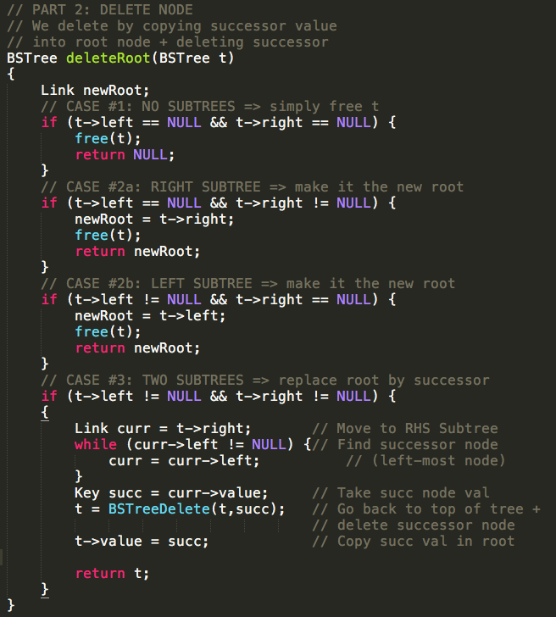

**Generic Tree – Tree Rotation (LEFT vs RIGHT rotation)**

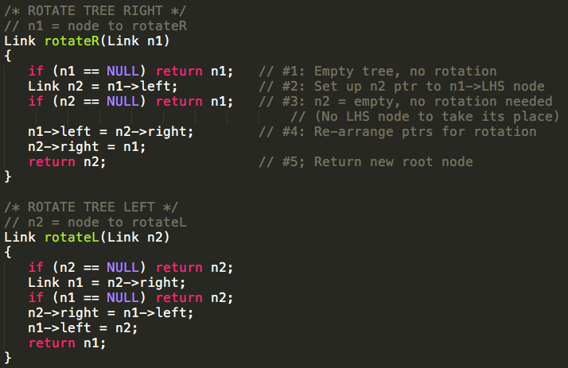

**Generic Tree – Insert At Root (Using RotateL && RotateR)**

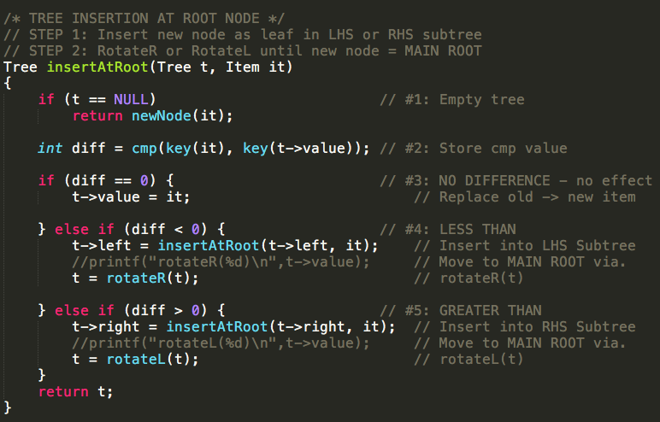

**Generic Tree – Rebalancing Trees**

// Trees are rebalanced by finding the Median Node and then moving it to the root via. recursively rotating

**PART 1: Main Rebalance Function**

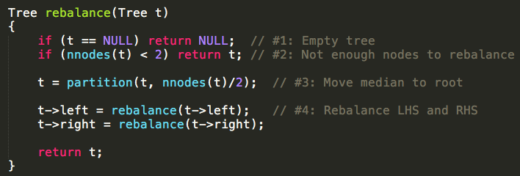

**PART 2: Partition Function**

