**Print List (Recursive VS. Iterative)**

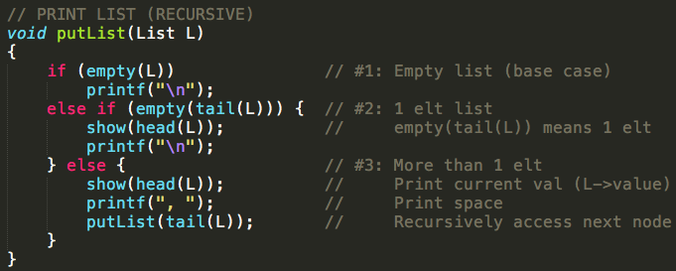

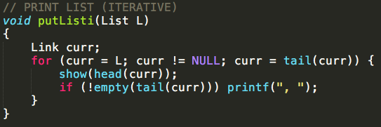

**Reverse Print List (Recursive) POSSIBLE EXAM PRAC QUESTION**

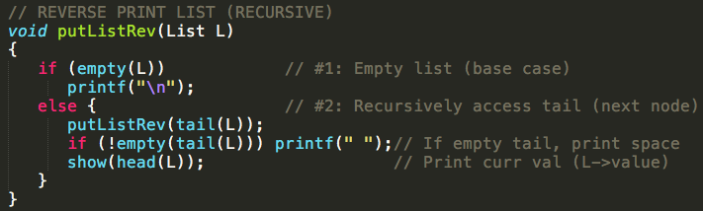

**What is the difference between ASCENDING / DESCENDING printing?**

* ASCENDING:
  + Does the print operation before recursive operation (L->next / Tail)
* DESCENDING:
  + Does the recursive operation (L->next / Tail) before printing
  + This works as the function will:
    1. Loop to the end of the list
    2. Print the SPACE + Print the curr (head) value
    3. Break out of the recursion
    4. Then repeat until the first case is reached