**QUEUES**

Queues

* First In First Out (remember stacks = L I F O)

Characteristic Operations:

* **Enqueue(Queue q, Item it)** add item onto queue
* **Item it = dequeue(Queue q)** remove item from stack

Other possible operations:

* **isEmpty(Queue q)** queue contains no items
* **Length(Queue q)** how many items in queue
* **Show(Queue q)** display queue on stdout
* **Queue q = newQueue()** create new empty queue
* **dropQueue(Queue q)** release queue data

Queue implementations

* As a linked list w/ array data
  + Pointer to first element of the list
  + Pointer to last element of the list
  + Dequeue = take off FIRST element
  + Enqueue = add to LAST element

**PRIORITY QUEUES**

Instead of FIFO, it is “one with the highest priority goes out” regardless of what goes in first.

* Items are processed in order of “key” / importance

Priority Queues (PQs) provide this via:

* **void join(PQ, Item)**: insert item in PQ
* **Item leave(PQ)**: remove item with the highest priority
* **Item remove(PQ, Key)**: remove item with specified key (non-standard)

Plus generic ADT operations:

* **newPQ** / **dropPQ** / **isEmpty**…

Highest priority could be:

* largest key
* smallest key
* E.g. taking out item with the highest or lowest timestamp

Priority order may involve “weight” based on other factors than just a key

Behaviour of priority queue

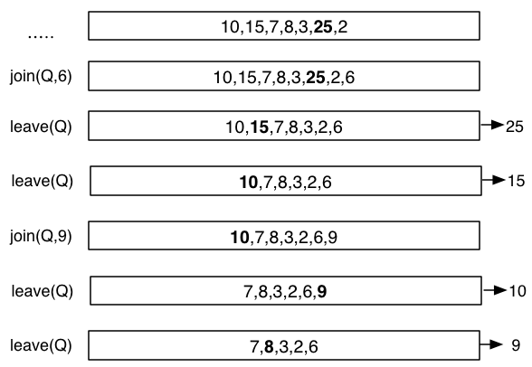

Highest priority = largest no.

* 6 joins queue
* Highest (25) leaves queue
* Highest (15) leaves queue
* 9 joins queue
* Highest (10) leaves queue
* Highest (9) leaves queue

Priority Queue Cost Representations:

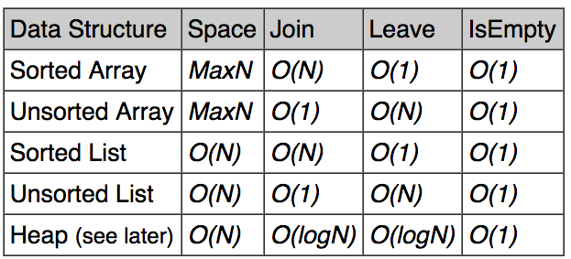

For a **PQueue** containing N items.

* Space = number of items in the data structure

HEAP is one of the better queue representations

UNSORTED is simple to join  
SORTED is simple to leave

**RECURSION**

**Add notes here**

**LISTS**

**Add notes here**

**GRAPH FUNDAMENTALS**

Many applications require:

* A collection of **items** (a set)
* **Relationships** / connections between the items

Examples:

* Maps: items are cities, connections are roads
* Web: items are pages, connections are hyperlinks
* Facebook: items are people, connections are “friends”

Collection types we’ve seen so far

* Sets: unordered collection of items
* Lists: linear sequence of items (list, stack, queue)

**Graphs are more GENERAL, they show arbitrary connections (more random)**

A **graph G = (V, E)**

* V is set of vertices
* E is a set of edges (subset of VxV)

Example:

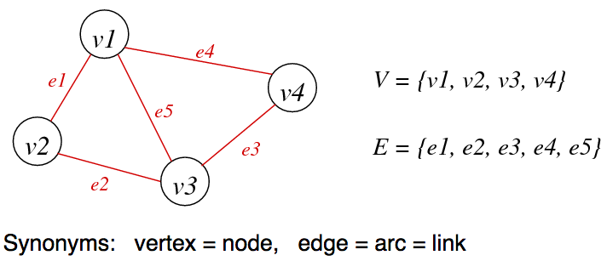

Edges can sometimes have info associated with them like:

* Weight / length / distance (maps) etc. / travel time
* A direction

Questions we might ask about a graph:

* Is there a way to go from A 🡪 B
  + E.g. Is it possible to drive from Sydney to Melbourne
* What is the best way to get from A 🡪 B
  + E.g. look at lowest weights / lengths / distances for edges in a map
* Which vertices are connected?
  + E.g. Is graph of roads from Sydney connected to graph of roads from New Zealand?

Graph algorithms are generally more complex than tree/list ones:

* No implicit order of items
  + There is no first vertex / item
* Graphs may contain cycles
  + For trees / lists you eventually reach the end
  + For graphs you can go around in a cycle
* Concrete representation is less obvious
  + Trees / list representations are more simple.
  + Graphs are harder to picture and can look like anything.
* Algorithm complexity depends on connection complexity
  + How connected vertices are between each other can increase complexity.

Properties of graphs:

* Terminology: **|V|** and **|E|** normally written as V and E
* A graph with V vertices has at most **V(V-1) / 2 edges**
* The ratio V:E can vary considerably (ratio of no. vertices to no. edges)
  + **E is closer to V2/2** = graph is DENSE
  + **E is closer to V** = graph is SPARSE
* Knowing whether a graph is sparse or dense is important
  + May affect choice of data structures to represent graph
  + May affect choice of algorithms to process graph

Describing graphs

* V needs to be identified (1 … V)
* E needs to be drawn or numbered

Four representations of the same graph:

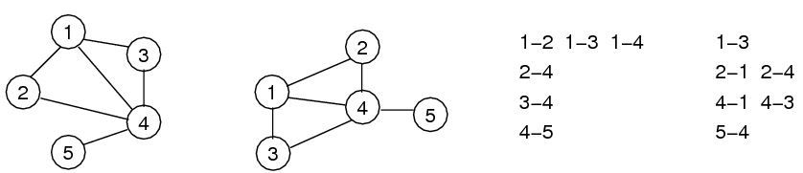x

**GRAPH TERMINOLOGY**

Graph Terminology

* For an **edge e**, that connects **vertices v and w**:
  + V and W are **adjacent**
  + E is **incident** on both V and W
* **Degree** of a vertex V = number of edges incident on V
* **Path** = sequence of vertices, each vertex has an edge to its predecessor
* **Cycle** = a type of PATH where last vertex in path is the same as first vertex in path

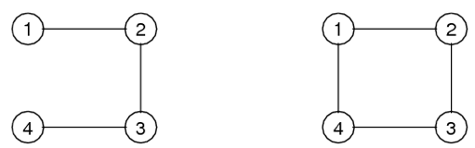

Path: 1-2 , 2-3 , 3-4 (connection stops at end)  
Cycle: 1-2 , 2-3 , 3-4 , 4-1 (connects back to the beginning)

Types of graphs

* 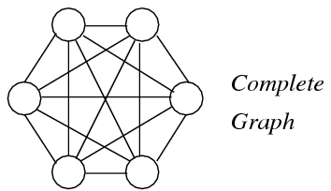**Connected Graph**
  + There is a PATH from each vertex to every other vertex
  + If a graph is not connected, it has connected components
  + E.g. Sydney and Melbourne are connected within, but not  
    connected to each other
* **Complete Graph**
  + There is an EDGE from each vertex to every other vertex
  + In a complete graph, **E = V(V-1) / 2**
* **Tree** = Connected subgraph with no cycles
* **Spanning Tree** = Tree containing all vertices
* **Clique** = Complete subgraph

Consider the following SINGLE GRAPH:

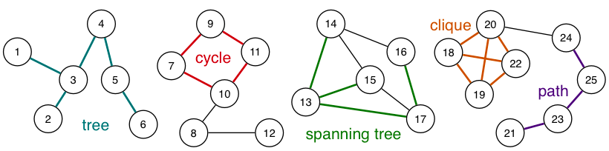

This graph has 25 vertices, 28 edges and 4 connected components

Other types of graphs:

* **Directed Graph (di-graph)** = Each edge has an associated direction (e.g. hyperlinks)
* **Weighted Graph** = Each edge has an associated value (weight) (e.g. Aus roads)
* **Multi-Graph** = Multiple edges between two vertices (e.g. function call graph 🡪 **f( ) calls g( ) in several places**)

**GRAPH ADT**

Data:

* Set of edges + Set of vertices

Operations

* Building: create graph, create edge, add edge
* Deleting: remove edge, drop whole graph
* Scanning: get edges, copy, show

Notes:

* Set of vertices is fixed when graph is initialised
* We treat vertices as **INTS** but they could be **Items**

With edges, an edge from vertex 2 🡪 3 is the same as an edge from vertex 3 🡪 2.

We can fix this by using **Canonical Edge Representation**

* We build vertexes in a way such that FIRST VERTEX is always smaller than SECOND VERTEX
* This is the preferred way when building graph
* See code for more details

**ADJACENY MATRIX REPRESENTATION**

Edges represented by a VxV matrix

Is there an edge between vertex X and W?

**0** = NO

**1** = YES

**Undirected Graph**

* Always going to have a symmetric matrix

**Directed Graph**

* Matrix won’t necessarily be symmetric

In C, a matrix is basically an **array of arrays**

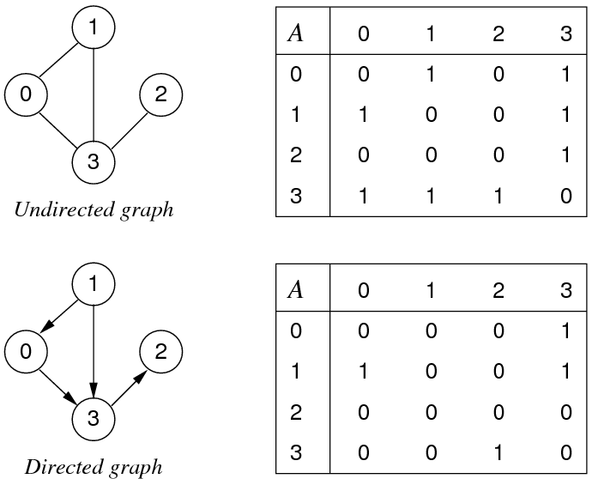

Implementation of **GraphRep**

**int nV** = # vertices

**int nE** = # edges

**int ** edges** = ptr to an **int ptr**.

**int ptr** = ptr to the start of an array of integers

We can’t do int **edges in the form of int edges[X][Y] unless we know for sure the number of vertices in the graph. Otherwise for unknown, we need pointers. (dynamic allocation with ptrs)

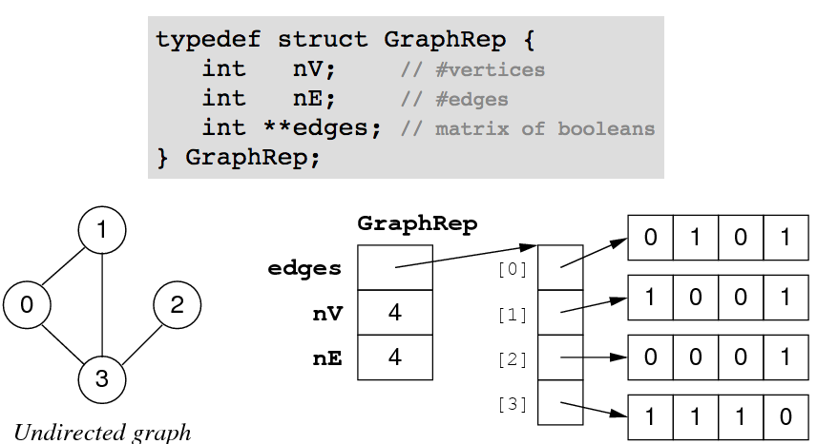

See code for graph initialisation.

See code for validity checking.

Check whether two vertices are connected.

Write a function to give a list of all vertices connected to a given vertex

* **Vertex *neighbours(Graph g, Vertex v, int *nv);**

This function:

* Returns a dynamically allocated array of vertices (**vs**)
* Sets the value of the **nv** parameter to size of array

Usage:

* **Graph g; Vertex v; int n;**

**Vertex *ns = neighbours(g, v, &n);** // return value of variable by passing the address of the variable