MATH3070 Assignment_5

NOTE: I have omitted most of your code from the output of this RMarkdown file in order to save space, as I didn’t think it would be useful for you to re-read your own code. I have just included the relevant chunks for each question, as well as my own bits of code.

## INFORMTION ABOUT THE MODEL

We are using cesm_rcp85, which is a GCM (General Circulation Model), with greenhouse gas forcing under RCP8.5 (high emissions), from 2006-2100.

The integrated primary production comes from a biogeochemical model (for nutrients and phytoplankton) forced by the GCM.

## [1] 360 180 1140

Note that the dimensions of the SST array are: [360, 180, 1140]. These represent 360 deg longitude, 180 deg latitude, and 1140 months between jan 2006 and dec 2100

## Q1. Plotting sea surface for Dec 2006 and Dec 2100

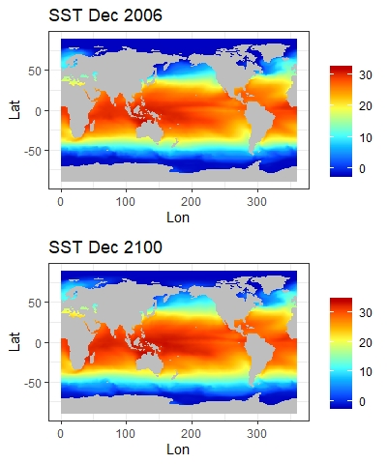# Plot SST for Dec 2006  
plot1 <- ggplot(data = df, aes(x = Lon, y = Lat, fill = SST_2006)) +   
 geom_raster() + scale_fill_gradientn(colours = matlab.like(12), guide = "colorbar", na.value = "gray") +   
 theme_bw() + labs(fill = "") + ggtitle("SST Dec 2006")  
  
# Plot SST for Dec 2100  
plot2 <- ggplot(data = df, aes(x = Lon, y = Lat, fill = SST_2100)) +   
 geom_raster() + scale_fill_gradientn(colours = matlab.like(12), guide = "colorbar", na.value = "gray") +   
 theme_bw() + labs(fill = "") + ggtitle("SST Dec 2100")  
  
grid.arrange(plot1, plot2)

From these plots we can see a global increase in temperature, in some regions more than others. To look at these changes more closely, I plot the difference in sea surface temperature from 2006 to 2100.

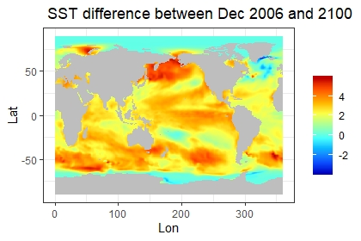# Plot SST difference between Dec 2006 and 2100  
ggplot(data = df, aes(x = Lon, y = Lat, fill = SST_2100 - SST_2006)) +   
 geom_raster() + scale_fill_gradientn(colours = matlab.like(12), guide = "colorbar", na.value = "gray") +   
 theme_bw() + labs(fill = "") + ggtitle(" SST difference between Dec 2006 and 2100")

#compute average temperature increase in sea surface and atmosphere  
ss =mean(df$SST_2100 - df$SST_2006, na.rm=T)  
ss

## [1] 2.282163

a = ss*1.5  
a

## [1] 3.423244

Here we can see increases of at least 4 degrees centigrade in places such as the south-eastern coast of Australia and around the top of Asia.

I also calculated the mean increase in global temperature from 2006 to 2100. This was 2.28 deg (3 sf) for the sea surface, and then I multiplied this by 1.5 to estimate the increase in atmospheric temperature, which was 3.42 deg (3 sf).

We now investigate the effects this has on how fast the phytoplankton are growing, i.e. the primary production.

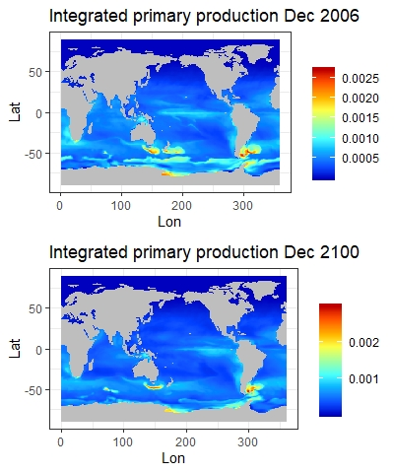  
# Plot SST for Dec 2006  
plot3 <- ggplot(data = df, aes(x = Lon, y = Lat, fill = IntPP_2006)) +   
 geom_raster() + scale_fill_gradientn(colours = matlab.like(12), guide = "colorbar", na.value = "gray") +   
 theme_bw() + labs(fill = "") + ggtitle("Integrated primary production Dec 2006")  
  
# Plot SST for Dec 2100  
plot4 <- ggplot(data = df, aes(x = Lon, y = Lat, fill = IntPP_2100)) +   
 geom_raster() + scale_fill_gradientn(colours = matlab.like(12), guide = "colorbar", na.value = "gray") +   
 theme_bw() + labs(fill = "") + ggtitle("Integrated primary production Dec 2100")  
  
grid.arrange(plot3, plot4, ncol=1)

# Calculate mean difference in primary production  
ppchange =mean(df$IntPP_2100 - df$IntPP_2006, na.rm=T)  
ppchange

## [1] -3.955745e-05

From these maps we can see a general decrease in primary production, especially in coastal areas. I calculated the mean change in IntPP and found an average decrease of 3.955745e-05 mmolC/m^2/s globally, which is 41.01316 mgC/m^2/d for each meter sq grid of ocean as viewed by a satellite.

## Q2. Estimating total fish biomass in the world

# Total fish catch in tonnes  
format(Biom_year[1], scientific = TRUE) # total biomass in 2006

## [1] "4.944208e+09"

format(Biom_year[15], scientific = TRUE) # total biomass in 2020

## [1] "4.760608e+09"

format(Biom_year[95], scientific = TRUE) # total biomass in 2100

## [1] "3.763634e+09"

Our estimate for the total fish biomass in the world now (2020) is 4.76 x 10^9 tonnes. In comparison, Jennings et al estimated the total fish biomass to be 8.99 x 10^8 tonnes˟˟ (at the time their data was collected circa 2008). Thus our model’s estimate is around 5 times larger than Jennings et al’s.

There are a few obvious reasons why these values may differ. Firstly, Jennings’ model estimated the biomass at its respective point in time, i.e. around 2008. And so, when we compare this to 2020, the primary production and sea surface temperatures will be different, (thanks to climate change), and so they gain different results. However, with this in mind, our model shows that SST increases with time, and our biomass estimates decrease. Hence, we would expect the biomass in 2008 to have been greater than it currently is in 2020, and so this doesn’t explain why Jennings et al have a lower value as their estimate.

Another reason could be that in Jennings’ methodology, they split the fish in the ocean into teleost fish and elasmobranchs (sharks and rays), and use this as another element of their model. They distinguish between them by their size at birth or hatch. In comparison, we just grouped all the marine life together and integrated over mass sizes from 1g to 1 tonne. This difference in methodology is sure to be partly responsible for the difference in the estimates.

Finally, I noticed that Jennings et al used SeaWiFS data on chlorophyll a as an input for their computation of primary production (PP) which was based off the approach from Longhurst (1995), which was a wavelength- and depth resolved model. We however used a biogeochemical model forced by the GCM to compute our PP. Since we used different models, our data for PP is bound to be different, and so unsurprisingly produces different output values. Similarly, for the sea surface temperature (SST), Jennings et al used NASA terra-satellites to gather the data, and each of their grid squares was 36km x 36km. This again is different to ours, since we used 1˚ x 1˚ area grids and so these must have been taken from a different source. Hence, this would also affect the outputted results, as not all temperature models give the same data values.

˟˟The value stated in this question on the assignment was 7.91 x 10^8 tonnes, however, having read Jennings et al’s paper, it appears that this value actually refers to their production estimate not their fish biomass one, and its units are tonnes per year instead. [<https://www.ncbi.nlm.nih.gov/pmc/articles/PMC2602712/>]

## Q3. Sensitivity analysis

For each parameter that I test, I keep the others constant. I calculate the biomass estimate at each value of the parameter within our expected bounds, and then plot the results. I have added a line to each graph to indicate where the default value is set in our main analysis.

First, we vary alpha…

#Varying alpha, everything else remains constant  
Beta <- 1000 # Predator Prey Mass Ratio  
E <- 0.63 # Activation energy  
k_b <- 8.62e-05 # Boltzmann's constant  
K <- SST + 273.15 # Temperature in Kelvin  
W_min <- 1 # Minimum mass  
W_max <- 1e6 # Maximum mass  
  
# Alpha = Trophic transfer efficiency  
  
Avec = c(0.05, 0.125, 0.2)  
BioVec = rep(0,3)  
  
for (i in c(1,2,3))  
{  
 A = Avec[i]  
 P_Wm <- (exp(25.22 - E/(k_b*K))*W_m^0.75)/365 # Abundance of phytoplankton  
 N_Wm <- PP_Wm/P_Wm # Abundance of phytoplankton at Wm  
 b <- log10(A)/log10(Beta)-0.75 # Slope of size spectrum  
 a <- N_Wm/(W_m^b) # Intercept of size spectrum  
 Biom_conc <- (a/(b+1))*(W_max^(b+1) - W_min^(b+1))  
 Biom_conc <- Biom_conc/10^6 # Convert to tonnes/m^3  
 Area_grid <- t(as.matrix(area(raster())))*1000*1000  
 Biom_total <- sweep(Biom_conc, c(1,2), Area_grid, '*')  
 Biom_month <- apply(Biom_total, 3, sum, na.rm = TRUE)  
 Biom_year <- colMeans(matrix(Biom_month, 12)) # Total global biomass in each year  
   
 TotalBio = format(Biom_year[15], scientific = TRUE) # total biomass in 2020  
 BioVec[i] = TotalBio  
}  
  
print(BioVec)

## [1] "9.258305e+07" "4.760608e+09" "4.009353e+10"

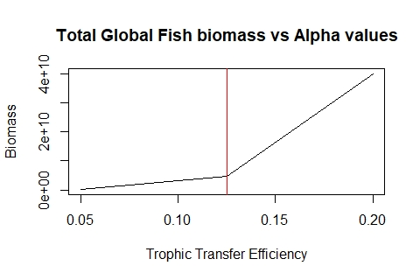plot(Avec,BioVec,  
 type="l",  
 main="Total Global Fish biomass vs Alpha values",  
 ylab="Biomass", xlab="Trophic Transfer Efficiency")  
abline(v=0.125, col="red")

From this graph, we notice that as alpha increases, it appears that our biomass estimates increase quadratically. i.e. as the transfer of energy between the trophic levels becomes more efficient, less energy is lost at each step, and so this results in a higher estimate of total biomass.

We now vary beta… (I used the same code block here just edited for beta values instead of alpha)

print(BioVec)

## [1] "3.20533e+02" "5.550369e+07" "4.760608e+09" "5.049508e+10"

## First I did a normal plot, but then decided a log transformation for the x-axis would be better  
  
plot(Bvec,BioVec,  
 type="l",  
 main="Total Global Fish biomass vs Beta values",  
 ylab="Biomass", xlab="PPMR",  
 log = "x")  
abline(v=1000, col="red")

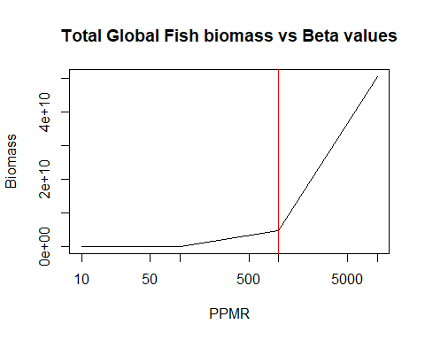

From this graph we see that as log(PPMR) increases, the biomass estimates increase exponentially. This suggests that the predator-prey mass ratio has an approximately linear relationship with biomass.

And finally, we vary E…

print(BioVec)

## [1] "1.389399e+09" "4.760608e+09" "1.634157e+10" "5.619556e+10"

plot(Evec,BioVec,  
 type="l",  
 main="Total Global Fish biomass vs E values",  
 ylab="Biomass", xlab="Activation Energy")  
abline(v=0.63, col="red")

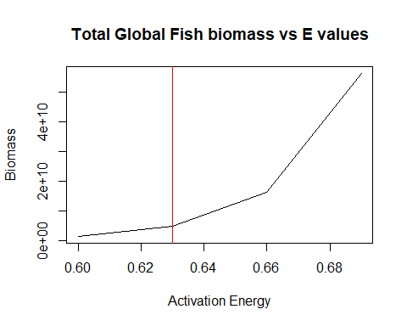  
This graph shows that as the activation energy of metabolism increases, the biomass estimate increases quadratically.

In conclusion, this analysis has shown that variation in our parameters (within expected bounds) does affect our global biomass estimate quite significantly, i.e. Our output values are indeed sensitive to the assumptions we have made about trophic transfer efficiency, predator–prey mass ratios, and activation energy of metabolism. From the graphs, we can see that as each of these parameters increase, so does the estimate of global biomass.

## Q4: What will happen to fish biomass in the future?

## Global time series

Firstly, we calculate the percentage change in fish biomass compared with 2006, and plot this as a global time series.

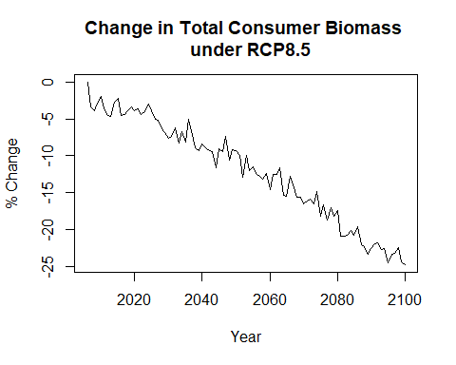# Plot relative change in % over 21st century  
Years <- 2006:2100  
PercChange <- 100*(Biom_year/Biom_year[1])-100 # % Change each year compared with 2006  
  
plot(Years, PercChange, type = 'l', lwd = 1.2,   
 ylab = '% Change',  
 xlab = 'Year',   
 main = 'Change in Total Consumer Biomass \n under RCP8.5')

From this graph we can see that our estimates of global fish biomass are decreasing significantly under RCP8.5, and by the end of the century we can expect the consumer biomass to have dropped by approximately 25%.

## Change in biomass from the 2010s to the 2090s

Here, we calculate the percentage change in fish biomass between the 2010s and 2090s

# Calculate % change in biomass between 2010s and 2090s  
Biom_2011_2020 <- apply(Biom_conc[,,61:180], c(1,2), mean, na.rm = TRUE)  
Biom_2091_2100 <- apply(Biom_conc[,,1021:1140], c(1,2), mean, na.rm = TRUE)  
  
#Biom_change = Change in biomass between 2011-2020 and 2091-2100 for each 1 deg grid of the world  
Biom_change <- 100*(Biom_2091_2100/Biom_2011_2020)-100  
  
### NOTE: I changed the comparison data from 2006-2015 to 2011-2020 so we can accurately talk about the 2010s as a complete decade

We check the raw distribution of % changes in biomass from 2010s to 2090s and modify any outliers.

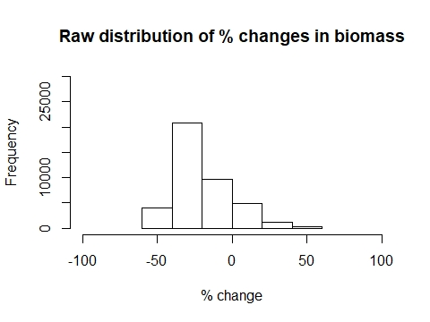hist(Biom_change, xlim=c(-100,100), ylim=c(0,30000),   
 xlab="% change", main="Raw distribution of % changes in biomass", breaks = 7)

# Modify high outliers, everything above + or -50%   
Biom_change[Biom_change > 50] <- 50  
Biom_change[Biom_change < -50] <- -50

We now use ggplot to plot these changes on a map.

## GLOBAL MAPS OF FISH BIOMASS  
## Use ggplot to make plot map of change in fish biomass  
Biom_frame <- expand.grid(Lon = Lons, Lat = Lats)  
Biom_frame$Biom_change <- as.vector(Biom_change)  
  
ggplot(data = Biom_frame, aes(x = Lon, y = Lat, fill = Biom_change)) +   
 geom_raster() + scale_fill_gradientn(colours = rev(matlab.like(12)), guide = "colorbar", na.value = "gray") +   
 theme_bw() + labs(fill = "") + ggtitle("Fish biomass change 2090s - 2010s")

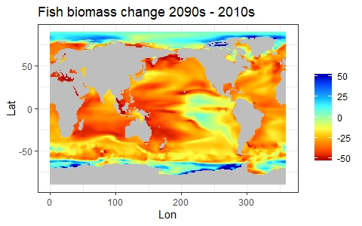From this map we can see major decreases in fish biomass all over the globe, especially in coastal areas. In many areas we can expect that by the end of the century, the total catch of fish will be as low as half of what it currently is.

However, we also notice that in the areas near to the poles, there are increases in fish biomass. This suggests that the ocean in the colder climates will become better fitted as an environment for fish populations as the temperatures increase.

## Q5: Countries/regions most affected by climate change

From our analysis so far, we can see that certain coastal areas will be most affected by climate change. Specifically countries such as Australia, Russia, and those found in the Mediterranean, Indonesia, and along the Eastern coast of Africa will all see significant decreases in the total fish catch within their Exclusive Economic Zones.

This could have disastrous consequences for peoples’ livelihoods in these countries, since many fisheries will no longer be profitable, and so these businesses will close and people will lose their jobs. For example, just looking at the eastern coast of Australia, we can see decreases in biomass by as much as 50%. We can expect the number of fisheries here to decrease as their business becomes less and less unprofitable.

We also notice from our analysis, that we can actually expect increases in fish biomass in Antarctica and along the north coast of Greenland. We may see more fishing businesses pop up over there, either people may emigrate here if the climate becomes habitable enough, or nearby countries (such as Argentina) may start sending big fishing vessels into these waters to try and harvest more of these fish.

## Q6: Global rate of decline in fish per degree c of warming

Firstly, I manipulate the data in to obtain the average sea surface temperature for each year, then compare this to what it was in 2006 to obtain a measure of the warming of our oceans. I then plot this as a time series and add the change in biomass to the same graph in order to compare them more easiliy.

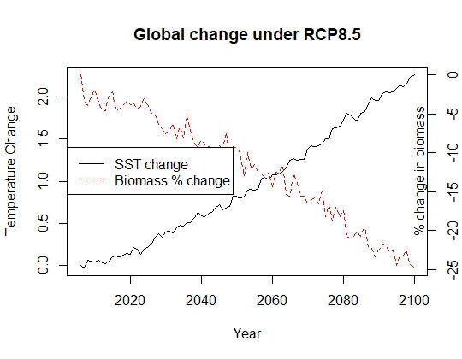#Getting data on the SST average each year  
SST_month <- colMeans(SST,na.rm=TRUE, dims=2)  
SST_year <- colMeans(matrix(SST_month, 12))  
#Computing the warming of the oceans  
SSTChange <- SST_year - SST_year[1]  
  
#Plotting global time series of both the temperature increase and fish biomass decrease   
plot(Years, SSTChange, type = 'l', lwd = 1.2, lty = 1,  
 ylab = 'Temperature Change', xlab = 'Year',   
 main = 'Global change under RCP8.5')  
par(new=TRUE)  
plot(Years, PercChange, type = 'l', col="red", lty = 2, xlab="", ylab="", yaxt = "n", xaxt="n" )  
axis(side=4)  
mtext("% change in biomass", side = 4, line = -1)  
legend("left", c("SST change", "Biomass % change"),  
 col = c("black", "red"), lty = c(1, 2))

From this plot we can clearly see that throughout this century, the sea surface temperature will continue to increase, and sadly our global fish biomass will decrease.

In order to investigate the global rate of decline in fish per deg of warming, I plot the percentage change in biomass against the warming of our oceans and fit a simple regression model to the data…

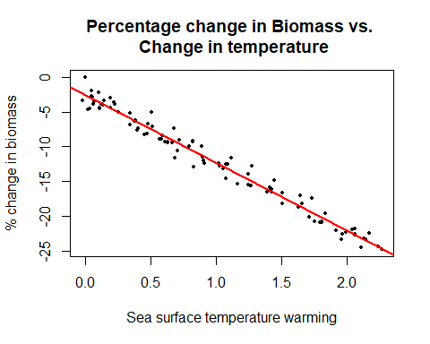#BPW refers to Biomass Per (degree of) Warming  
BPW <- data.frame(SSTChange, PercChange, Biom_year, SST_year)  
  
lmod <- lm(formula = PercChange ~ SSTChange, data = BPW)  
  
plot(SSTChange, PercChange,  
 ylab = '% change in biomass',  
 xlab = 'Sea surface temperature warming',   
 main = 'Percentage change in Biomass vs. \n Change in temperature',  
 pch = 16, cex=0.5  
 )  
abline(lmod, col="red", lwd=2)

summary(lmod)

##   
## Call:  
## lm(formula = PercChange ~ SSTChange, data = BPW)  
##   
## Residuals:  
## Min 1Q Median 3Q Max   
## -2.34324 -0.76721 -0.04014 0.59134 2.61529   
##   
## Coefficients:  
## Estimate Std. Error t value Pr(>|t|)   
## (Intercept) -2.6153 0.1846 -14.16 <2e-16 ***  
## SSTChange -9.7631 0.1548 -63.06 <2e-16 ***  
## ---  
## Signif. codes: 0 '***' 0.001 '**' 0.01 '*' 0.05 '.' 0.1 ' ' 1  
##   
## Residual standard error: 1.047 on 93 degrees of freedom  
## Multiple R-squared: 0.9771, Adjusted R-squared: 0.9769   
## F-statistic: 3976 on 1 and 93 DF, p-value: < 2.2e-16

# ggplot(BPW, aes(x = SSTChange, y = PercChange)) +   
# geom_point() +  
# stat_smooth(method = "lm", col = "red")

From this graph, we can observe a linear relationship between the two variables. And from the linear model we can see that the slope of our regression line = -9.3995, which implies that for every degree of warming in our oceans, the total fish biomass is estimated to decrease by 9.4% (with reference to the levels in 2006). To convert this to tonnes per degree of warming, we take 9.4% of the estimated biomass in 2006.

format((0.093395*4.944208e+09, scientific=TRUE)

## [1] "4.617643e+08"

And so we estimate the rate of decline in fish to be 4.62 x 10^8 tonnes per degree of warming.

## Q7: Outline what the model is doing

Our model extracts data from SST_nc and IntPP_nc in order to get monthly information about predicted sea surface temperatures and primary production globally between the years of 2006 and 2100. These predictions come from a General Circulation Model and uses the future scenario RCP8.5 (i.e. a high emissions forecast). We then use this data to run a simplified version of Jennings’ model in order to estimate the global fish biomass for each year from 2006 to 2100.

Firstly, the model converts the integrated primary production (IntPP) to simply the primary production (PP) per m^3 of ocean. This uses the assumption that phytoplankton are equally distributed throught the euphotic zone (top 100m of water).

We then calculate the median phytoplankton cell size, and compute how much pp is at this median cell size. And then we use Brown’s equation to compute the daily production per individual phytoplankton. Once we have the daily production per individual, we can divide the daily pp of all pytoplankton at the median size, by their daily production per individual and thus obtain the number of individual phytoplankton at this size. With a bit of thought, we see why this works, notice that (mgC/m^3/day) / (mgC/individual/day) = individuals/m^3, and hence through this calculation we have obtained a value for the abundance of phytoplankton.

Now that we have the abundance of phytoplankton, we just need the slope and intercept of the abundance spectrum to gain estimates of the abundance of all of the different size classes. And then we simply integrate over all the size classes to get an estimate of the total biomass.

To calculate the slope of the abundance spectrum, we use the formula b = (log10(A)/log10(B)-0.75), where A is the trophic transfer efficiency (alpha) and B is the PPMR (Beta).

To calculate the intercept, we rearrange the formula N = aw^b, to get a = N_Wm/(W_m^b), where N_Wm is the number of phytoplankton at the median cell size, W_m is the median cell size, and b is the slope we just calculated.

Next, we compute the total biomass estimate for each grid by integrating the abundance spectrum over all possible fish, we use min mass = 1g and max mass = 1 tonne. The definite integral gives us the biomass concentration and we then convert this to tonnes/m^3.

And then we’re on the home stretch. First, we sum all the biomass in each grid square, being careful to approximate the surface area of each grid first (since these are not all of equal size). And then we sum up the totals from each grid to get the overall global biomass estimate per month. And finally, we sum these in groups of 12 in order to get estimates of the total global fish biomass each year. Voila.