Sustainable Smart City Assistant Using IBM Granite LLM

**Project Overview**  
Include:  
“The Sustainable Smart City Assistant is an AI-powered platform using IBM Watsonx's Granite LLM to enhance urban sustainability, citizen engagement, and governance.”

**Purpose**

• To **enhance urban governance** through AI-driven document summarization, citizen feedback collection, and smart decision-making tools.

• To **empower city administrators** with real-time insights from diverse data sources such as policies, KPIs, and citizen reports.

• To offer **accessible, AI-generated summaries** of complex policy documents for better public transparency and engagement.

• To enable **predictive analysis and forecasting** using historical data for planning resources and budgets effectively.

• To promote **sustainable living** by delivering AI-generated environmental tips tailored to user input.

•To provide a **scalable and modular platform** for integrating multiple smart city services (like anomaly detection and eco-advice) in one dashboard.

•To leverage IBM Watsonx's **Granite LLM** for contextual understanding, natural language interaction, and generative capabilities.

Introduction

**IDEATION PHASE**

**Empathy Map Canvas**

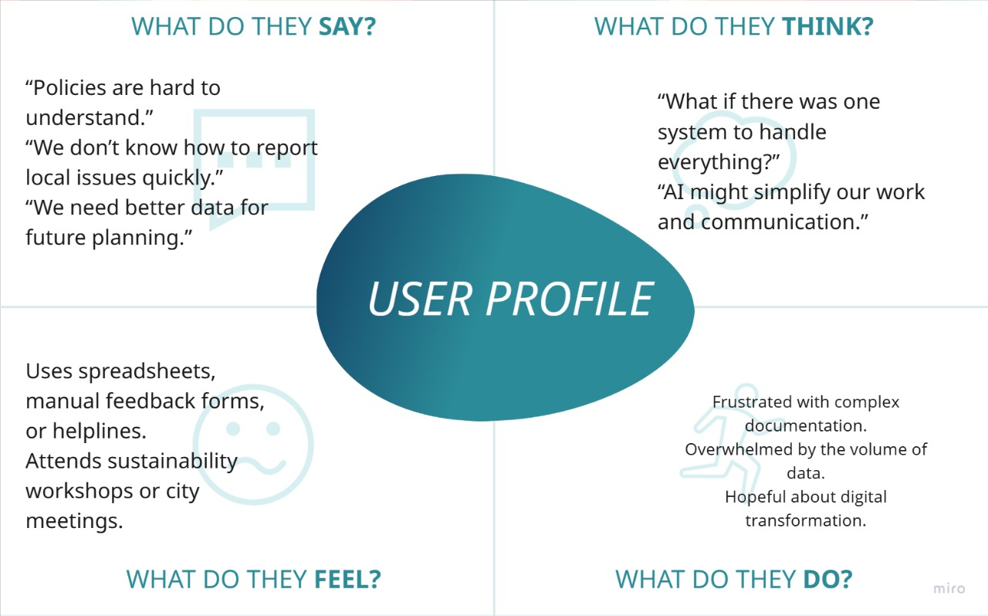

**Problem Statement**

Modern cities face a multitude of challenges related to urban planning, sustainability, and citizen engagement. City administrators often work with large, unstructured policy documents, outdated reporting methods, and isolated data systems. There is a growing need for a unified, intelligent assistant that can simplify policy interpretation, forecast KPIs, detect anomalies, and assist in citizen interaction — all through a smart, scalable platform.  
This project aims to solve these issues by developing an AI-powered assistant that integrates IBM Watsonx’s Granite LLM to support better governance, transparency, and urban sustainability.

### ****Brainstorming****

To identify the most impactful and feasible features for the Sustainable Smart City Assistant, multiple brainstorming sessions were conducted. The goal was to address the pain points of urban administrators and citizens through AI-driven solutions. The following functional components were shortlisted for development:

* **Policy Summarization**: Automatically summarize lengthy and complex city policy documents into concise, citizen-friendly formats using IBM Granite LLM.
* **Chat Assistant**: Provide a natural language interface for citizens and administrators to interact with the assistant and receive AI-generated responses.
* **KPI Forecasting**: Enable forecasting of key performance indicators such as water usage or energy consumption based on historical data using machine learning techniques.
* **Anomaly Detection**: Identify unusual patterns or outliers in datasets, such as unexpected spikes in utility consumption, to support timely interventions.
* **Eco Tips Generator**: Offer personalized environmental advice based on user queries to promote sustainable living practices.
* **Citizen Feedback Module**: Allow citizens to submit issues, suggestions, or concerns directly through the platform, enabling structured feedback collection.
* **Semantic Search**: Use a vector-based database (Pinecone) to allow semantic-level search across documents and policies for improved accessibility and relevance.

REQUIREMENT ANALYSIS

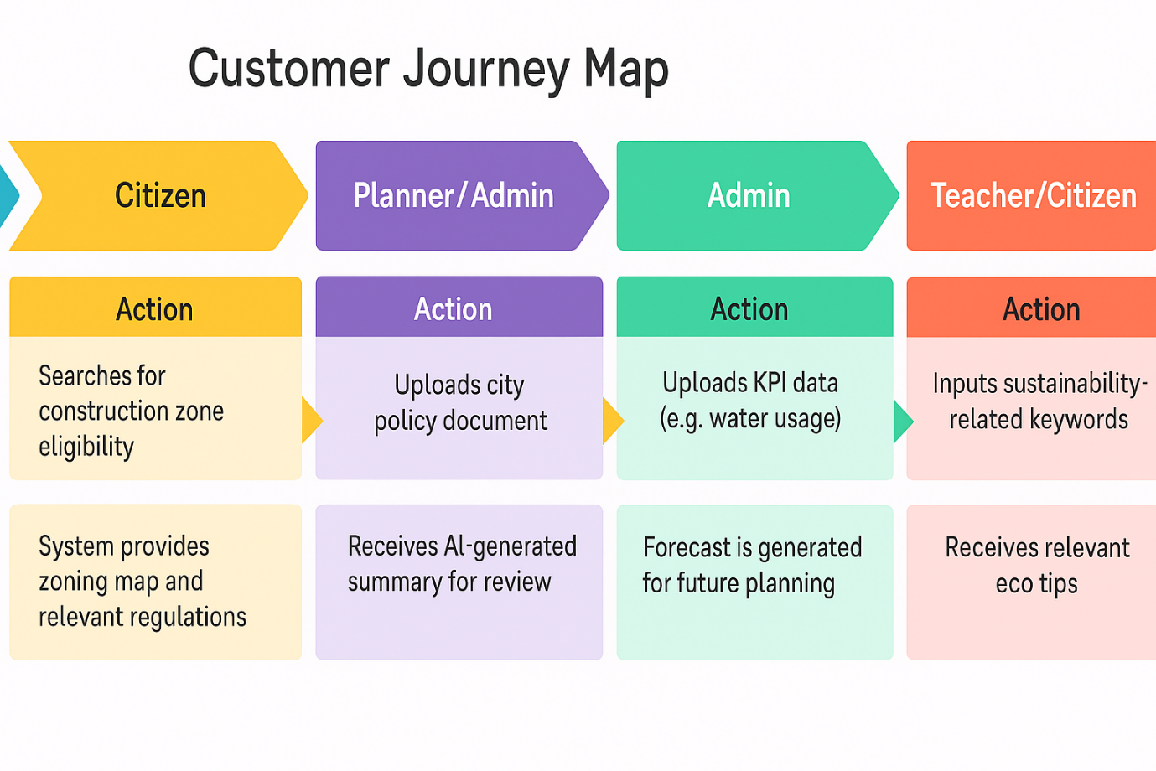

### ****Solution Requirement****

#### **Functional Requirements:**

* Allow citizens to submit categorized feedback via an online form
* Upload and summarize policy documents using IBM Watsonx Granite LLM
* Search city policies using semantic search
* Forecast KPIs using historical data (CSV input)
* Generate eco-friendly tips based on user input
* Detect anomalies in energy/water consumption trends
* Display construction zoning eligibility and guidelines

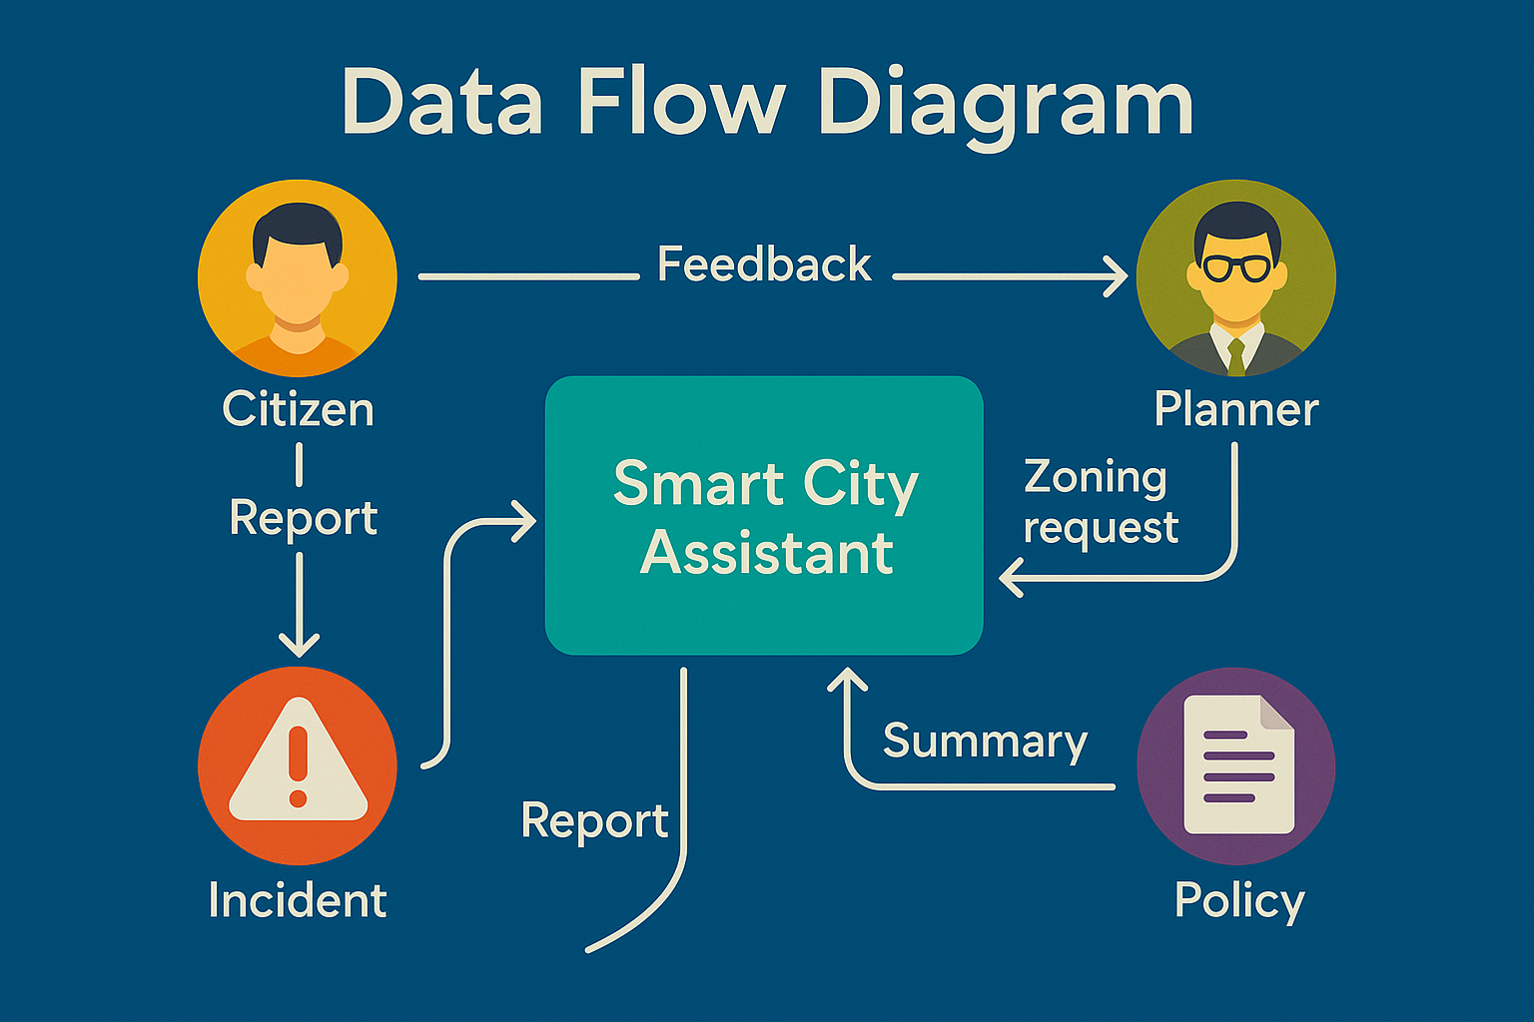

Data Flow Diagram

#### **Non-Functional Requirements:**

* Web-based dashboard accessible from desktop and mobile
* Fast response times (low latency)
* Secure file upload and storage
* Scalable backend to accommodate new city modules

**Technology Stack**

| **Component** | **Technology** |
| --- | --- |
| AI Language Model | IBM Watsonx Granite LLM |
| Frontend Dashboard | Streamlit |
| Backend API | FastAPI |
| Data Modeling/Validation | Pydantic |
| Environment Configuration | Dotenv |
| Vector Search Engine | Pinecone |
| Machine Learning | Scikit-learn (Linear Regression) |
| File Types Supported | CSV, JSON, TXT |

Product Design

### ****Problem-Solution Fit****

Urban governance involves managing vast amounts of unstructured data, citizen feedback, and infrastructure KPIs. However, traditional systems often fail to provide timely insights, resulting in delayed decision-making and poor citizen engagement. The following key problems were identified, each addressed by a targeted solution in the proposed system:

#### **Problem 1:**

City administrators face difficulty in interpreting long, complex policy documents, which delays policy implementation and communication with the public.

**Solution:**  
The assistant uses **IBM Watsonx Granite LLM** to automatically **summarize city policies** into clear, concise, and accessible formats for faster internal review and public communication.

#### **Problem 2:**

Citizens lack a structured, accessible platform to report issues such as infrastructure damage or civic complaints.

**Solution:**  
A **citizen feedback module** is integrated into the platform, allowing users to submit categorized reports. These are logged in real time for administrative review and resolution tracking.

#### **Problem 3:**

City planners struggle to forecast future infrastructure needs like water or energy usage due to lack of predictive tools.

**Solution:**  
The assistant accepts **CSV-based KPI inputs** and applies **machine learning algorithms (e.g., Linear Regression)** to forecast future usage trends, aiding in planning and budgeting.

### ****Proposed Solution****

The Sustainable Smart City Assistant is designed to serve as a multi-functional digital platform that supports city governance, citizen engagement, and environmental awareness. It integrates the following modules:

* **Document Summarization**: Summarizes uploaded policies using IBM Granite LLM.
* **Citizen Feedback Portal**: Collects, categorizes, and stores public issue reports.
* **Construction Zoning Insights**: Provides zoning eligibility based on policy inputs.
* **KPI Forecasting**: Uses machine learning to predict resource consumption.
* **Eco Tips Generator**: Generates AI-based sustainability tips for educational and community use.
* **Semantic Search**: Enables context-aware document search via Pinecone vector embeddings.
* **Chat Assistant**: Responds to queries in natural language using the Granite LLM.

#### **Problem 4:**

Construction guidelines and zoning regulations are not easily accessible to the public, leading to confusion and violations.

**Solution:**  
The assistant allows users to search for **construction eligibility and zoning information** based on uploaded documents or predefined datasets, with AI-based summarization for clarity.

#### **Problem 5:**

Urban authorities are often unaware of unusual trends in resource consumption, leading to delayed action on issues like overuse or theft.

**Solution:**  
An **anomaly detection module** flags sudden spikes or drops in KPIs, enabling proactive intervention and monitoring.

### ****Solution Architecture****

* **Frontend:**
  + Frontend Dashboard: Basic HTML and CSS
  + LLM Integration: Hugging Face model ibm-granite/granite-3.3-2b-instruct
* **Backend:**
  + Framework: FastAPI manages routing and API endpoints
  + LLM Integration: IBM Watsonx Granite LLM for text processing
  + Processing: Handles preprocessing and ML-based forecasting
* **Databases and Storage:**
  + Pinecone vector database for semantic search
  + Local/Cloud storage for uploaded files and feedback logs
* **Data Sources:**
  + City policy documents (PDF, TXT)
  + KPI CSV files
  + Text feedback from citizens
* **AI/ML Modules:**
  + Text Summarization (Granite LLM)
  + KPI Forecasting (Linear Regression)
  + Anomaly Detection (rule-based or ML-based)
  + Contextual Search (embedding-based)

PROJECT PLANNING & SCHEDULING

### ****Project Plan (Milestone-Based)****

| **Day** | **Milestone** | **Task Description** | **Status** |
| --- | --- | --- | --- |
| Day 1 | **Milestone 1: Requirements Specification** | Identified user roles, features, modules, and project scope | Completed |
| Day 2 | **Milestone 2: Environment Initialization** | Set up virtual environment, API keys (.env), dependencies (LLM, Streamlit, Pinecone) | Completed |
| Day 3 | **Milestone 3: AI Model Integration** | Connected IBM Granite LLM for summarization and prompt responses | Completed |
| Day 4 | **Milestone 4: Backend API Development** | Developed FastAPI routes for file upload, summarization, chat, feedback handling | Completed |
| Day 5 | **Milestone 5: Streamlit Frontend UI** | Created UI for document upload, feedback form, and eco tips generator | Completed |
| Day 6 | **Milestone 7: ML Forecasting & Anomaly Detection** | Built forecasting using regression and rule-based anomaly detection on KPI data | Completed |
| Day 7 | **Milestone 8: Sustainability Report Generation** | Compiled all outputs (summaries, forecasts, tips) into a structured report format | Completed |
| Day 8 | **Milestone 9: Chat Assistant Creation** | Implemented LLM-based chat interface for public/citizen queries | Completed |
| Day 9 | **Milestone 10: Final Integration & Testing** | Combined frontend + backend + AI modules and tested flows end-to-end | Completed |

## FUNCTIONAL AND PERFORMANCE TESTING

| **Module** | **Test Case** | **Expected Outcome** |
| --- | --- | --- |
| Document Summarization | Upload a city policy document (TXT/PDF) | Generates an accurate, concise summary |
| Chat Assistant | Ask “How can my city reduce carbon emissions?” | Returns strategies like green rooftops, EV incentives, etc. |
| Feedback Submission | Submit an issue report via form with category tagging | Logged and stored with correct metadata |
| KPI Forecasting | Upload a CSV file with past water usage | Forecasts next year’s water consumption |
| Anomaly Detection | Input energy usage data with outliers | Flags sudden abnormal usage spikes |
| Eco Tips Generator | Input “solar” as a keyword | Returns sustainability advice related to solar energy |
| Semantic Search | Search for “building permit rules” | Returns context-relevant policy sections using Pinecone |
| Frontend Integration | Navigate between modules using Streamlit UI |  |