Accelerators and Accelerated Systems
Exercise 1

Avi
Yonatan Nakonechny 200752061

1.1 The CUDA version on the machine is 10.2.89

1.2 The GPU name is GeForce RTX 2080 SUPER

1.4 There are 48 SM’s in the GPU

3.3 The atomicAdd is required since different cores will accses the shared data (histogram) at unknown times and unknown order.

3.4 The state needed for a serial task is:
a. A pointer to the input image.
b. A pointer to the output image.
c. A pointer to a stream.

3.7 We’ve chose to use 1024 threads since this is the maximum number of threads per block

3.8
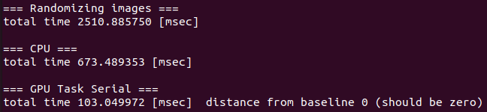
The total serial runtime on the GPU is 103.05 ms thus the throughput is

3.9

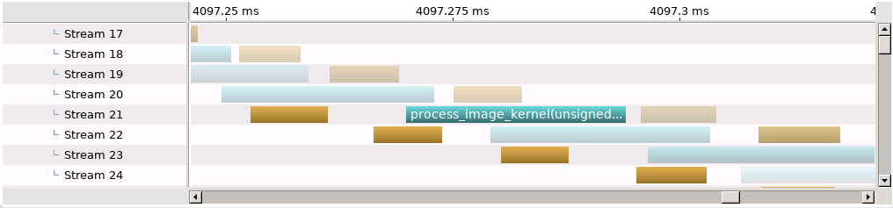

3.10 The Memcpy we examined took 8.512 micro seconds

