**Explanation: Hello World RESTful Web Service**

**1. Network Tab of Developer Tools**  
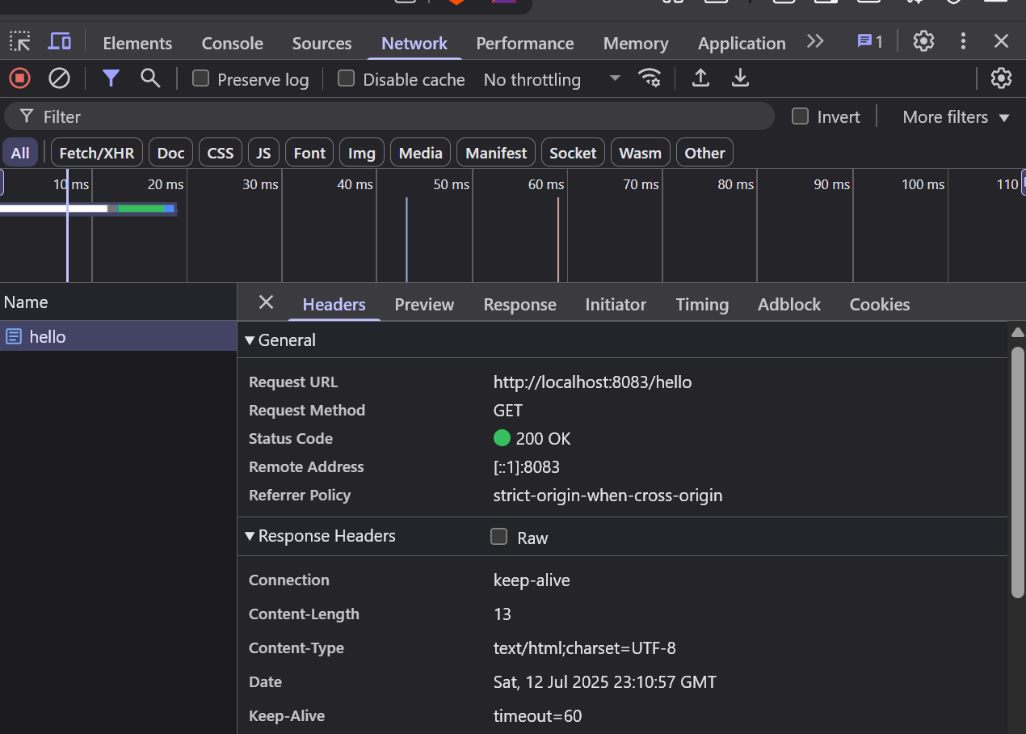

# 2. Headers Tab in Postman

