# Spring Boot Country Web Service - SME Explanation

## 1. What happens in the controller method?

In the controller method getCountryIndia():  
- The method is mapped to /country using @RequestMapping.  
- It loads the Country bean (with code "IN" and name "India") from the Spring XML configuration using ApplicationContext.  
- The method returns a Country object, which Spring Boot automatically converts into a JSON response using HttpMessageConverter.

## 2. How is the bean converted into JSON response?

- Spring Boot uses Jackson (a JSON library) internally.  
- When the Country object is returned from the controller, the MappingJackson2HttpMessageConverter converts it into JSON.  
- This works because the class is a standard Java bean and the controller is annotated with @RestController (which includes @ResponseBody).

## 3. In Network tab of browser Developer Tools, what HTTP headers are seen?

When accessing http://localhost:8083/country, the browser's Network tab typically shows:  
  
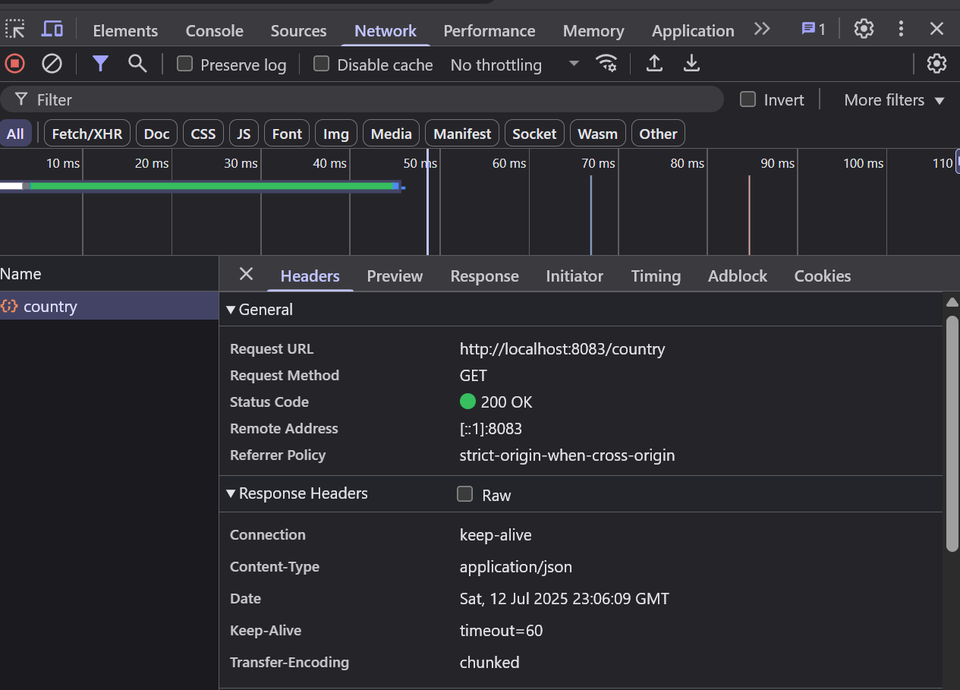  
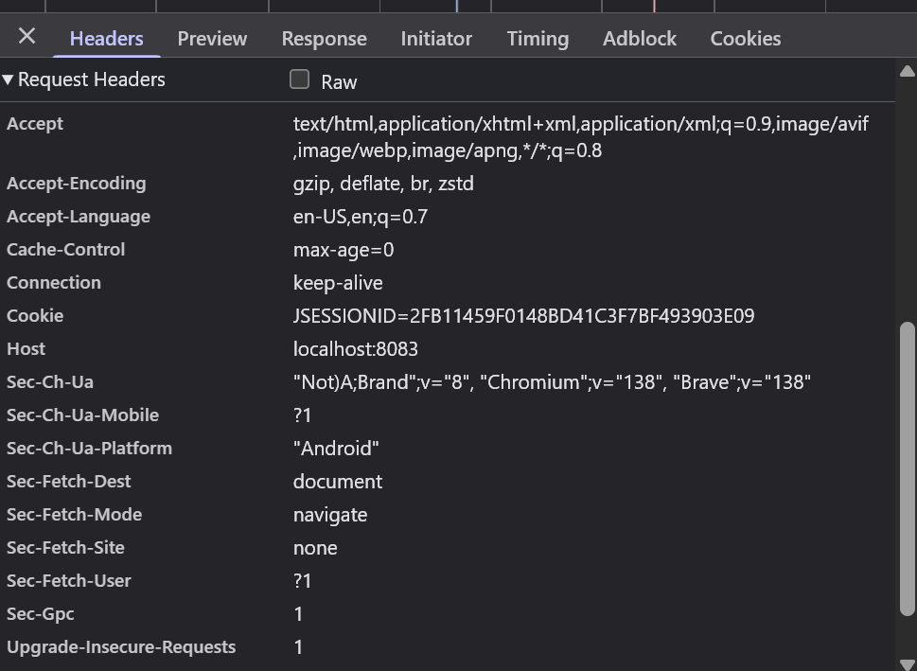

## 4. In Postman, what headers are shown under the "Headers" tab?

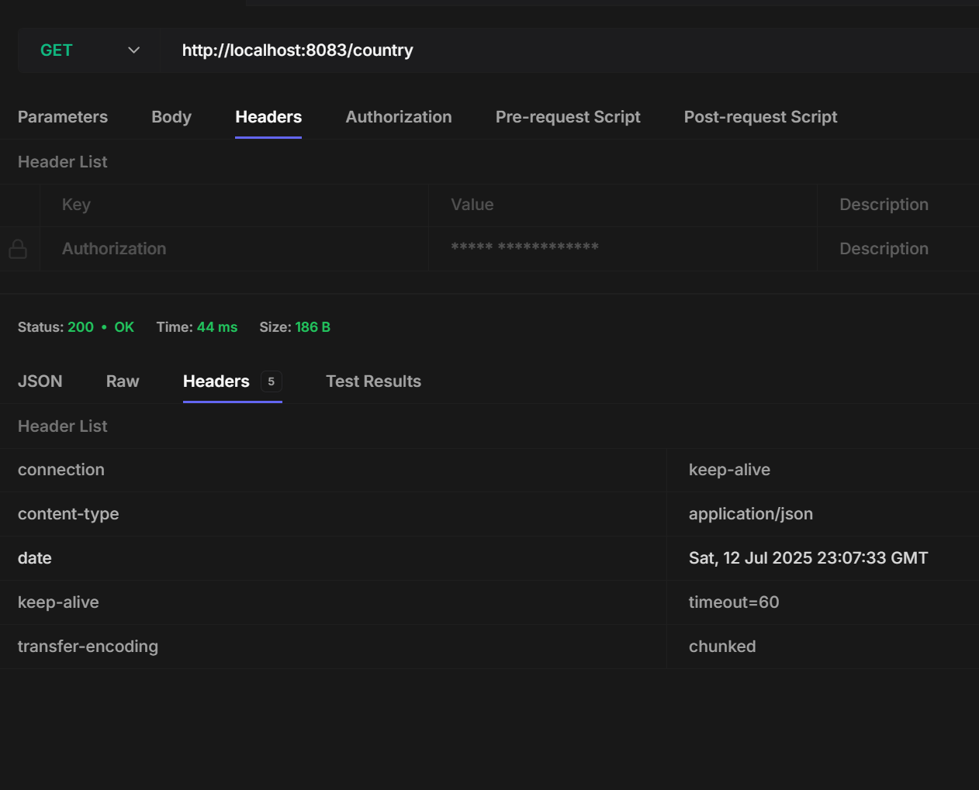When testing in Postman: