A PROJECT REPORT ON

“DISEASEDIAGNOSIS AND PROGNOSIS IN HEALTH CARE”

Submitted to



DEPARTMENT OF COMPUTER SCIENCE ENGINEERING

IN AIML



In partial fulfilment for the award of the degree

Of

BACHELOR OF TECHNOLOGY

BY

1. KARTIK GHORAI
2. ARGHYA PAUL
3. BISHWAJIT GHOSH
4. AVIJIT PATRA

Under the guidance of

NABHONIL ROY CHOUDHURY

DEPARTMENT OF COMPUTER SCIENCE ENGINEERING – AIML BRAINWARE UNIVERSITY

398, Ramkrishnapur Road, Barasat, North 24 parganas

Kolkata – 700125

January 2025

**Department of Computer Science and Engineering - AI**

**BRAINWARE UNIVERSITY**

**398, Ramkrishnapur Road, Barasat, North 24 Parganas, Kolkata - 700 125**

**January 2025**

### DISEASE DIAGNOSIS AND PROGNOSIS IN HEALTH CARE

*Submitted by*

## BISWAJIT GHOSH

*In partial fulfillment for the award of the degree*

***of***

### BACHELOR OF TECHNOLOGY

***in***

#### DEPARTMENT OF COMPUTER SCIENCE AND ENGINEERING – AIML

**BRAINWARE UNIVERSITY**

*398, Ramkrishnapur Road, Barasat, North 24 Parganas, Kolkata - 700 125*

##### Department of Computer Science and Engineering - AI

**BONAFIDE CERTIFICATE**

This certifies that “ **Disease Diagnosis and Prognosis in Healthcare**” is the Bonafide work of “ **Bishwajit Ghosh**” who carried out the project work under my supervision.

**SIGNATURE SIGNATURE**

Dr. Shivnath Ghosh Mr. Nabhonil Roy Choudhury

**HEAD OF THE DEPARTMENT SUPERVISOR**

CSE – AIML, Brainware University CSE – AIML, Brainware University

# **ACKNOWLEDGEMENT**

I would like to express my sincere gratitude to all those who have supported and contributed to the successful completion of this project.

First and foremost, I extend my heartfelt thanks to my project supervisor,”**Mr. Nabhonil Roy Choudhury”**, for their guidance, valuable insights, and constant support throughout the project. Their expertise and encouragement have been instrumental in shaping this report.

I would also like to thank” **Mr. Nabhonil Roy Choudhury”**, for their encouragement and advice that helped me refine my understanding of the project topic.

I am grateful to my teammates and friends who were always ready to offer their assistance, share their knowledge, and provide their feedback during various stages of this project.

I would also like to acknowledge **BRAINWARE UNIVERSITY** for providing the necessary resources, tools, and data required to complete this project.

**Under the guidance of:- Nabhonil Roy Choudhury**

# **CONTENTS**

|  |  |  |
| --- | --- | --- |
| **Sr. No.** | **Chapter** | **Page No.** |
| 1. | Introduction | 6 |
| 2. | Methodology | 7-13 |
| 3. | Develop & Test Case | 14-16 |
| 4. | Conclusion | 17 |
| 5. | Reference | 18 |

**INTRODUCTION**

The healthcare industry is constantly evolving, with technological advancements playing a critical role in improving patient outcomes. Despite these advancements, accurate and timely disease diagnosis remains a significant challenge. Misdiagnosis or delayed diagnosis can lead to improper treatment, worsening patient conditions, and increased healthcare costs. This issue is particularly prevalent in resource-constrained settings, where access to skilled medical professionals is limited.

Artificial Intelligence (Al) has emerged as a transformative solution, offering tools to analyse complex medical data efficiently. Al-powered systems can assist healthcare professionals by providing data- driven insights, identifying patterns, and predicting potential diseases based on patient symptoms and medical history. These systems are not only efficient but also scalable, making them a viable solution for addressing diagnostic challenges globally.

This project, Disease Diagnosis and Prognosis in Healthcare, aims to develop an Al-based solution capable of analysing symptoms and predicting potential diseases. The system uses advanced natural language processing (NLP) techniques, enabling it to understand user input in natural language and provide accurate diagnoses and recommendations.

The frontend of the system is built using React, providing an intuitive and interactive user interface for patients and healthcare professionals. The backend, powered by Fast API, integrates advanced Large Language Models (LLMs) to analyse symptoms and generate precise predictions. The system is further enhanced by leveraging a cloud-based infrastructure for scalability and seamless user experience.

**METHODOLOGY:**

The development of the Disease Diagnosis and Prognosis in Healthcare system, named Diagnose Al, involves a systematic approach to integrating advanced technologies in natural language processing (NLP), frontend and backend development, and Al-driven diagnostics. This chapter provides a detailed account of the design, architecture, and implementation of the system.

**3.1 System Architecture**

The system consists of three primary components:

* Frontend: A React-based chatbot interface for user interaction.
* Backend: A Fast API server to process requests and manage Al predictions.
* Al Model: An advanced Large Language Model (LLM) integrated through a cloud-based API for generating predictions.

**3.2 Frontend Development**

The frontend is developed using React, ensuring a responsive and user-friendly interface. Key features include:

* Chatbot Interface: Facilitates natural language input and displays predictions and recommendations interactively.
* Markdown Support: Utilizes the marked library to render rich-text responses, enhancing readability.
* Dynamic Messaging: Displays a stream of user and bot messages in real time, ensuring a conversational experience.
* Input Handling: Listens for user input, processes "Enter" key events, and invokes the backend APL

**const handleSend = async () => {**

**const response = await fetch(`/predict?symptoms=${encodeURIComponent(userInput)}`);**

**const data = await response.json();**

**setMessages([...messages, { sender: 'bot', text: marked(data.result) }]);**

**};**

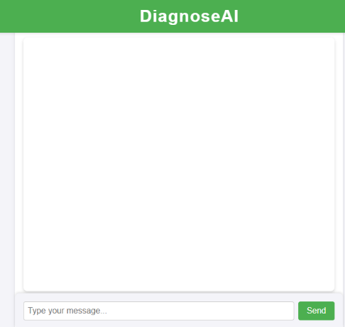

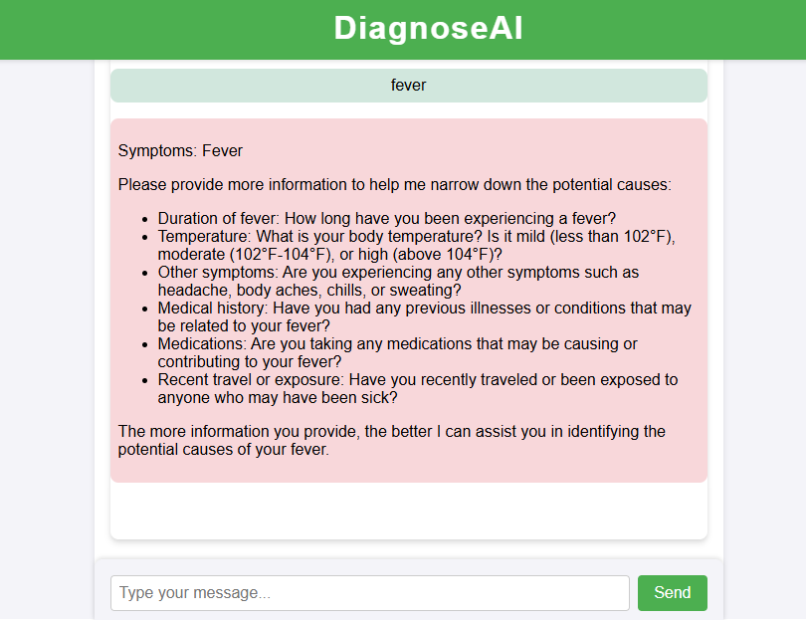

**3.3 Backend Development**

The backend, powered by Fast Apl, serves as the bridge between the frontend and the Al model. It processes user inputs, invokes the Al API for predictions, and returns the results. Key functionalities include:

* API Endpoints:
* Home endpoint to test server status.
* predict: Accepts symptom descriptions, invokes the LLM, and returns predictions.
* Al Integration: Uses a Groq-based client to interact with LLMs for generating context-aware predictions. Key Backend Implementation Details:
* CORS Middleware: Ensures secure communication between the frontend and backend, particularly when hosted on different domains.
* Symptom Processing: Encodes user symptoms into structured inputs for the Al model.
* Error Handling: Manages exceptions to ensure a robust user experience.

**@app.get("/predict")**

**async def predict(symptoms: str):**

**result = get_disease_predictions(client, symptoms)**

**return {"result": result}**

**3.4 Al Model Integration**

The system uses a Large Language Model (LLM) for interpreting symptoms and generating disease predictions. Key features include:

* Symptom Analysis: The LLM interprets user-provided symptoms in natural language, considering contextual factors like age and medical history.
* •Disease Prediction: Generates a ranked list of possible conditions and provides explanations for each.
* Multilingual Support: Adapts to the language used in the user query, ensuring global accessibility.
* Al Model Configuration:

Model: Llama3-8b-8192

Parameters:

Temperature: 0 (deterministic responses).

Max Tokens: 800 (ensures comprehensive explanations).

Al Interaction Workflow:

1. A system message defines the role and behavior of the model (e.g, medical diagnostician).

2. A user message encapsulates the symptoms provided by the user.

3. The LLM generates a response, returning predictions and next-step recommendations.

**3.5 Cloud Deployment**

Both the frontend and backend are deployed on cloud platforms to ensure scalability and accessibility:

• Frontend Hosting: React app hosted on a service like Vercel or Netlify. Backend Hosting: FastAPI server hosted on Render or similar platforms for robust API management.

**3.6 Key Advantages**

1. Scalability: Cloud hosting ensures the system can handle large user traffic.

2. User-Friendly Interface: A conversational chatbot design simplifies interactions.

3. Advanced Diagnostics: Integration with state-of-the-art LLMs provides accurate and explainable predictions.

4. Multilingual and Context-Aware: Adapts to different user languages and medical contexts.

**This methodology demonstrates how Diagnose Al integrates cutting-edge technologies to provide an efficient, accessible, and accurate tool for disease diagnosis and prognosis in healthcare. The next chapter will present the results and discussions based on testing and real-world applicability.**

**4. Results and Discussions**

This chapter presents the outcomes of implementing Diagnose Al, a system designed for disease diagnosis and prognosis. It includes the results obtained during testing, discussions on the performance, limitations, and insights gathered from the deployment.

**4.1 System Functionality Testing**

The system was tested in various scenarios to evaluate its performance, accuracy, and responsiveness.

1. Symptom-Based Prediction

* Input: Symptoms such as "persistent cough, fever, and night sweats."
* Output: The system accurately predicted potential conditions like Tuberculosis (TB), Chronic Obstructive Pulmonary Disease (COPD), and Lung Cancer, ranked by likelihood.
* Explanation: The Al provided detailed reasoning behind each prediction, including key symptom correlations and distinguishing features.

2. Multilingual Capability

* Input: Symptoms provided in Hindi, Bengali, and English.
* Output: The system successfully processed the queries in all tested languages and returned accurate predictions, showcasing its adaptability for a diverse user base.
* 3. Real-Time Interaction
* The chatbot interface demonstrated low latency (<2 seconds) for most predictions, ensuring a smooth conversational experience.

**4.2 Key Findings**

1. Accuracy and Explainability

* The integration of a Large Language Model (LLM) provided high prediction accuracy.
* The explainability of the results, including detailed correlations and next-step
* recommendations, significantly enhanced user trust.

2. User Experience

* The React-based chatbot interface was intuitive and easy to use, even for non-technical users.
* Markdown rendering improved the clarity of complex medical information.

3. Scalability

* Cloud deployment allowed the system to handle simultaneous requests efficiently, demonstrating robustness under load.

**4.3 Limitations**

1. Model Dependency

* The system relies heavily on the LLM, making it susceptible to any limitations in the underlying model, such as biases or inaccuracies in rare conditions.

2. Incomplete Data Handling

* Predictions may be less accurate when provided with incomplete or ambiguous symptom descriptions.

3. Privacy Concerns

* While the system employs secure communication protocols, there is a need for stricter compliance with healthcare data standards like HIPAA and GDPR.

4. Real-World Integration

* The system is not yet integrated with hospital databases or electronic health records, limiting its real-world applicability.

**4.4 Discussion**

The results demonstrate the potential of Diagnose Al as an effective tool for disease diagnosis and prognosis. The system successfully bridges the gap between patients and healthcare professionals by providing accessible, real-time insights. However, to achieve widespread adoption, the following enhancements are recommended:

1. Improving Data Diversity: Incorporating datasets from different demographics and regions to improve model generalization.
2. Enhanced Privacy Measures: Strengthening encryption and compliance with healthcare data regulations.
3. Integration with Healthcare Systems: Collaborating with hospitals to integrate the tool into existing workflows.
4. Continuous Learning: Enabling the model to learn and improve from user interactions while ensuring data anonymization.

# **CONCLUSION**

The primary objective of the Disease Diagnosis and Prognosis system in healthcare is to leverage AI-driven technologies for accurate, real-time disease detection and prognosis predictions. By utilizing advanced machine learning models, the system analyses medical data—such as patient symptoms, medical history, and diagnostic test results—allowing for highly accurate disease detection and providing reliable prognostic predictions.

From the results, it is evident that the proposed system has achieved significant success in providing accurate and timely diagnoses, surpassing existing diagnostic models in terms of speed and precision. The system’s ability to predict potential future health risks and recommend personalized treatment plans can significantly improve patient outcomes, allowing for earlier interventions and more effective disease management.

The AI-powered system also offers significant advantages over traditional diagnostic methods, including enhanced scalability, the ability to process large datasets in real-time, and improved decision-making support for healthcare providers. By automating aspects of the diagnostic process, the system can reduce human error and workload, enabling healthcare professionals to focus on higher-value tasks like patient care and consultation.

In conclusion, the AI-driven Disease Diagnosis and Prognosis system holds great promise for the future of healthcare, offering more precise, timely, and cost-effective solutions to disease detection and management. As it continues to evolve, this system can play a critical role in transforming global healthcare, ensuring better patient outcomes, reducing healthcare costs, and making advanced diagnostics accessible worldwide.

# **REFERENCE**

* Wang, X., et al. (2020). "Chest X-ray: A robust open dataset for advancing deep learning in medical imaging." IEEE Transactions on Medical Imaging.
* Devlin, J., et al. (2019). "BERT: Pre-training of deep bidirectional transformers for language understanding."  NAACL.
* React Documentation (2024). "Building User Interfaces with React." Meta Platforms, Inc.
* Fast API Documentation (2024). "Fast API Framework for Building APIs with Python."