RMarkdown Demo

Avi Kluger

September 3, 2019

##Method ###Participants

A total of 773 answered the listening survey, *M*age = 33.2 (11.1), 59.3% females.

###Results

For descritive statistics, see Table 1.

Table 1. Descriptive statistics for listening-related scales

|  |  |  |  |  |
| --- | --- | --- | --- | --- |
|  | mean | sd | skew | kurtosis |
| Empathy | 5.88 | 1.95 | -0.24 | -0.21 |
| PAIR | 5.79 | 2.14 | -0.29 | -0.44 |
| support | 6.33 | 2.32 | -0.55 | -0.33 |
| SWL | 4.54 | 1.41 | -0.48 | -0.55 |

Surprisingly, we did not find the interaction we did not hypothesized. As can be seen in Figure 1.

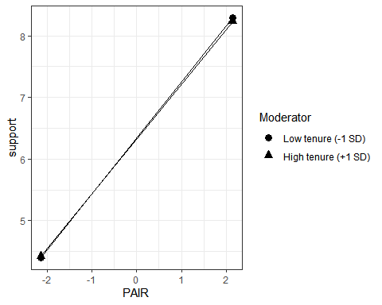

*Figure 1.* The effect of learning **too much R in one week** on the well-being of novices by tenure in using SPSS or Stata