**Analysis And Findings**

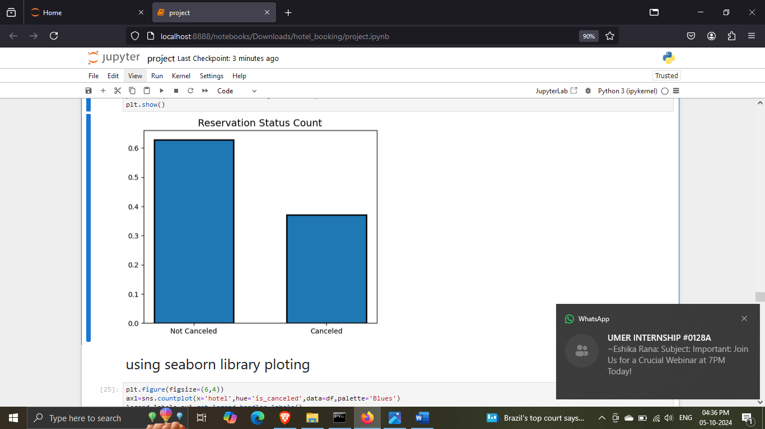

The accompanying bar graph shows the percentage of reservations that are cancelled and those that are not .it is obvious that there are still a significant number of reservations that have not been cancelled. There are still 37% of clients who cancelled their reservation, which has a significant impact on the hotels earning.

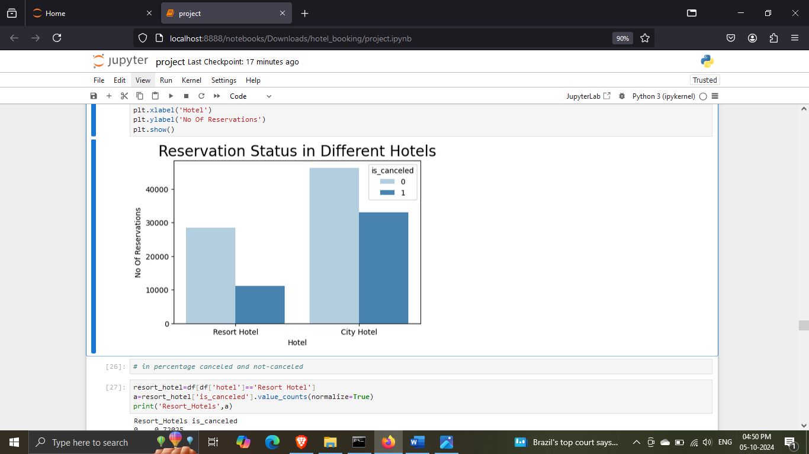

In comparison to resort hotels, city hotels have more booking. it’s possible that report hostels are more expensive than those in cities.

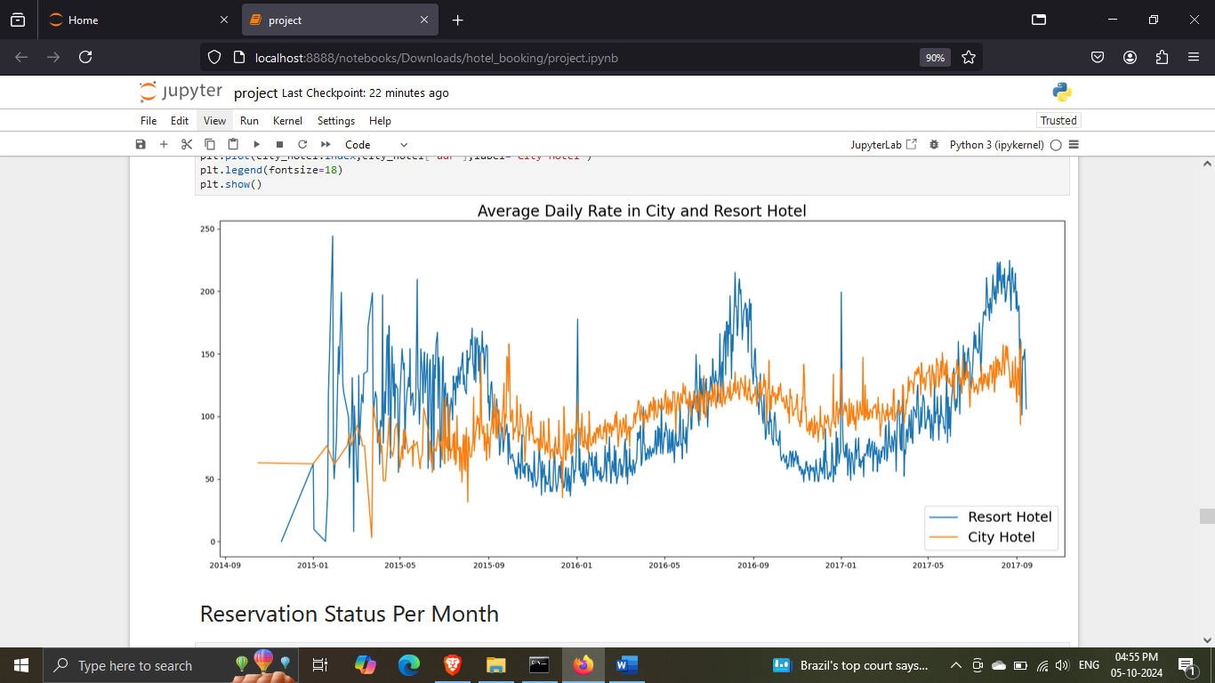

The line graph above shows that, on certain days, the average daily rare for a city hotel is less than that of resort hotel. And on other days, it is even less. It goes without saying that weekends and holiday may see a rise in resort hotel rates.

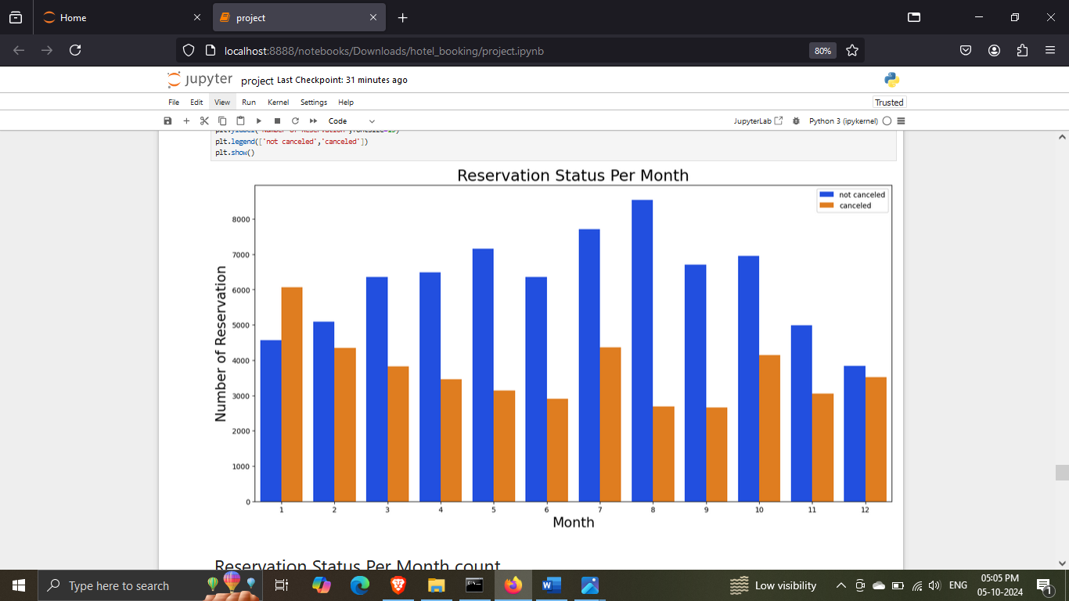

We have developed the grouped bar graph to analyse the month with highest and lowest reservation levels according to reservation status. As can seen both the numbers of confirmed reservations and the number of cancelled reservations is largest in the mouth of August. Whereas January is the mount with the most cancelled reservation.

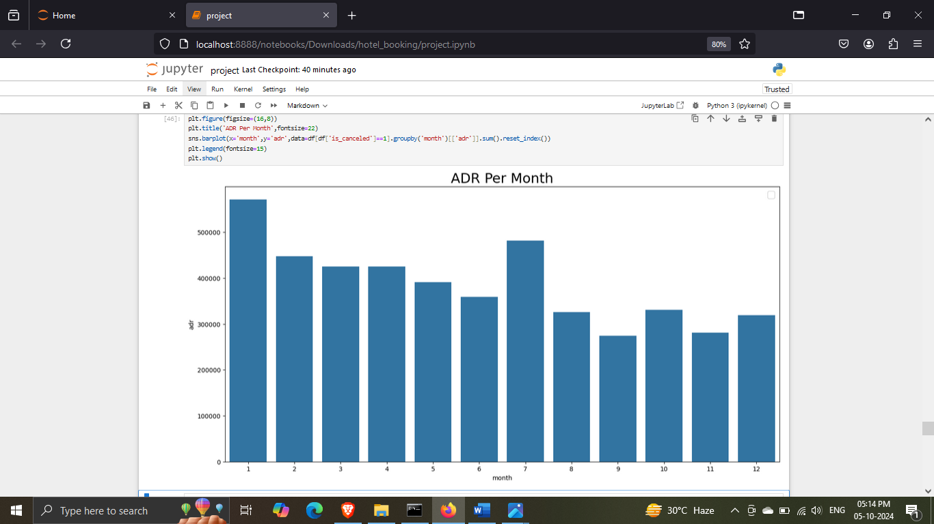

This bar graph demonstrates that cancellation is must common when price is greatest and are least common when they are lowest. Therefore, the cost of the accommodation is solely responsible for the cancellation.

Now, let’s see which country has highest reservation cancelled. The top country is Portugal with the highest number of cancellations.

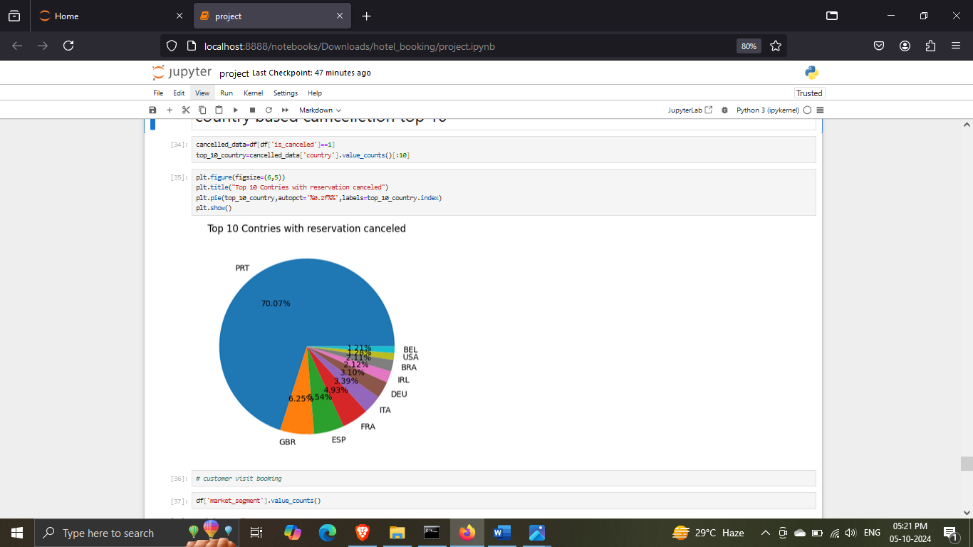

Let’s check the area from where guests are visiting the hotels a making reservation. Is it coming from Direct or Groups, Online or Offline travel Agents? Around 46% of the clients come from online travels agencies. Whereas 27% come from groups. Only 4% of clients book hotels directly by visiting them and making reservations.

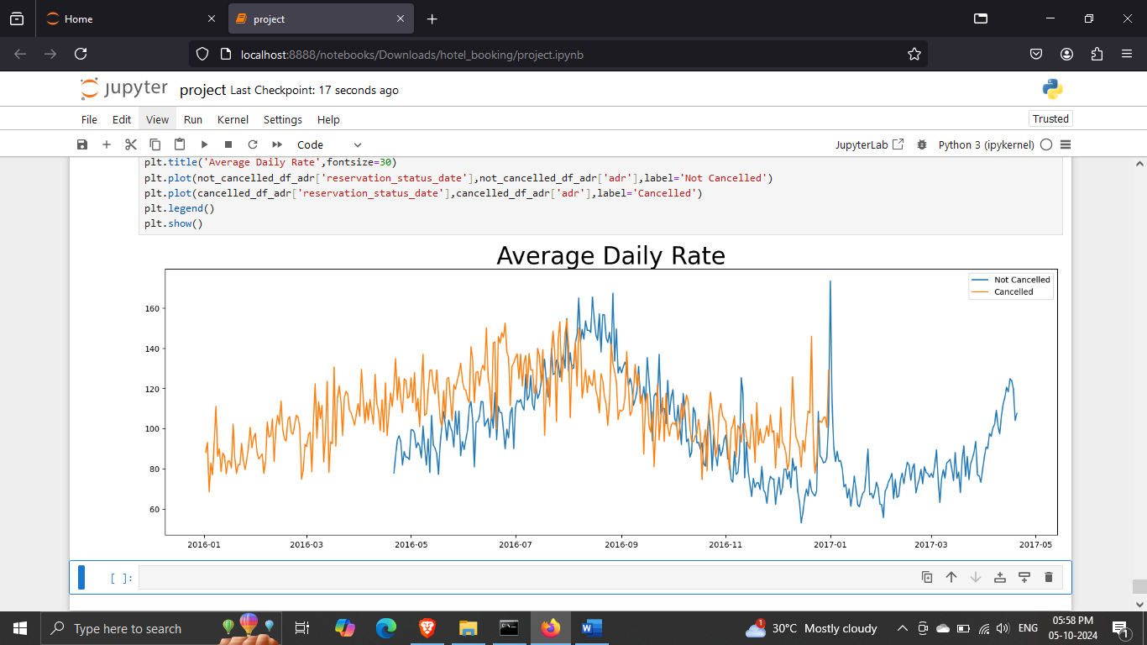

As seen in the graph, reservations are cancelled when the average daily rate is higher than when it is not cancelled. It clearly proves all the above analysis that the higher price leads to higher cancelations.

**Suggestions**

1. Cancellation rates rise as the does. In order to prevent cancellations of reservations, hotels could work on their pricing strategies and try to lower the rates for specific hotels based on locations. They can also provide some discounts to the consumers.
2. As the ratio of the cancellations and not cancellation of the resort hotel is higher in the city hotels. So, the hotels should provide a reasonable discount on the room prices on weekends or on holidays.
3. In the month of January, hotels can start campaigns or marketing with a reasonable amount to increase their revenue as cancellation is the highest in this month.
4. They can also increase the quality of their hotels and services mainly in Portugal to reduce the cancellation rate.