23/06/206
Tables: 1. Employee 2. Department

Questions:
1. Top 5 highest salary employees
2. Department wise employee count
3. Find Second highest salary
4. Employees whose salary > department average salary
5. Inner Join
6. Left Join
7. Group By with Having
8. Employees hired in last 6 months
9. Find the Duplicates records
10. How to remove the duplicates record

Submission: SQL file Output screenshots GitHub upload

-- create database if not exists tsdb;
use tsdb;

CREATE TABLE Department (
Dept_ID INT PRIMARY KEY,
Dept_Name VARCHAR(50)
);
INSERT INTO Department VALUES
(101, 'HR'),
(102, 'IT'),
(103, 'Finance'),
(104, 'Sales'),
(105, 'Marketing');

CREATE TABLE Employee (
Emp_ID INT PRIMARY KEY,
Emp_Name VARCHAR(50),
Salary DECIMAL(10,2),
Hire_Date DATE,
City VARCHAR(50),
Dept_ID INT,
FOREIGN KEY (Dept_ID) REFERENCES Department(Dept_ID)
);

INSERT INTO Employee VALUES
(1,'Amit Sharma',55000,'2025-01-10','Pune',101),
(2,'Priya Patil',65000,'2025-02-15','Mumbai',102),
(3,'Rahul Verma',70000,'2024-12-20','Nagpur',103),
(4,'Sneha Joshi',80000,'2025-03-05','Pune',104),
(5,'Vikas Singh',75000,'2024-11-11','Nashik',105),
(6,'Neha Gupta',90000,'2025-04-01','Mumbai',102),
(7,'Rohit Kulkarni',62000,'2025-05-10','Aurangabad',101),
(8,'Pooja Deshmukh',58000,'2025-01-25','Nagpur',103),
(9,'Karan Yadav',95000,'2024-10-15','Pune',104),
(10,'Anjali Mehta',72000,'2025-02-28','Nashik',105),
(11,'Deepak Jadhav',68000,'2025-03-18','Mumbai',102),
(12,'Meena Pawar',81000,'2025-04-20','Kolhapur',103),
(13,'Suresh Chavan',87000,'2024-12-05','Satara',104),
(14,'Kavita More',60000,'2025-05-22','Pune',101),
(15,'Arjun Thakur',78000,'2025-06-01','Solapur',105);

-- 1. Top 5 highest salary employees
select emp_id,emp_name,salary
from employee
order by salary desc
limit 5;
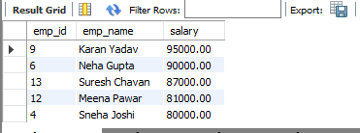

-- 2. Department wise employee count
select d.dept_name,count(e.dept_id) emp_counts
from employee e join department d
on e.dept_id = d.dept_id
group by dept_name;

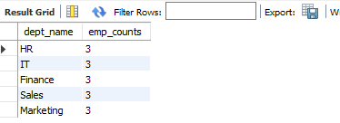

-- 3. Find Second highest salary
select max(salary) as 2nd_highest_salary from employee
where salary < (select max(salary) from employee);

select salary as 2nd_highest_salary from employee
order by salary desc
limit 1 offset 1;

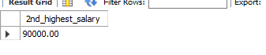

-- 4. Employees whose salary > department average salary
select emp_name,salary from employee e
where salary > (select avg(salary) from employee
where dept_id = e.dept_id);

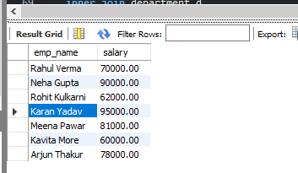

-- 5. Inner Join
select * from employee e
inner join department d
on e.dept_id = d.dept_id;

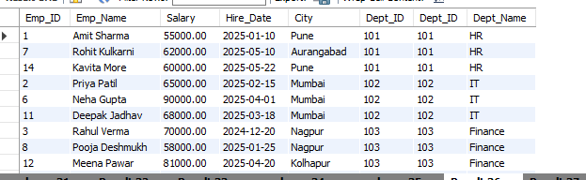

-- 6. Left Join
select * from employee e
left join department d
on e.dept_id = d.dept_id;

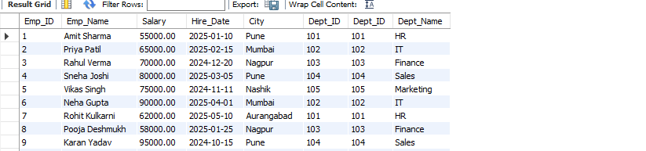

-- 7. Group By with Having
select d.dept_name,count(e.dept_id) emp_count from employee e
left join department d
on e.dept_id = d.dept_id
group by d.dept_name
having emp_count > 2;

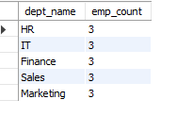

-- 8. Employees hired in last 6 months
Select emp_name,hire_date from employee
where hire_date >= date_sub(curdate(),interval 6 month);

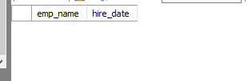

INSERT INTO Employee VALUES
(16,'Amit Sharma',55000,'2025-01-10','Pune',101),
(17,'Priya Patil',65000,'2025-02-15','Mumbai',102);

-- 9. Find the Duplicates records
SELECT Emp_Name,Salary,Hire_Date,Dept_ID,COUNT(*) AS Duplicate_Count
FROM Employee
GROUP BY Emp_Name, Salary, Hire_Date, Dept_ID
HAVING COUNT(*) > 1;

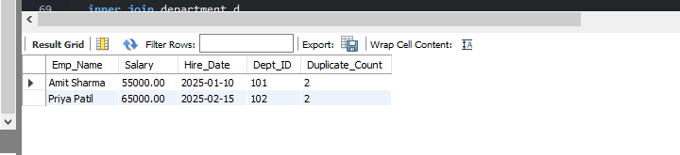

-- 10. How to remove the duplicates record
SET SQL_SAFE_UPDATES = 0;

DELETE e1 FROM Employee e1
INNER JOIN Employee e2
ON e1.Emp_Name = e2.Emp_Name
AND e1.Salary = e2.Salary
AND e1.Hire_Date = e2.Hire_Date
AND e1.Dept_ID = e2.Dept_ID
AND e1.Emp_ID > e2.Emp_ID;

24/06/2026
-- 1. Add some data in the existing table

insert into employee
(emp_id,emp_name,salary,hire_date,city,dept_id)
values
(17,'Karan Javle',55000,'2026-10-02','Aurangabad',103),
(18,'Rahul Varma',70000,'2024-12-30','Nagpur',103),
(19,'Rohan Jadhav',60000,'2025-08-10','Nashik',105);

insert into employee
value
(16,'Saksham Patil',75000,'2026-02-22','Mumbai',102);

-- 2. Handle Window function
select emp_id,emp_name,salary,
row_number() over(partition by dept_id order by emp_id) as row_no
from employee;

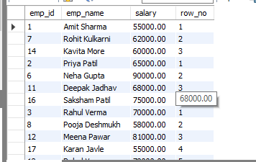

select emp_id,emp_name,salary,
RANK() over (order by salary desc) as emp_rank
from employee ;

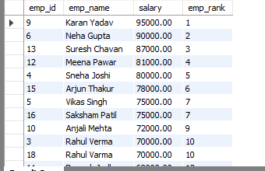

select emp_id,emp_name,salary,
dense_rank() over (order by salary desc) as emp_rank_DENSE
from employee ;

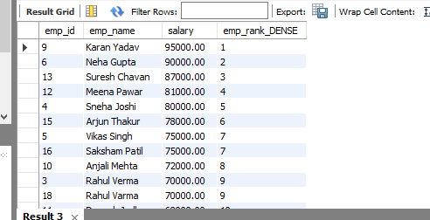

select emp_id,emp_name,salary,
lag(hire_date) over (order by Hire_date) as emp_lag
from employee ;

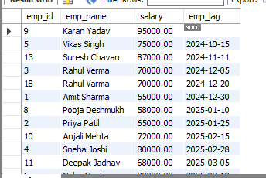

select emp_id,emp_name,salary,
lead(hire_date) over (order by Hire_date) as emp_lead
from employee ;

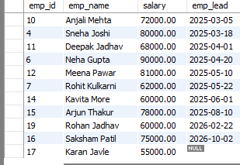

-- 3. Handle Case When
select emp_id,emp_name,salary,
case
when salary >= 90000 then 'High'
when salary between 70000 and 90000 then 'Medium'
when salary between 40000 and 70000 then 'Average'
else 'Low'
end as salary_category
from employee;

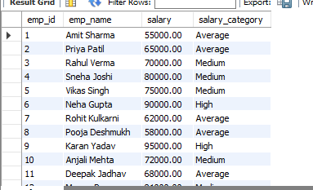

-- 4. Views
create view punes_emp as
Select Emp_id,Emp_name,Salary,city
from employee
where city ='PUNE';

select * from punes_emp ;

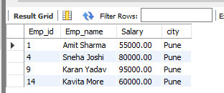

create view emp_pune_mumbai as
select emp_id,emp_name,salary,city
from employee
where salary between 60000 and 80000 and city in ('Pune','Mumbai');

select * from emp_pune_mumbai;

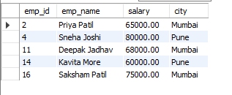

--5 Trigger

select *from employee;

delimiter //
create trigger after_add_data
before insert
on employee
for each row
begin
set new.salary_hike = new.salary * 0.2;
end //
delimiter ;

alter table employee add column salary_hike int;
alter table employee modify column salary_hike int default 0;

INSERT INTO Employee
(Emp_ID, Emp_Name, Salary, Hire_Date, City, Dept_ID)
VALUES
(20,'Chirag Rao',37000,'2026-08-18','Jalna',102);

show triggers;

update employee set salary = 48000 where emp_id = 18;

select *from employee;

-- update trigger
delimiter //
create trigger before_update_data
before update
on employee for each row
begin
set new.salary_hike = new.salary * 0.2;
end //
delimiter ;

