App – root or top level component
Message – child

When our application starts React takes the component tree and builds and JS datastructure called the Virtual DOM. It is different from the DOM in our browser, it is a lightweight in memory representation of our component tree.

Each node represents its components and its properties

When the state or data of a component changes React updates the corresponding node in the virtual DOM to reflect the new state and it compares the new version of the DOM to the older version to identify the nodes that need to be updated and then updated those nodes in the actual DOM.

Technically the DOM update in not done by React itself, it is done by a companion library called REACT DOM.
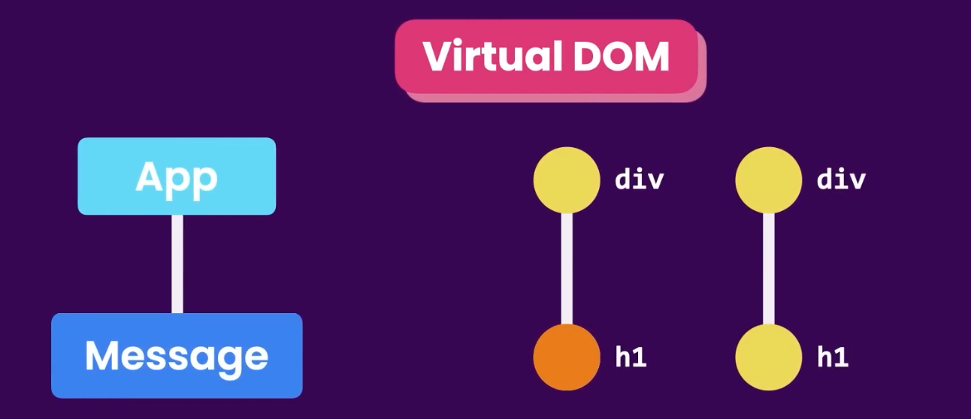

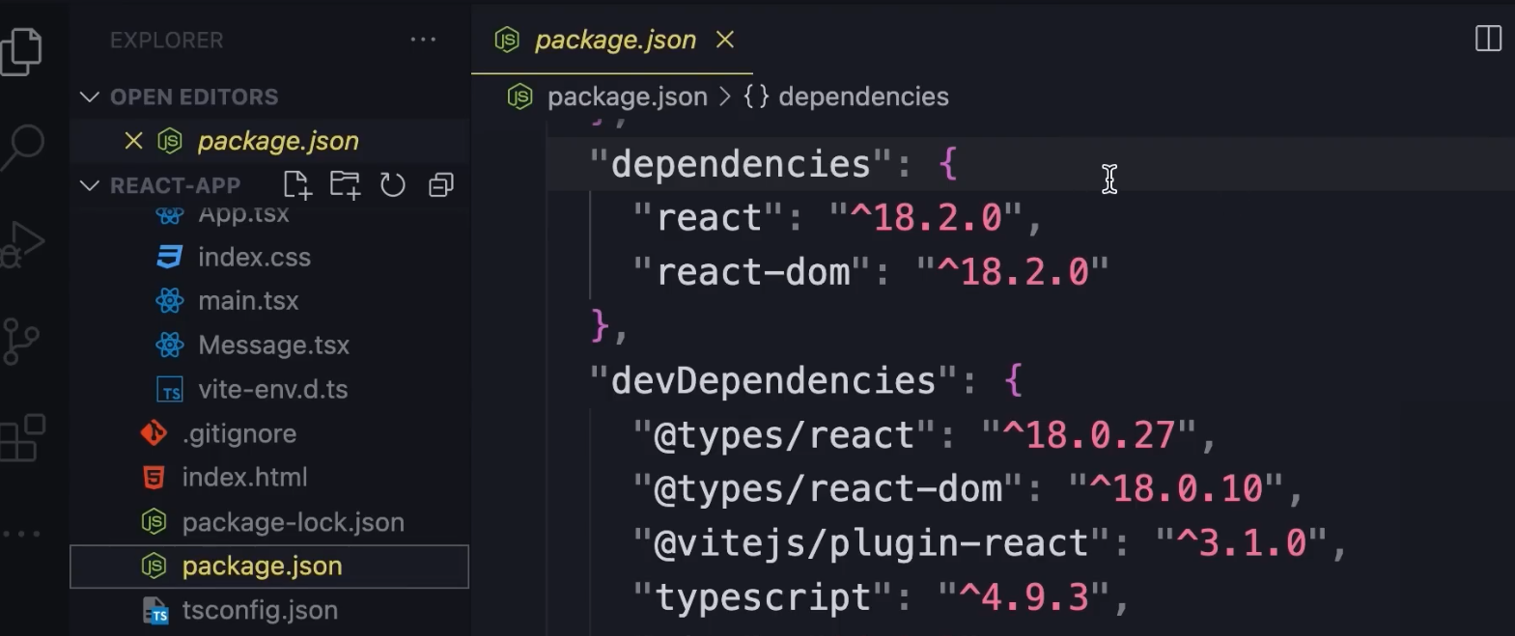

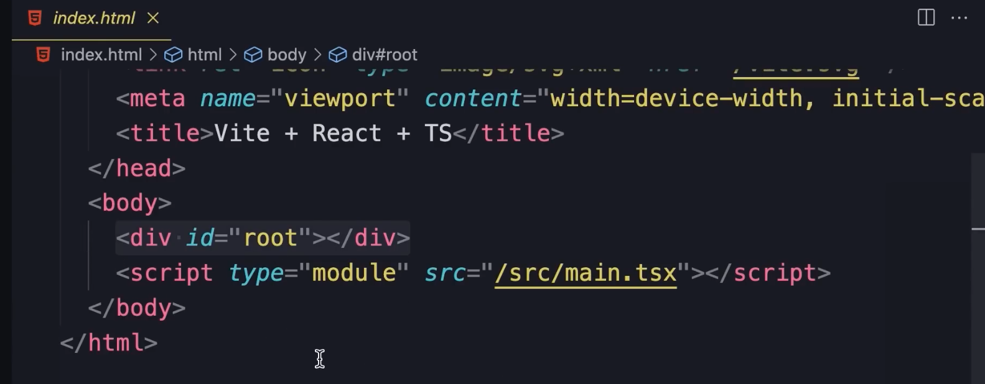
root is the container of the application. Click on main.tsx

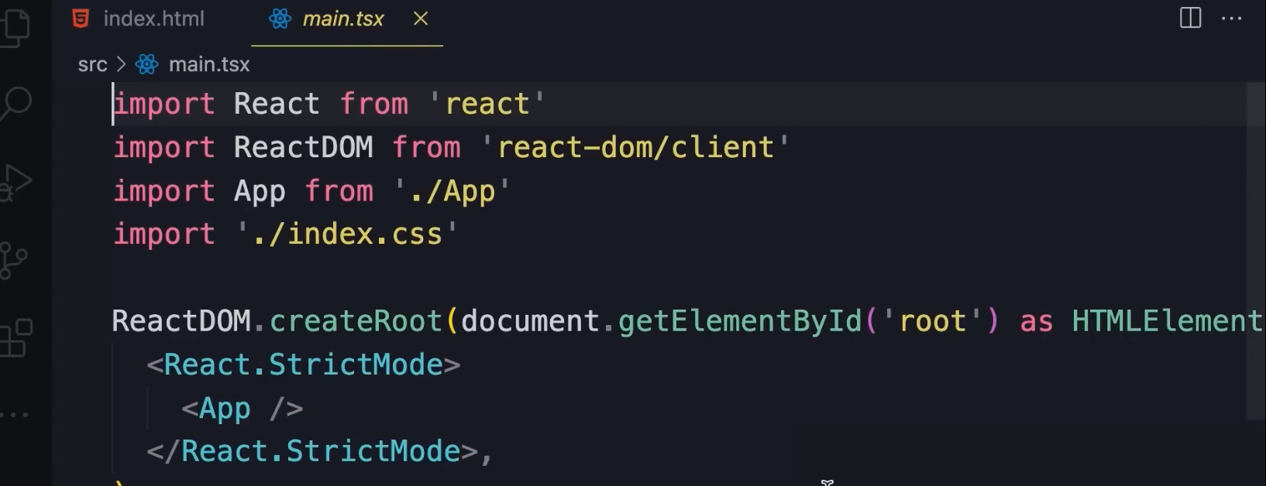
We are using ReactDOM to render the “React.Stri.....” component tree inside the element of id root.

The App component is wrapped by another component called StrictMode whose purpose is to identify potential problems.

We will display the component tree inside the element with id ‘root’, to do that we are using the ReactDOM library.

----------

We can also render the component tree in a mobile app using a different library called ‘React Native’

React itself is not tied to a particular platform like web or mobile. It is platform agnostic and can be used to develop apps for web, mobile or desktop devices.

-----------------------------------------------------------------

React is a javascript library for creating user interfaces.



React can only create dynamic and interactive user interfaces. We often need additional tools for the following concerns.
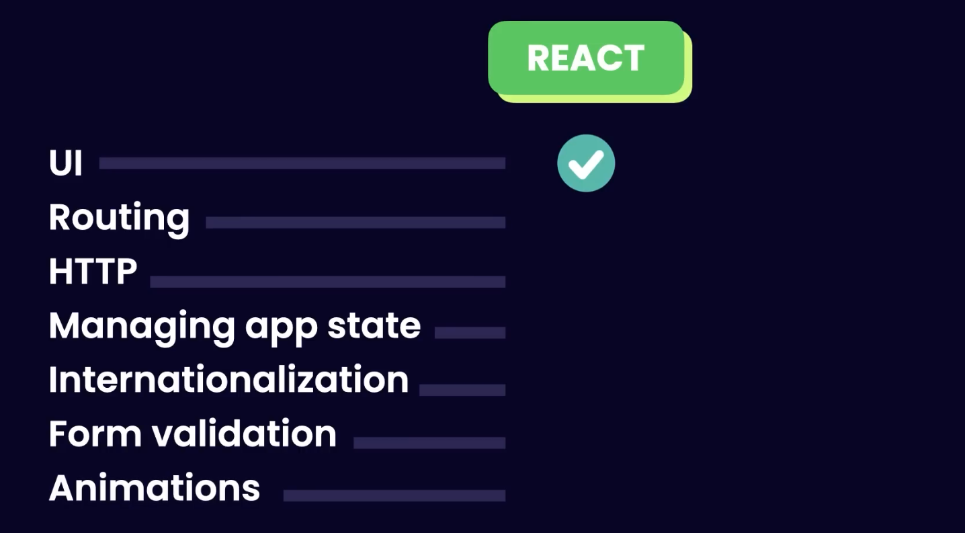

We can use any tool for the above concerns.



- Fragments

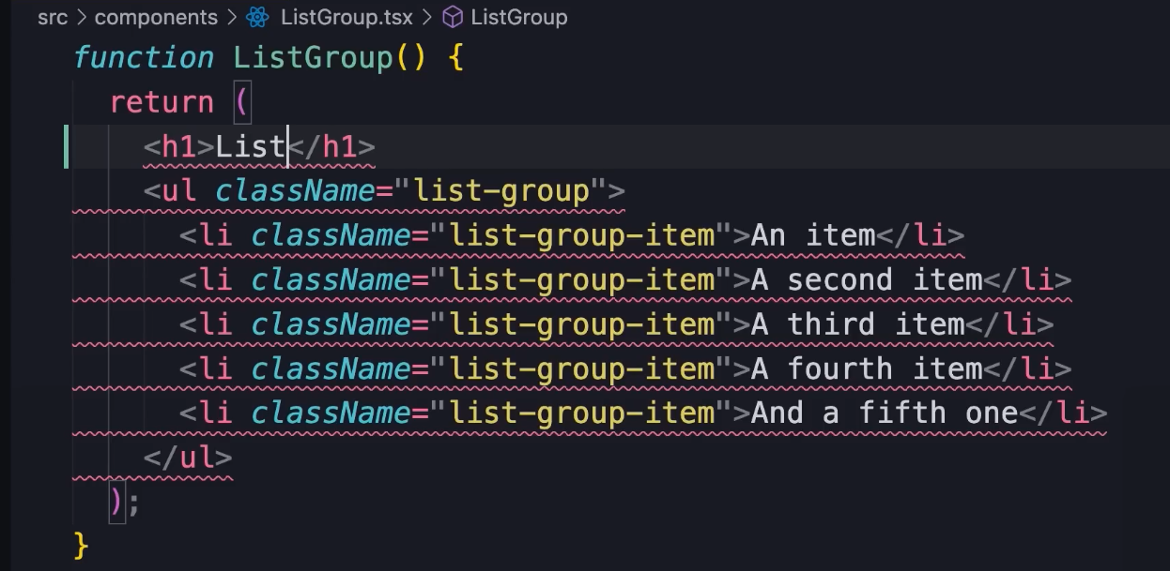
Adding another element leads to errors, because in React a component cannot return more than one element.

The h1 element above will be compiled to JS
The same thing will happen with the next element which leads to multiple elements and is not allowed in React.

Solution – Wrap the entire expression inside a div or another element. It is unnecessary to add another eleement to make it work. Instead we can use a fragment.

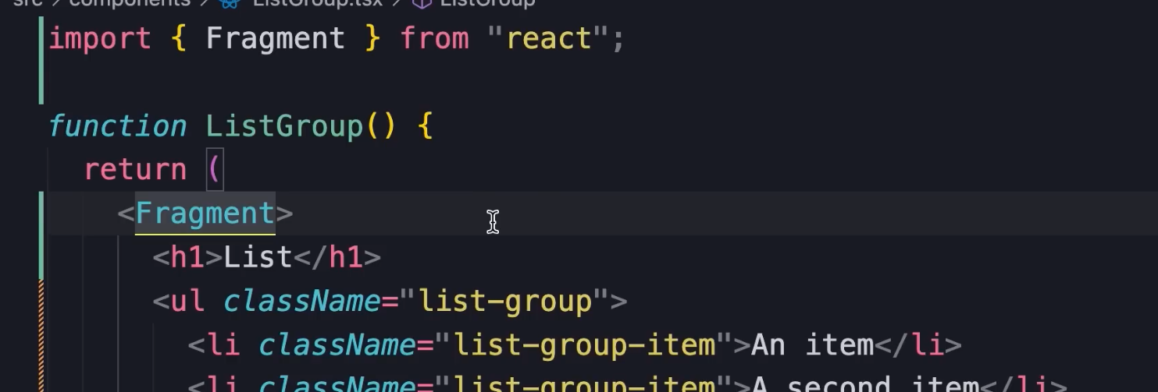
We dont need an additional element.

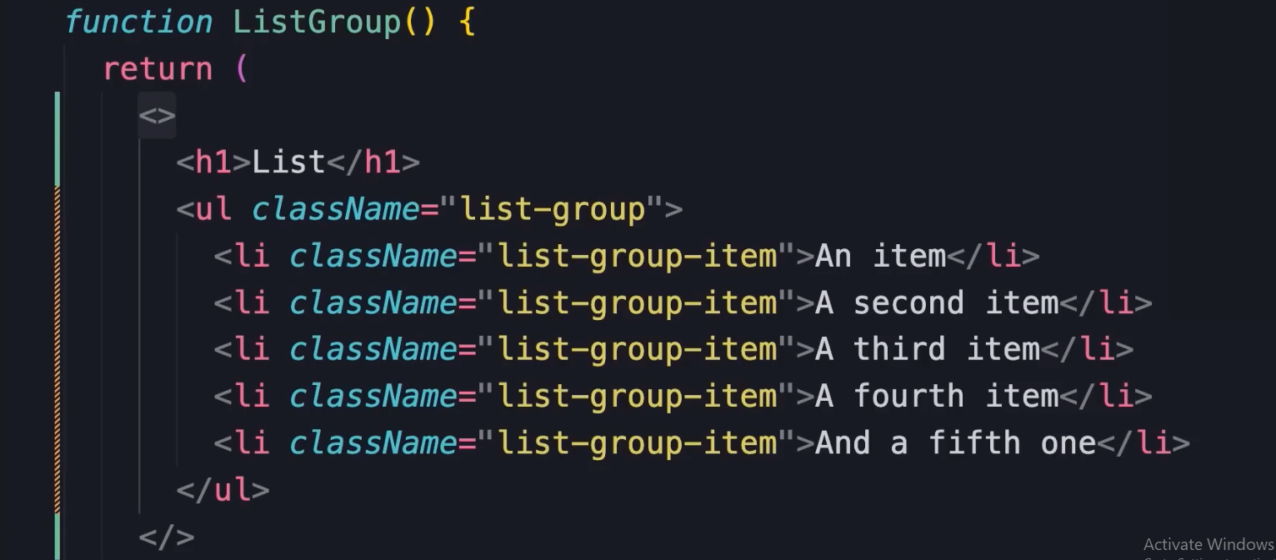

Adding empty angle brackets tells react to use Fragments without importing

-----------------------------------------------------------------

Rendering lists
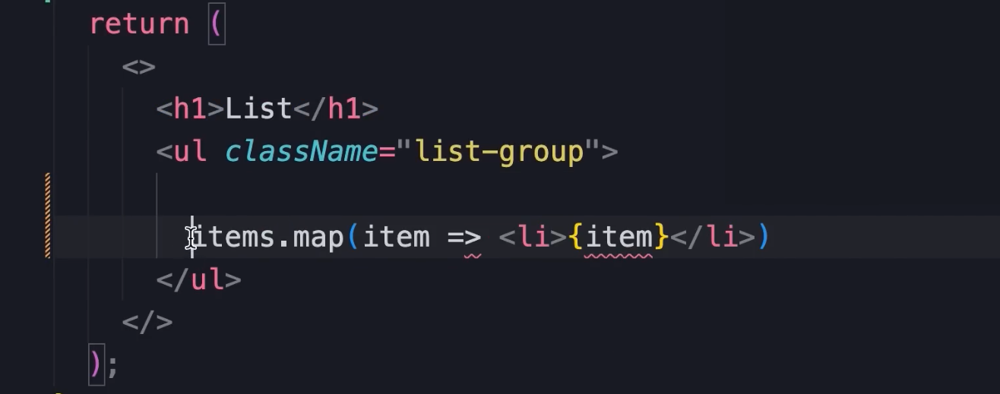
The above will result in a compilation error because expressions are not allowed in the middle of a jsx markup, we can only use html elements or other react components.

To render data dynamically we need to wrap the data in braces.

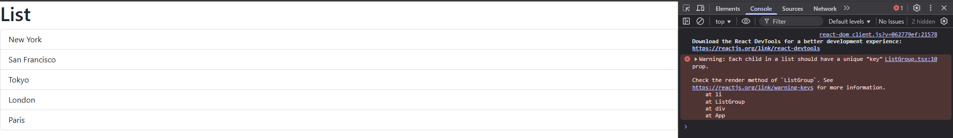
The warning each item should have a key prop or key property which identifies that item. React needs this to keep track of our item and/or to remove items dynamically, react knows what part of the page should be upadated.

In the above case each item is unique string so we will use it as the key.

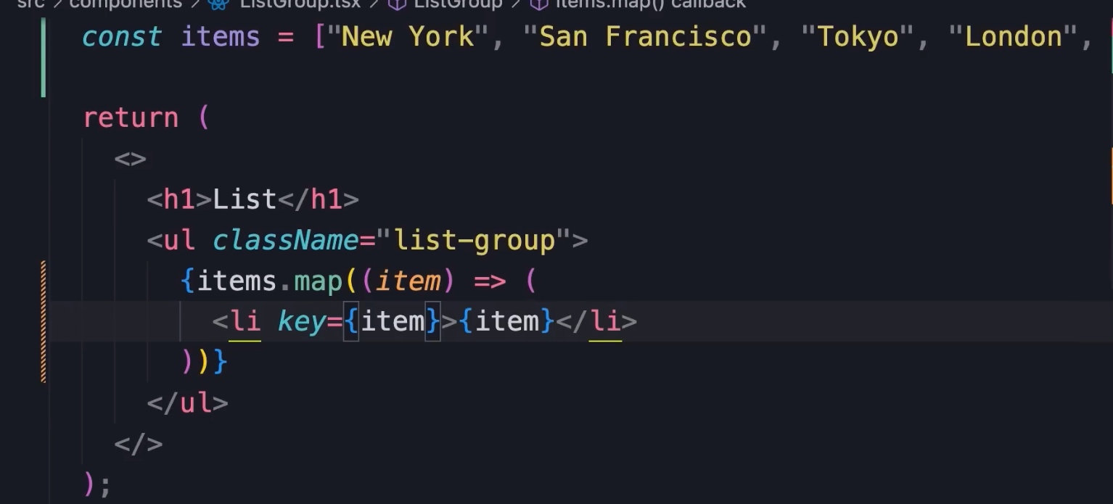
------------------------------------------------------------------

05 Conditional rendering

if we have a boolean value true and perform a logical and with another value like 1
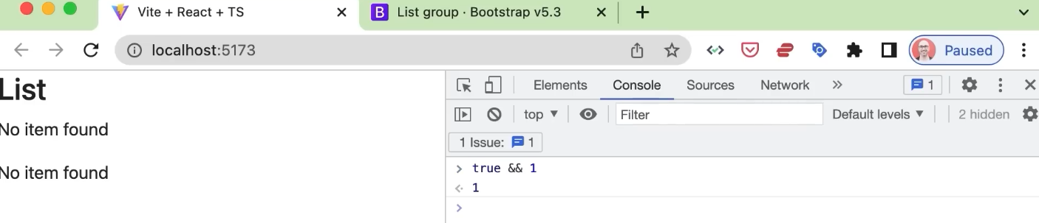

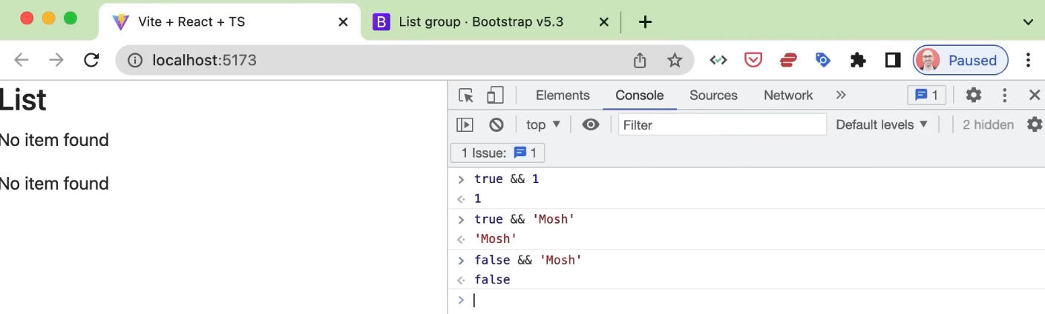
------------------------------------------------------------------

03 Handling events

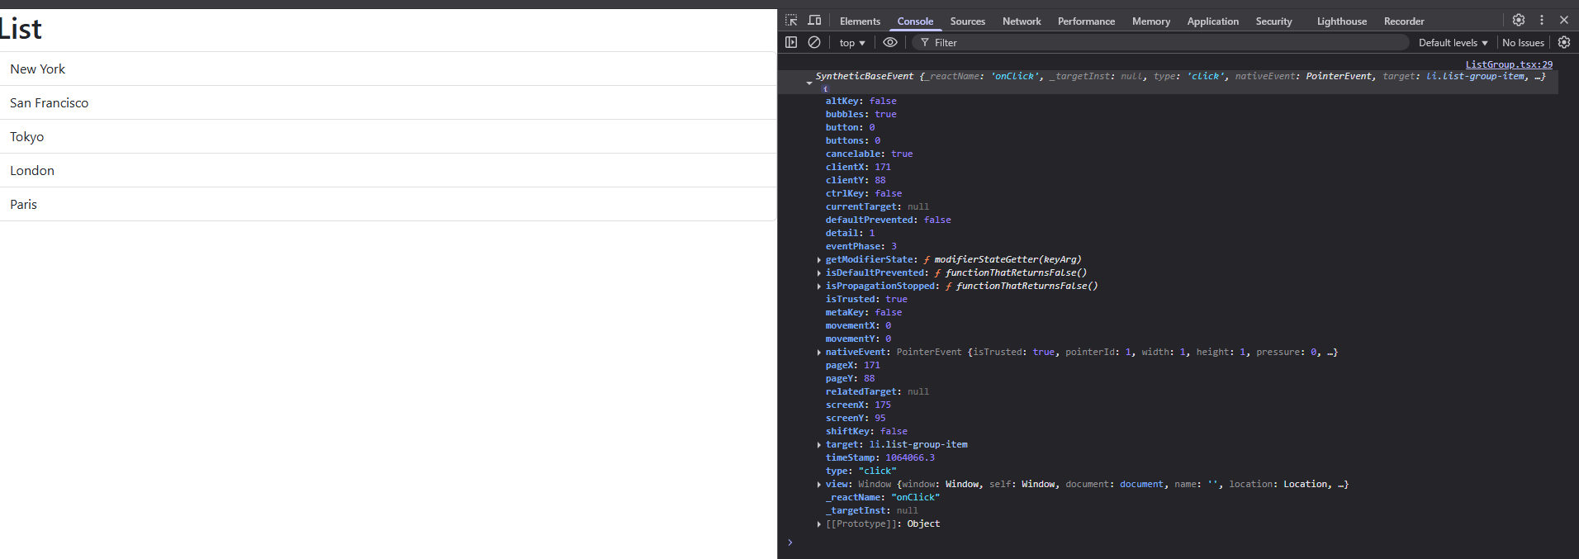
The type of object is SyntheticBaseEvent. It is a built in class in React. Different classes have different implementations of event objects. So to make this cross-browser React team have created a class called SyntheticBaseEvent which is a wrapper around the native browser event object.

We have properties like clientX and clientY which represents the position where we clicked. Type and target.

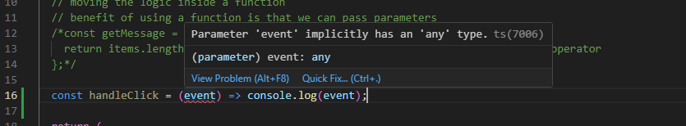
More complex logic can be moved to a separate function.

We know that the issue is typescript because it says ts . The ts compiler does not know the type of parameter, is ‘event’ a number, string or object.

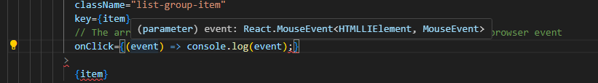
Move the code to the onclick function and hover over the event object to see the type. When we pass an inline function ts compiler knows the type of compiler.

--------------------------------------------------------------

Handling events - highlighting one item at a time

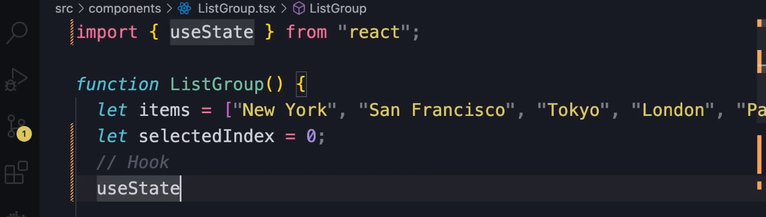
‘selectedIndex’ variable is local to this function component. We have to tell React this component will have data or state that might change overtime. We use a built in function is called

useState. This is called the state hook.

this function is called a HOOK. A hook allows us to tap into built in features in react.


Initializing the variable to -1
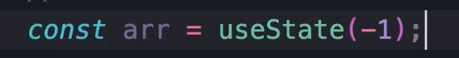
useState returns an array

The above array will have 2 elements
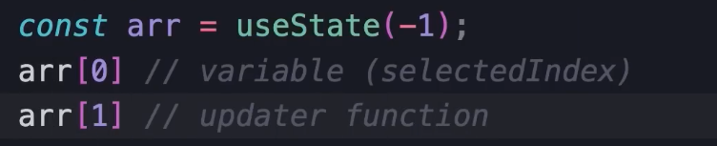

The updater function will be used to update the variable and at that point React will be notified, so that it will know that the state of our component has changed and then React will re-render our component which causes the DOM to be updated.

WITH REACT WE NEVER HAVE TO TOUCH THE DOM DIRECTLY, we think in terms of components that have state. When the state of the component changes React will update the DOM to match the updated component state.

Convention followed in react

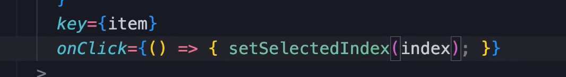
calling the updater function.

NOTE : Each component will have its own state

------------------------------------------------------------------

Passing data via props

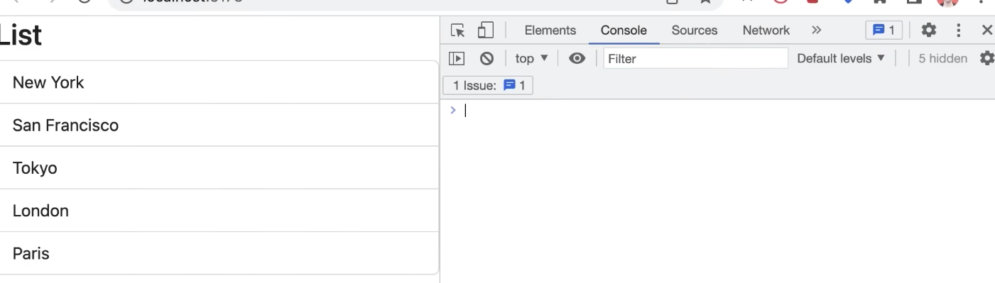
Showing a list of cities above. What if we want to display a list of colours or names. We can make this component reusable by using Props or Properties.

Props are the inputs to our components.

The above items can be passed as input to the component.

First we will decide the shape of the input to this component.

items – array , heading – string . We will use in interface to define the shape or the interface of an object.

By convention the interface can be called ‘Props’ but we can also add the name of the component in the beginning.
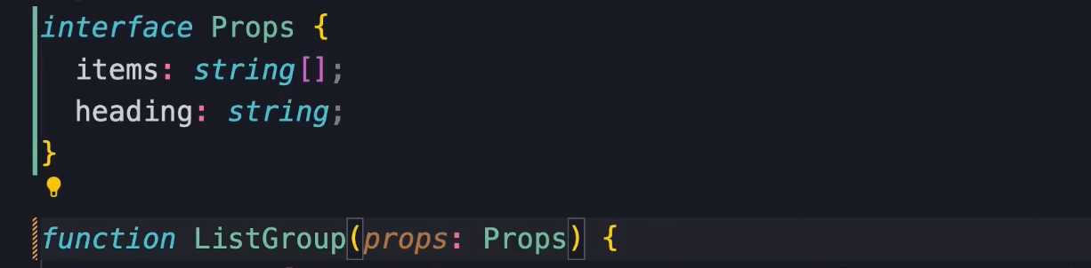
Defining the property and type and passing the parameter to the function of type props.

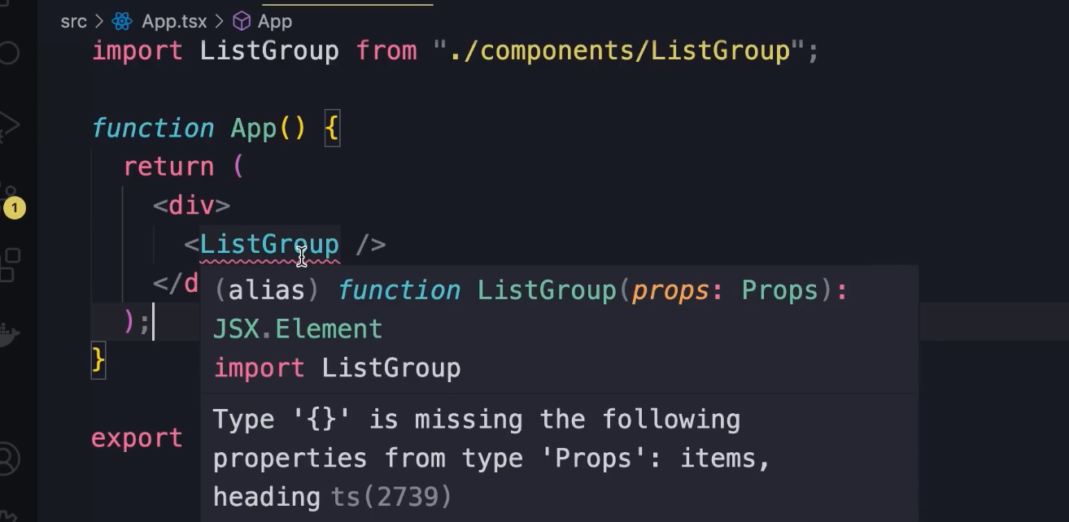

Compilation error in App.js

The advantage of using typescript is that the ts compiler is reminding us that the parameter is missing. Helps us catch potential errors at compile time before running our application.

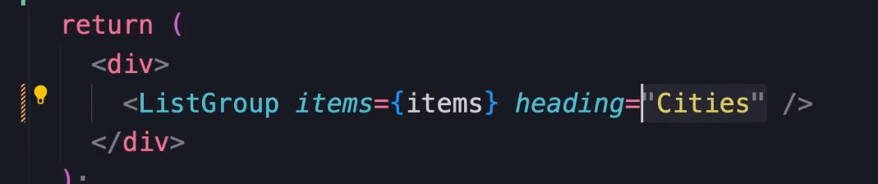
Using quotation marks for heading because Cities is a static value.

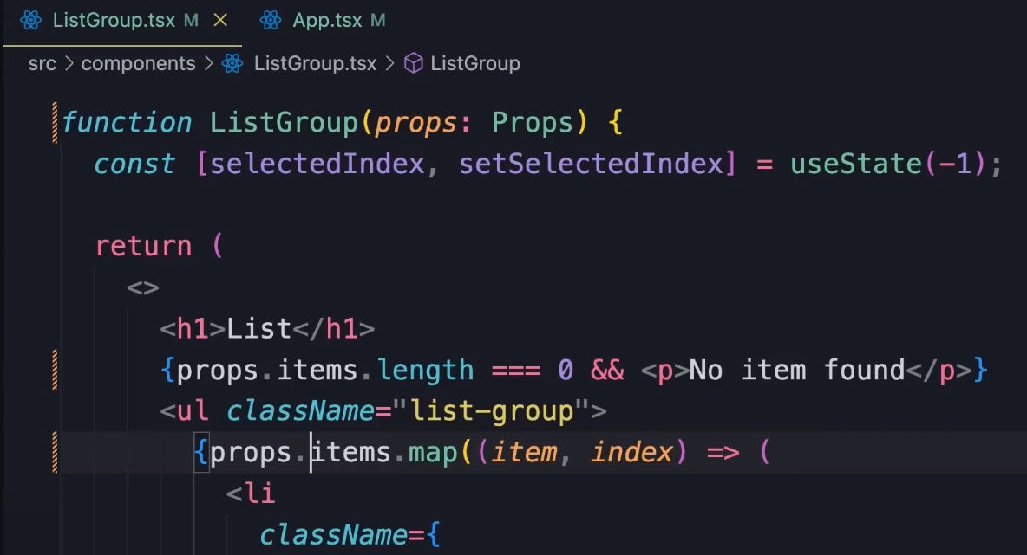
props.items is repetitive which is unnecessary.

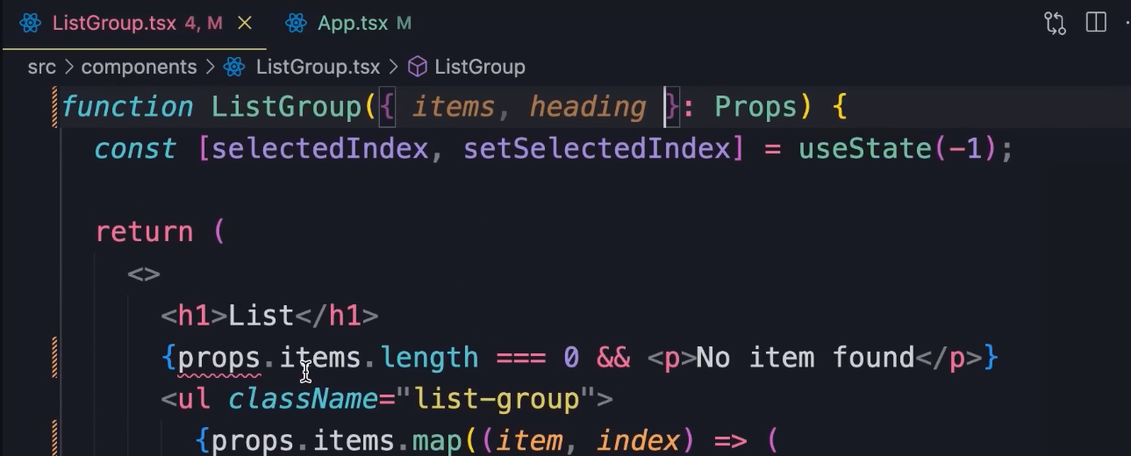
We will de-structure the parameter and pick the 2 properties. We will have access to the properties anywhere in the function.

------------------------------------------------------------------

Passing functions via props

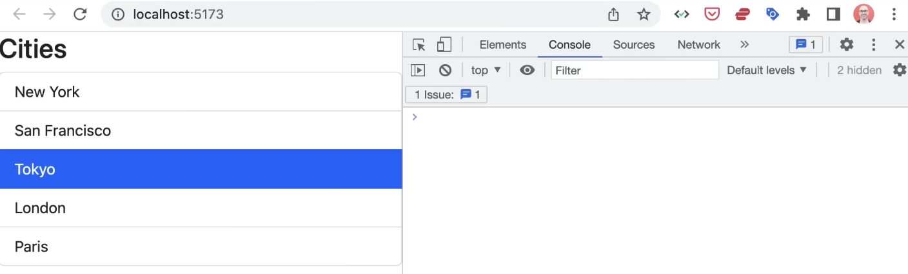
We need something to happen when we click. The requirement can change from one application to another. So we cannot implement that logic in the specific component because it will not be reusable.

We need a mechanism to notify the consumer or parent of the component that an item is selected.

We will add another property within props which will be a function.

We need a function that takes a parameter of type string and returns void. Naming convention for the function is to start with ‘on’ and then the task it will perform.

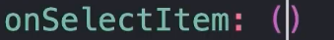

We have a property called onSelectItem which is of type function. Has a parameter of type string and returns void.
This results in a compilation error in App.tsx. We have to pass the new prop.

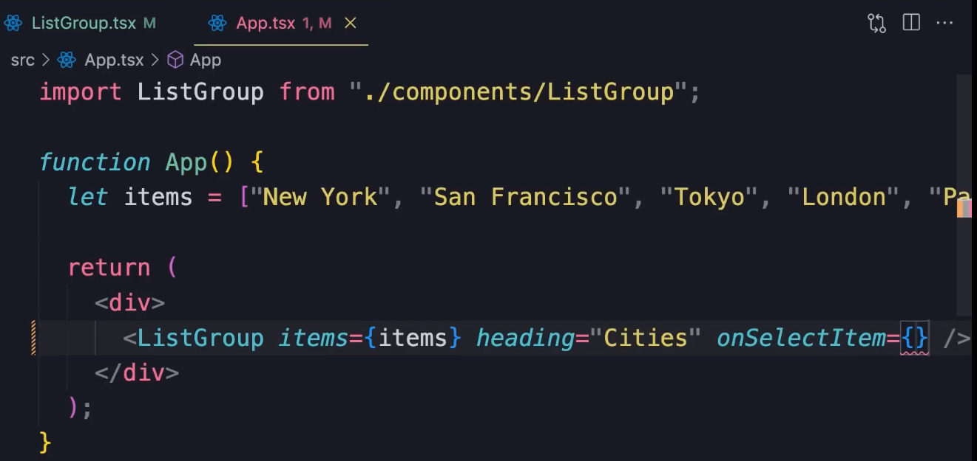
we can write an inline function else we can write a separate event handler.

