**Environmental Studies**

( Q.1 ) What do you understand by the multidisciplinary nature of Environmental

Studies ?

(Ans.) Environment is a term that comprehends all our surroundings not only air,

water but also all biotic and non-biotic things or organisms. Environmental

studies deals with every issue that affects an organism. It is essentially a

multidisciplinary approach that brings about an appreciation of our

natural world and human impacts on its integrity.

It is an applied science as its seeks practical answers to making human

civilization sustainable on the earth’s finite resources. Its components

include biology, geology, chemistry, physics, engineering, sociology,

health, anthropology, economics, statistics, computers and philosophy.

You can understand by this diagram :-

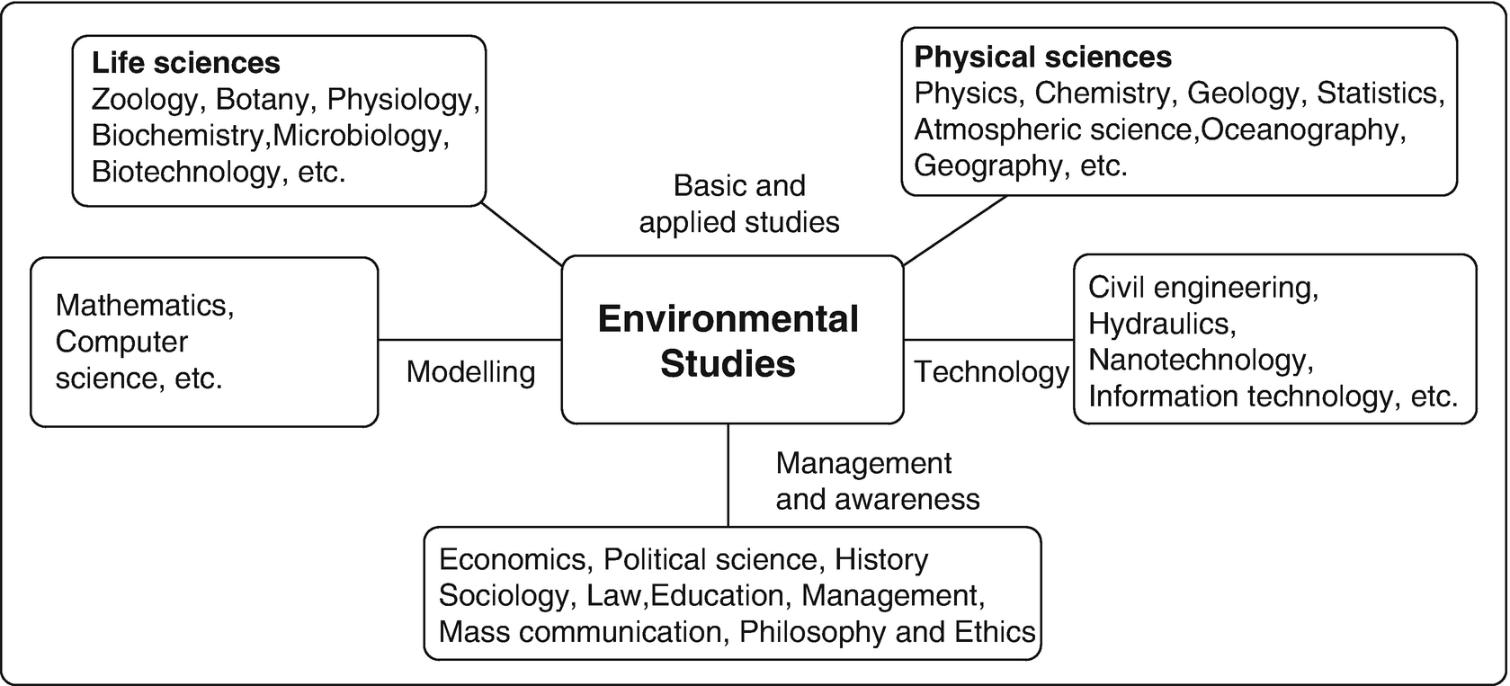

**Multidisciplinary Nature of Environmental Studies:**

Because, the environment is complex and actually made up of many different environments, including natural, constructed and cultural environments, environmental studies is the inter disciplinary examination of how biology, geology, politics policy studies, law, geology, religion engineering, chemistry and economics combine to inform the consideration of humanity’s effects on the natural world.

This subject educates the students to appreciate the complexity of environmental issues and citizens and experts in many fields. By studying environmental science, students may develop a breadth of the interdisciplinary and methodological knowledge in the environmental fields that enables them to facilitate the definition and solution of environmental problems.

It is essentially a multidisciplinary approach and its components include Biology, Geology, Chemistry, Physics, Engineering, Sociology, Health Sciences, Anthropology, Economics, Statistics and Philosophy. It is essentially a multidisciplinary approach.

An Understanding of the working of the environment requires the knowledge from wide ranging fields.

**Interdisciplinary Nature of Environmental Science:**

**Ex: Air Pollution:**

|  |  |
| --- | --- |
| **Environmental issue/topics** | **Major subject/ Topic knowledge required** |
| Nature and reaction of air pollutants | Chemistry and Chemical engineering |
| Effects of air pollutants on human beings, animal and plants | Zoology and botany and various branches of life science. Physics and Chemistry |
| Effect of air pollutants on materials | Meteorology, Thermodynamics, Geography |
| Effect of climate on air pollution | Mathematical modeling, etc. |
| Air pollution control devices | Physics, chemistry and various branches of Engineering |
| History of air pollution and air pollution episodes | History |
| Economic impacts of air pollution | Economics, Demography |
| Sociological impacts of air pollution | Sociology |
| Alternative fuels | Various branches of physical sciences |
| Conservation of resources and pollution control | Various branches of physical and political sciences |
| Ozone hole and global warming | Almost all fields under the sun has got something to contribute to the understanding and prevention of these phenomenon. |

Thus you can understand the scope and multidisciplinary nature of Environmental Studies. Well, Environmental science is not a theoretical subject, it is a practical subject from which we all are connected. So if you want more details about it, you just have to surf on the internet and search about it. You can also get knowledge from your surroundings.

( Q.2 ) Why do we need for public awareness for Environment ?

(Ans.) As I said earlier that Environment is related to every biotic and abiotic

orgasms. While we utilize several goods and services of nature and enjoy

its benefits, we must recognize that every activity that we do in our daily

lives has an adverse impact on nature’s integrity. Thus if we use up all our

resources, kill off and let species of plants and animals become extinct on

earth, pollute our air and water, degrade land, and create enormous

quantities of waste, we as a generation will leave nothing for future

generations. Our present generation has developed its economies and

lifestyles on unsustainable patterns of life.

However, nature provides us with various options on how we utilize its

goods and services. This is its option value. We can use up goods and

services greedily and destroy its integrity and long term values, or we can

use its resources sustainably and reduce our impacts on the environment.

The option value allows us to use its resources sustainably and preserve its

goods and services for the future.

As the earth’s natural resources are dwindling and our environment is

being increasingly degraded by human activities, it is evident that

something needs to be done. We often feel that managing all this is

something that the Government should do. But if we go on endangering

our environment, there is no way in which the Government can perform

all these clean-up functions. It is the prevention of environment

degradation in which we must all take part that must become a part of all

our lives. Just as for any disease, prevention is better than cure. To prevent

ill-effects on our environment by our actions, is economically more viable

than cleaning up the environment once it is damaged. Individually we can

play a major role in environment management. We can reduce wasting

natural resources and we can act as watchdogs that inform the

Government about sources that lead to pollution and degradation of our

environment.

This can only be made possible through mass public awareness. Mass media such as newspapers, radio, television, strongly influence public opinion. However, someone has to bring this about. If each of us feels strongly about the environment, the press and media will add to our

efforts. Politicians in a democracy always respond positively to a strong publicly supported movement. Thus if you join an NGO that supports conservation, politicians will make green policies. We are living on spaceship earth with a limited supply of resources. Each of us is responsible for spreading this message to as many people as possible.

**Disciplines where Public Awareness is needed :**

1. Pollution (like : Air, water, soil, sound pollution)
2. Deforestation
3. Solid & Plastic waste
4. Cleanliness
5. Loss of Biodiversity
6. Increasing Population
7. Global Warming

Some of them are briefly described here :-

1. **Pollution** :-

As we know in today’s world, there are different kind of pollutions. Such as :

1. Air Pollution
2. Water Pollution
3. Sound Pollution

Because of these pollutions different diseases raise up and harm our society. The quality of life deteriorates due to pollution as it causes not only temporary but long term effects. The hearing impairment, lung diseases like asthma, bronchitis, allergy, diarrhoea are the common diseases.

Insects too get attracted into polluted areas thus contaminating other water bodies present in the region.

Pollution also affects abiotic factors, example is global warming. This in turn has caused major effects which include forest fires,

upcoming of several dormant pathogenic organisms. This directly effects the lifestyle.

1. **Cleanliness** :-

“Hygiene is important and desirable because it protects us and others against infection and promotes health.” As we all know that Good Health is our prime aspect. By understanding this thing, our Government has started “CLEAN INDIA MISSION”. The very motive of this mission was to inform as well make people aware of the significance of cleanliness. Some of its slogans include:

(a) “Clean India, beautiful India.”

(b) “Don't destroy greenery and don't spoil scenery. ”

Taking into consideration sanitation, toilets have been

constructed in many villages and schools. It was one of the

massive steps taken by the Government under this mission.

1. **Increasing population:**

Specific issues are chained to this problem itself for example- urbanization, poverty, pollution, destruction of habitat are causing the degradation of natural assets. Currently, we are about 1.38 billion and the capacity of the earth is 10 billion.

We are ingesting natural sources so speedily that the day is not far when they will be completely extinct. Our existence is primarily based on abiotic elements. If the population is mismanaged, the survival of human beings on earth will be tremendously challenging. India's population in 2020 is estimated to be 1.38 Billion (138 crores).

It is high time to implement the two-child policy strictly and make it compulsory in each state. The Economic Times reports that the

Government in collaboration with the authorities in Assam is currently drafting a population policy. Underneath the coverage, those with more than two children will not be eligible to get government jobs or avail other benefits including government housing in Assam.

**How Public Awareness can be achieved:**

1. Incorporating environmental awareness in the education system
2. Mass Media
3. Cultural Events & Activities

* **Mass Media**

We are connected to social media via one or several different means. In this area, there are a lot of requirements that people need to focus and work upon.

Most schools and colleges have a particular society working for the betterment of the environment. On one hand, simply forming a society is not enough but on the ground level, what measures or steps are taken by us for the betterment of the habitat is crucial.

There is a need to approach and convince people to take part in weekly seminars, joining local movements imparting understanding about growing worries about the environment, organize donation camps and utilize the money in planting small saplings. Promoting and practicing good civic sense including saving trees, no throwing of garbage on roads, no urinating on public places and the issues such as the 3 Rs in waste management, proper waste disposal should be encouraged.

According to me, Individual awareness is needed for preserving the environment.