🍽️ GHOROYA RESTAURANT
Assistant
RAG-Powered AI Chatbot System

Amontron - Your Intelligent Assistant
Project Documentation | June 2026

PROJECT OVERVIEW
Amontron is a sophisticated Retrieval Augmented Generation (RAG) system designed to power an intelligent AI chatbot assistant for Ghoroya Restaurant, an esteemed Bengali fine dining establishment. The system seamlessly integrates advanced language models with semantic search capabilities to deliver contextual, accurate responses about restaurant operations, menu offerings, inventory management, loyalty programs, and comprehensive customer service.

Quick Reference
Restaurant  Ghoroya - Bengali Fine Dining | Assistant  Amontron
Support  📞 1234567899 | Type  RAG System

TECHNICAL ARCHITECTURE
The system is built on a modern, scalable stack designed for optimal performance and reliability:

Technology Stack
Component | Technology | Purpose
Workflow | n8n | Orchestrates data & chat flows
Language Model | GPT-4o (OpenRouter) | Intelligent responses
Vector Database | Pinecone | Semantic search
Storage | Google Drive | Document source
API Gateway | OpenRouter | LLM API routing

System Components

Amontron_Assistant.json
The main chatbot orchestration workflow
- N8n workflow configuration with chat webhook trigger
- GPT-4o language model integration via OpenRouter
- Pinecone vector store semantic search
- Conversation context memory (10-message window)

Ghoroya_Restaurant_Data_Insert.json
The automated data ingestion and vectorization pipeline
- Google Drive integration for document retrieval
- Intelligent batch processing and extraction
- Embedding generation and vectorization
- Pinecone insertion with 'Ghoroya' namespace

FEATURES & CAPABILITIES

Core Functionalities
Feature | Description
🍽️ Menu | Complete items, pricing, ingredients & dietary info
📦 Inventory | Real-time stock levels & availability
📱 Orders | Multi-platform tracking (Uber, DoorDash)
💳 Loyalty | Member tiers, points & rewards
🎉 Promotions | Current campaigns & discounts
👥 Staff | Schedules & shift management
📞 Reviews | Customer feedback & ratings
📍 Locations | Hours, addresses & policies

Communication Style
- Warm, friendly, and professional tone
- Concise, informative, and empathetic responses
- Smart fallback to human support when needed

KNOWLEDGE BASE
The system is powered by 11 comprehensive operational documents, each carefully curated and stored in the Pinecone vector database:
# | Document | Purpose
1 | Customer Reviews | Feedback & ratings
2 | Employee Schedule | Shift assignments
3 | Social Media | Engagement data
4 | Hours | Operating times
5 | Inventory | Stock levels
6 | Loyalty | Tiers & rewards
7 | Menu | Items & pricing
8 | Orders | Delivery history
9 | Promotions | Campaigns
10 | Reservations | Policies
11 | Branches | Locations

DATA FLOW & ARCHITECTURE

Ingestion Pipeline
Google Drive Documents → Google Drive Integration → Batch Processing → Content Extraction → Embedding Generation → Vector Conversion → Pinecone Storage

Query Processing Pipeline
User Message → Chat Webhook → LLM Processing → Vector Search → Context Retrieval → Response Generation → User Output

USE CASES

For Restaurant Staff
- ⚡ Quick access to menu items, pricing, and ingredient information
- 📦 Real-time inventory checks and stock availability
- 👥 Employee scheduling and shift management
- 📱 Multi-platform order retrieval and tracking
- 💳 Loyalty program member insights

For Customers
- 🍽️ Browse complete menu with pricing
- 📅 Check reservation availability
- 🎁 Loyalty rewards and point information
- ⏰ Hours and location information
- 🎉 Current promotions and special offers

CONFIGURATION

Agent Settings
Setting | Value
Language Model | GPT-4o (OpenRouter)
Vector Index | ghoroya
Namespace | Ghoroya
Max Iterations | 10
Reranking | Enabled
Memory | 10 messages

UI Customization
- Title: "Ghoroya - Your search of Bengal ends here!"
- Colors: Orange (#d9480f) & Brown (#7c2d12) - brand heritage
- Dimensions: 430px × 680px (mobile-optimized)
- Welcome: "My name is Amontron. How can I assist you today?"

LIVE CHAT ACCESS
🚀 LIVE CHAT URL
https://curious06.app.n8n.cloud/webhook/6f4f3b9f-f263-42e6-bbc5-9a19845a867c/chat

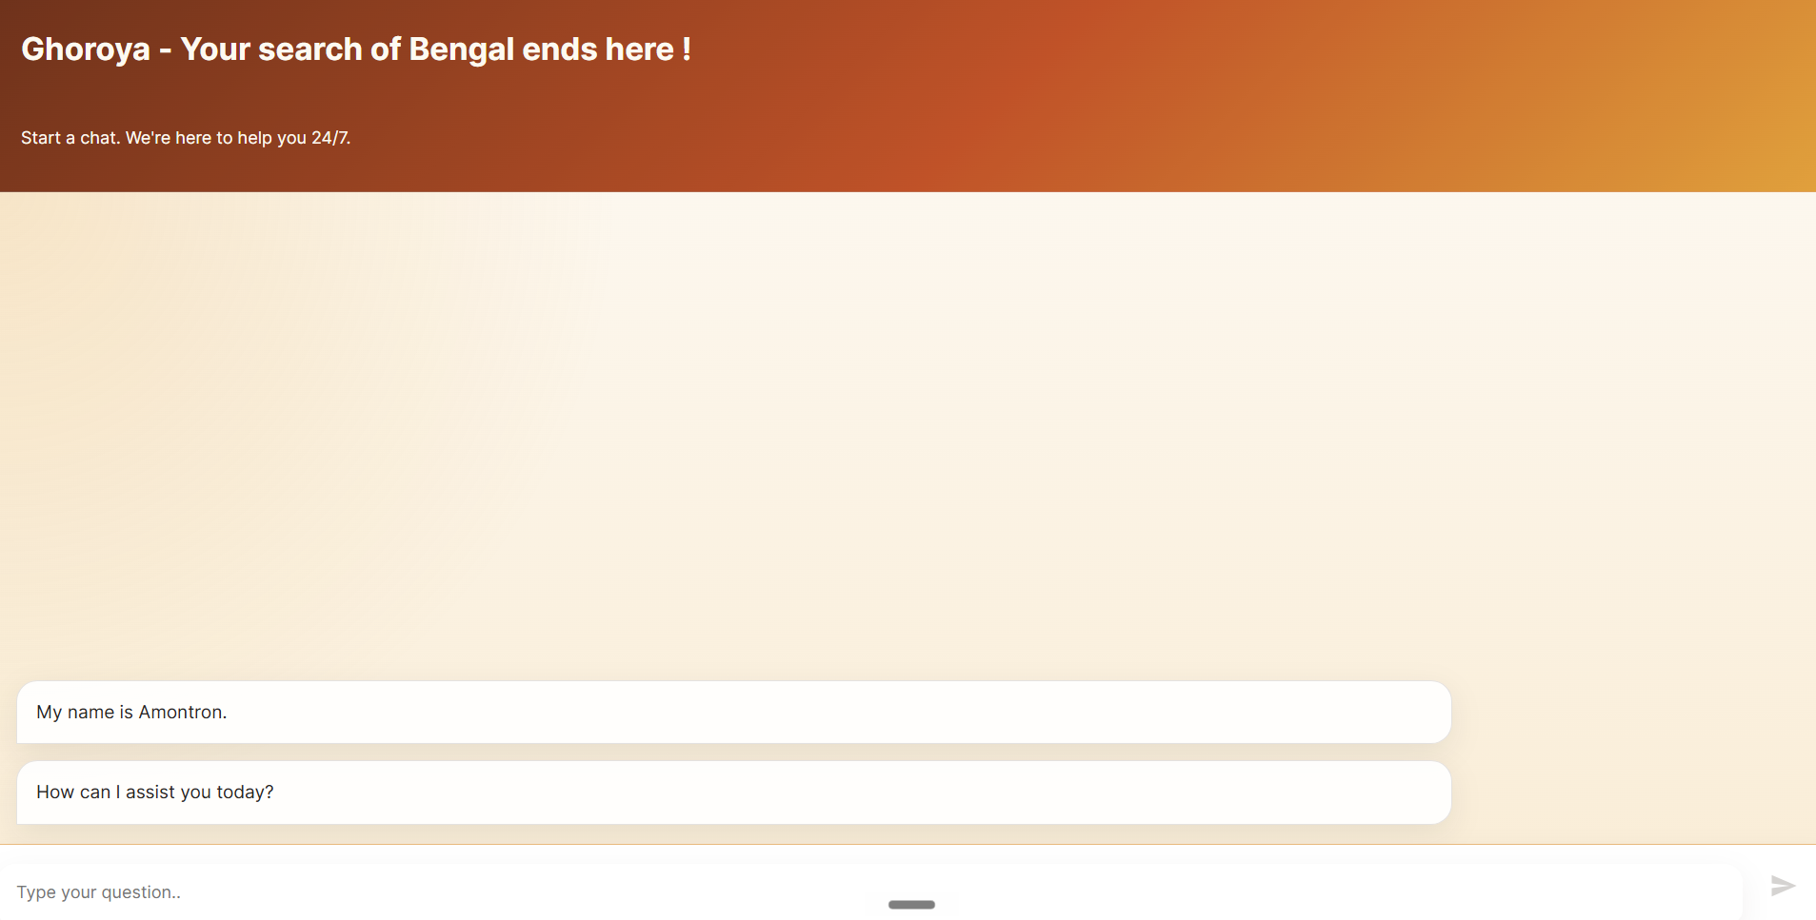

SAMPLE CONVERSATIONS
Real examples demonstrating the system's intelligence and versatility:
User Query | Assistant Response
What was my last order? | Uber Eats: Khaled Rahman on June 9, 2026
Weekend buffet price? | Bengali Buffet: $28.95 (14+ dishes)
Is goat meat in stock? | Yes: 62 lbs available
Reward campaigns? | 4 campaigns: Bonus, Dessert Tuesday, Priority, Birthday
Astoria location? | 30-18 Steinway St, Astoria NY 11103

SUPPORT & RELIABILITY

When Information Is Unavailable
"I am not aware of this information. For immediate assistance, kindly contact:"
📞 1234567899

Design Principles
- ✓ No hallucinations - Only grounded, verified information
- ✓ Graceful degradation - Clear path to human support
- ✓ Context awareness - 10-message conversation memory

DATA MANAGEMENT

Data Lifecycle
- 📥 Source: Google Drive (operational documents)
- 💾 Storage: Pinecone ('Ghoroya' namespace)
- 🔐 Access: N8n with OAuth2 & API credentials
- 🔄 Updates: Automated via data insertion pipeline

KEY METRICS

Knowledge Base Scale
📊 11 Documents • Ghoroya Namespace • 10 Message Memory • 10 Max Iterations • Reranking Enabled

